THE FIGURATIVE ART
IN JEWISH, CHRISTIAN AND ISLAMIC LAW
By
Sami A. Aldeeb Abu-Sahlieh
2007
www.sami-aldeeb.com
saldeeb@bluewin.ch
Introduction 2
Chapiter I. Jewish norms 4
1) Historic precedent 4
2) Sources of Jewish norms 5
3) The Bible and figurative art 6
4) Mishnah, Talmud and figurative art 10
5) Interdiction between rigorists and liberals 12
6) Is there a modern Jewish art? 15
7) Maimonides, victim of his writings 16
Chapter II. Christian norms 18
1) Sources of Christian norms 18
2) Figurative art in the New Testament 18
3) Positions and practices of the first centuries 19
4) Byzantian iconoclasm (725-843) 22
5) Rehabilitation of art in Nicea II 23
6) Reform and figurative art 24
7) Sollicitudini Nostrae of Benedict XIV (1745) 26
8) Second Vatican Council and Code of Canon law 27
Chapter III. Islamic norms 29
1) Sources of Islamic norms 29
2) Koran and figurative art 29
3) Sunnah and the figurative art 30
4) Interpretation of the Koran and the Sunnah 33
5) Islamic figurative art today 42
6) Modern inventions: Photographs, movies, television and theatre 49
7) Extreme position of the Saudi scholars 58
Conclusion: Hibernation and wakening of the religious norms 61

Introduction
In March 2001, the Taliban destroyed the gigantic statues of Buddha and other objects of figurative art that were in the Afghan museums.
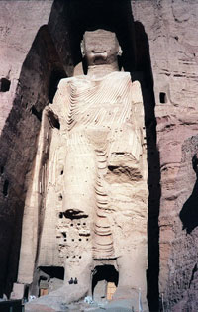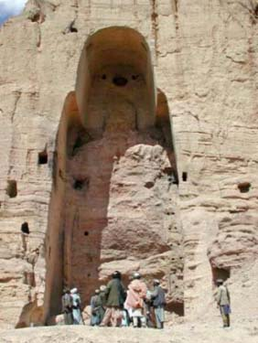
Statue of Buddha before and after 2001
Similar destructions took place through ancient and contemporary history. The fall of the Communist regime in the USSR and in the satellite countries led to the fall of the statues of the founding fathers of Communism and the dignitaries of these countries; and at the time of the occupation of Iraq, the Americans and their allies conducted the destruction of Saddam's statues and pictures.
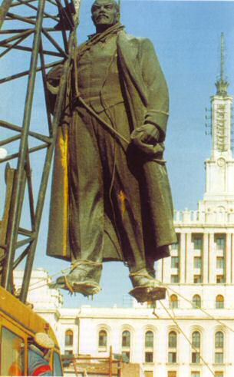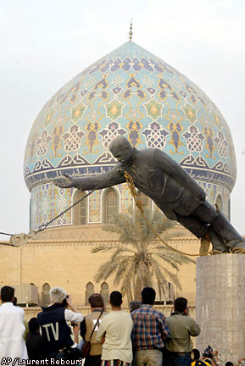
Statues of Lenin and Saddam victims of modern iconoclasm
This attitude belongs to primary animal instinct of domination. However, contrary to animals, human beings try always to justify their acts.
This text aims to identify the Islamic norms concerning figurative art, comparing them to the Jewish and Christian norms. It could help predict and prevent gestures similar to those of the Taliban.

Chapiter I. Jewish norms

1) Historic precedent
Egyptian, as well as Mesopotamian civilization, put figurative art in the service of divinity and authorities. Statues and pictures brought them closer to the people. As all civilizations, Egyptian civilization had its temptations of iconoclasm. Thus, in the Museum of Cairo, we see the remains of statues of Pharaohs that were brocken and thrown into wells by their successors.
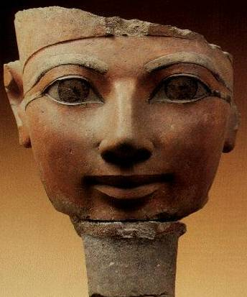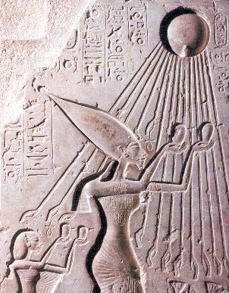
Hatshepsut (1490-1468 before J.-C.) Akhenaton (1372-1354 before J.-C.)
In religion, Egypt had a rather tolerant attitude towards figurative art, judging by the large number of their paintings, relieves and statues. However, there is a case of religious iconoclasm, which occurred during the last three or five years of Akhenaton who reigned from about 1372 until 1354 before J-C. This Pharaoh, considered as the father of monotheism, declared the Sun, Aton, only and unique divinity, and commanded the closing down of the temples of other divinities and the destruction of their statues. An inscription found in his capital Akhet-Aton (Tell Al-Amarna) says that God Aton shapes himself with his hands, and no sculptor knows this shape. The only human form preserved from Aton is its hands at the end of the rays of the sun, giving sign of life to the king to maintain the creation. Nevertheless, the Pharaoh and his wife Nefertiti are depicted in company with solar disc. After his death, the city of Akhet-Aton was abandoned. Everything that related to this Pharaoh was destroyed and the cult of Amon and all other gods was restored. Akhenaton was indicated by his successors as being the criminal of Akhet-Aton.
The Greek historian Strabo (died 21 or 25) thinks that Egyptians were the ancestors of the Jews. Sigmund Freud (died 1939) identifies Moses as an Egyptian at the time of Akhenaton. An administrator/General or member of the royal family, or priest or all three. After the fall of Akhenaton, Moses, held to the faith, left to govern a new people and introduced the monotheism to them. Could this explain the attitude of the Bible with regard to the figurative art?
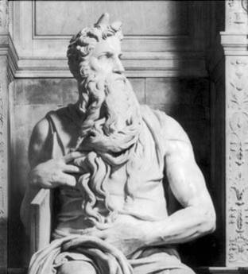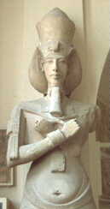
Moses and Akhenaton

2) Sources of Jewish norms
For the Jewish believer, the Bible imposes itself as a legal code to follow at all times and in all places. One reads:
Everything that I command you you shall be careful to do; you shall not add to it or take from it.
The secret things belong to the Lord our God; but the things that are revealed belong to us and to our children for ever, that we may do all the words of this law.
It is a statute forever throughout your generations in all your dwellings.
Quoting these verses, Maimonides (died 1204) writes, “It is clearly stated in the Torah that it contains the Law which stands for ever, that may not be changed, and nothing may be taken from it or added to it”. According to Maimonides, if one pretends the opposite, “he shall die by hanging”. This punishment is also foreseen for anyone who “uproots any of our verbal traditions or says that God had charged him to interpret the Law in such and such a way, he is a false prophet and is to be hanged even though he give a sign”.
In addition of the Bible, the Jews assign a major importance to the Mishna and the Talmud which are considered the second source of Jewish law. What is the position of these sources concerning figurative art?

3) The Bible and figurative art

A) Interdiction of the figurative art
If the Bible is the first source of Jewish law, the famous Ten Commandments constitute the heart of this law.
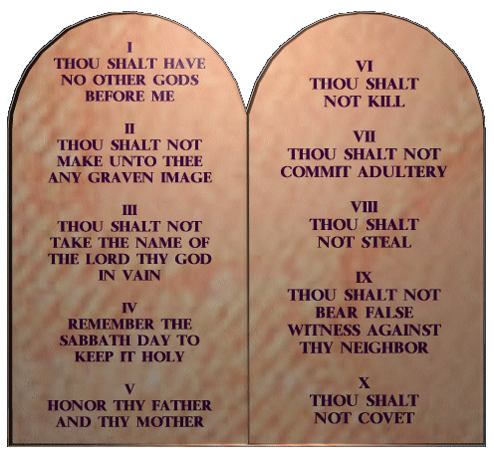
The Ten Commandments
The interdiction of figurative art is registered at the head of these commandments:
I am the Lord your God, who brought you out of the land of Egypt, out of the house of slavery. You shall have no other gods before me. You shall not make for yourself an idol, or any likeness of what is in heaven above or on the earth beneath or in the water under the earth. You shall not worship them or serve them; for I, the Lord your God, am a jealous God.
Other verses resume the same idea, which is developed in the following passage:
So watch yourselves carefully, since you did not see any form on the day the Lord spoke to you at Horeb from the midst of the fire, so that you do not act corruptly and make a graven image for yourselves in the form of any figure, the likeness of male or female, the likeness of any animal that is on the earth, the likeness of any winged bird that flies in the sky, the likeness of anything that creeps on the ground, the likeness of any fish that is in the water below the earth.
The interdiction of the pictures or statues does not limit itself to the Jews. Jews are ordered by the Bible to eliminate the representations of the divinities of dominated peoples. Moses instructs his coreligionists before entering in the "Promised Land":
When the Lord your God brings you into the land where you are entering to possess it, and clears away many nations before you… you shall utterly destroy them. You shall make no covenant with them and show no favour to them… But thus you shall do to them: you shall tear down their altars, and smash their sacred pillars, and hew down their Asherim, and burn their graven images with fire.
When you cross over the Jordan into the land of Canaan, then you shall drive out all the inhabitants of the land from before you, and destroy all their figured stones, and destroy all their molten images and demolish all their high places.
These norms seem to forbid the representation of any object, but in fact they only concern living beings, as the floral decoration did not pose any problems to Jews. On the other hand, they concern all representations of living beings, but some consider that they only concern the representation of living beings used as objects of cult. These two readings coexisted and continue to coexist even today, not only among Jews, but also among Muslims who are inspired by Jewish norms. Those who limit these rules to the objects of cult adopt a teleological interpretation according to which the goal of the prohibition is to prevent idolatry (of the Greek eidolon latreia, cult of the idols). On the other hand, those who extend them to all living beings consider that any picture is potentially an idol and must therefore be banned.
Whatever the correct reading may be, there is a general problem: what is the reason behind the prohibition of idols and why could Moses (Jehovah for the believer) not accept that everyone had his small idol at home? Such a question presupposes the acceptance of individual freedom of religion, freedom contested even today. The principle Cujus regio, eius religio has the pre-eminence in history.

B) Contradictions in the Bible
If we examine the Bible, we note numerous violations of the interdiction of figurative art, even by Moses (Jehovah, for the believer) himself.
According to the Bible, Jehovah asks Moses for a tabernacle with an ark and gives him the descriptions: "You shall make a mercy seat of pure gold, two and a half cubits long and one and a half cubits wide. You shall make two cherubim of gold; make them of hammered work at the two ends of the mercy seat". Jehovah is supposed to sit above the ark and the cherubim in his invisible majesty. The tabernacle should be made "with ten curtains of fine twisted linen and blue and purple and scarlet material; you shall make them with cherubim, the work of a skilful workman". This presence of the cherubim is explained by the fact that Jehovah uses them like a setting. On the other hand, always by order of Jehovah, "Moses made a bronze serpent and set it on the standard; and it came about, that if a serpent bit any man, when he looked to the bronze serpent, he lived". The Jews ended up adoring this snake and offering him sacrifices; it was destroyed by Hosea.
To solve the previously mentioned contradiction, it is considered that initially figurative art was barred, but to justify the decorations of the temple under Salomon, the editors of the Bible added the unlikely passages concerning the tabernacle of Jehovah in Moses' time. Indeed, it is difficult to imagine the Jews in the desert preparing curtains of fine twisted linen. The scribes attempted to remedy to this difficulty by indicating that God has himself filled the artists "with skill to perform every work of an engraver and of a designer and of an embroiderer, in blue and in purple and in scarlet material, and in fine linen, and of a weaver, as performers of every work and makers of designs".
Concerning Salomon's temple, the Bible indicates that it had two big cherubim. Other cherubim were sculpted on all its walls, outside and inside. There was also a sea of bronze carried by twelve oxen. The Bible indicates also that Salomon had a throne decorated with lions and that he constructed other temples for the gods of his 700 wives and 300 concubines. Let us mention here that the eschatological temple of Ezekiel also comprises figurative ornaments, including cherubim with two faces: a man's face and a lion's face.
The prophets repeatedly condemned the idols. This condemnation shows that the Jews did not stop having them and that monotheism was not unanimously accepted. The Bible indicates that the Jews made a molten calf from gold after the exodus from Egypt and made him offerings saying: "This is your god, O Israel, who brought you up from the land of Egypt". Moses hurried to reduce it to dust and to massacre about three thousand men among those who adored it. Two other molten calves were made by king Jeroboam (931-910 before J-C) who said to the people: "It is too much for you to go up to Jerusalem; behold your gods, O Israel, that brought you up from the land of Egypt". He set one in Bethel, and the other in Dan. 150 years later, the prophet Hosea fulminated against this representation: "He has rejected your calf, O Samaria, saying: 'My anger burns against them!' How long will they be incapable of innocence? For from Israel is even this! A craftsman made it, so it is not God, Surely the calf of Samaria will be broken to pieces". The Bible also indicates that Jews had statues and pictures representing divinities known as teraphim and ephod. Under Antiochus, they introduced idols in the temple and presented them offerings. These idols have been destroyed at the time of the revolt of the Maccabee. However, even the slain soldiers of Judas who fought this idolatry carried under their coats "things consecrated to the idols of the Jamnites, which is forbidden the Jews by the law. Then every man saw that this was the cause wherefore they were slain".
In a recent book, Israel Finkelstein and Neil Asher Silberman questioned the historicity of the books of the Bible initially attributed to Moses and the interdiction of the figurative art. They consider that these books have been written under the reign of king Josias (of 639 to 609 av. J-C) and revised by priests who invented persons and facts (as Abraham, Moses and the exodus of Egypt, David, Salomon and his temple, the queen of Saba, etc.) for political and theological reasons. These priests represented a monotheistic current opposed to figurative art and cult of the other divinities existing at all times among the Jewish population. Under the impulse of these priests, Josias undertook an iconoclastic movement described by chapter 23 of the 2nd Book of Kings, which recalls the iconoclastic movement under Byzantium or the Reform. The two authors add that the archaeological discoveries show that Josias was far from eradicating the veneration of the images. They indicate that in dwelling quarters of all important sites of the end of the 7th century before J.-C., a large number of figurines have been discovered, representing a standing woman supporting her breasts with her hands (identified generally to goddess Asherah [wife of Jehovah]). Therefore, at least for what concerns the private domain, this very popular cult appears to have continued, in spite of the instructions imposed by Jerusalem.
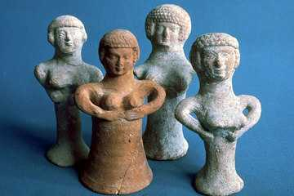
The goddess Asherah wife of Jehovah
After the death of Josias, his successors put an end to the iconoclastic and monotheistic movement inspired by the priests of Jehovah and restored the idolatrous customs of the former kings of Judah.
We can conclude therefore that in spite of the strict biblical interdiction (which was applied probably by the political authorities for a short period of about thirty years), figurative art and polytheism always existed among Jews, often provoking the anger of monotheistic Jewish religious groups.

4) Mishnah, Talmud and figurative art
The Mishnah comprises a tractate titled Aboda zara, foreign cult, taken over and commented by the Talmud. It insists on the interdiction of making a cult to the idols, either directly or indirectly. It indicates that it is necessary to avoid commercial relations with the pagans three days before and after their feasts, by fear that these relations serve to the pagan cult. The Talmud enters in casuistry to know for example if it is allowed to enjoy an income obtained accidentally from such a business. The Mishnah makes an exception to this interdiction: "In a city where the idol is placed, interfering is forbidden inside, but not outside. And if outside, the inside is not forbidden. May one go to the city at that time? If the way leads to the idol only, it is forbidden, but if it leads also to another place, it is not". "If, during an idol festival in the city, some stores were there decorated, one must not buy from these stores, while he may from the others ".
The Mishnah indicates the products that can be sold to pagans: "Fir-cones, white figs on their stems, frankincense, and a white cock. R. Jehudah, however, said: That a white cock may be sold among other cocks, and if singly, he has to cut off a finger of it, because the heathens do not sacrifice an animal of which an organ is missing. All other things may be sold anonymously, but if they say that they buy it for worshipping, one must not sell". Concerning construction, the Mishnah says: "One must not conjoin himself in building their court houses (from the roofs of which they usually throw the one who is sentenced to death, to be killed), gradus, arenas and scaffolds. However, in building monuments and bathhouses, one may. But when they reached that chamber in which their idols should be placed, he must stop". It indicates the objects (wine, vinegar, milk, cheese etc.) which are barred and the ones that are not allowed to be used if they concern idolatry.
After these cautions, the Mishnah dedicates a chapter to the idols themselves as objects, either statues or pictures. It indicates that "all images are prohibited, for they are worshipped at least once a year", according to the recommendation of Rabbi Meir. But others affirm that are prohibited "only those that have in their hand a staff, a bird or a sphere". The Talmud explains: "This prohibition is based upon the following reasons: The staff in the hand of the idol is an indication that it submits itself to the whole world. The bird in the hand of the idol indicates that, like the bird, it sacrifices itself for the world. Finally, the sphere is to indicate that it sacrifices itself for the whole globe". It adds. "The rabbis allow only the use of city images, as these are but ornaments and not idols, but they prohibit the images of the villages which are worshipped idols". The Mishnah indicates the controversies of the rabbis: if the idol is adored in a city, is it barred everywhere or only in that city? Can one except the idols raised to decorate the places? Can one look at them when they are standing or on the ground? Can one read the inscription placed below them the day of Saturday or the other days of the week? The Talmud of Jerusalem reports in this regard that "When rabbi Nahum bar Simai died, they covered up the icons with mats. They said: 'Just as he did not set eyes upon them when he was alive, so let his eyes not set upon them after death." It adds that this rabbi "never gazed upon the face of a coin in his entire life [to avoid seeing the idol inscribed thereon]". The Talmud does not say what walls this concerns: those of a mortuary chamber? of a synagogue? or of a house belonging to a Jew?
The Mishnah says: "If one finds fragments of images, he is allowed to use them. However, if he finds fragments in form of a hand or a foot, they are prohibited, for such are worshipped". It adds: "If one finds vessels with the image of the sun, moon, or of a dragon on them, he must throw them into the salt lake. R. Simeon b. Gamaliel said: Only when these vessels are of a distinguished character they are forbidden, while insignificant vessels with such images on are allowed"
Can one enter a bath where there is an idol? The Mishnah reports the following fact:
Peroklas, the son of a philosopher, asked once R. Gamaliel at Ako, who was then bathing in the bath of the goddess Aphrodite: Your law prescribes [Deut. xiii. 17]: "Let nothing of the devoted objects cleave to thy hands"; why, then, do you bathe in the bath of Aphrodite? And he answered: Such questions are not answered--at a bathing place. After he had left the bath he said: I am not come into her domain, but it is she that is come into mine; truly, people do not say: The bath is erected to adorn the Aphrodite, but the Aphrodite is to ornate the bath; moreover, you would not agree for any amount of money to appear before your idol when you are naked or urinating. The Aphrodite, however, stands on the channel, and everybody urinates in front of her. The law says their gods, i.e., to say such toward whom one behaves with dignity inspired by something divine; while whatever does not inspire such a behaviour, is allowed.
The Mishnah indicates how an idol can be profaned, and thereafter its material used: "By cutting off the tip of its ear, the point of the nose, or the ends of the fingers, or by disfiguring its face with a hammer, even if thereby nothing is broken off. But if he only spat or urinated before it, dragged it about in the dirt, or cast such upon it, it is not profaned" . It adds: "An idol abandoned by its worshippers in time of peace is allowed, but is forbidden when abandoned in time of war. Altars erected for kings are allowed, for the idol is put on them only when the kings pass".

5) Interdiction between rigorists and liberals
The above stated passages of the Mishnah and the Talmud relate divergent opinions of the rabbis, oscillating between active rigorists and tolerant liberals. Rigorism is manifest in the first century. Speaking of the Jews, Tacit (died 120) writes:
Quite different is their faith about things divine. The Egyptians worship many animals and images of monstrous form; the Jews have purely mental conceptions of Deity, as one in essence. They call those profane who make representations of God in human shape out of perishable materials. They believe that Being to be supreme and eternal, neither capable of representation, nor of decay. They therefore do not allow any images to stand in their cities, much less in their temples. This flattery is not paid to their kings, nor this honour to our Emperors.
This rigorism is confirmed by the Jewish historian Josephus Flavius (died 100), who belonged to the Pharisians' sect. Josephus blames Salomon because "he sinned, and fell into an error about the observation of the laws, when he made the images of brazen oxen that supported the brazen sea, and the images of lions about his own throne; for these he made, although it was not agreeable to piety so to do". Named commander of Galilee, one of his first measures was to "demolish that house which Herod the tetrarch had built there, and which had the figures of living creatures in it, although our laws have forbidden us to make any such figures".
Replying to Apion who blames the Jews for not making statues of emperors, Josephus writes:
Accordingly, since the Grecians and some other nations think it a right thing to make images, nay, when they have painted the pictures of their parents, and wives, and children, they exult for joy; and some there are who take pictures for themselves of such persons as were no way related to them; nay, some take the pictures of such servants as they were fond of; what wonder is it then if such as these appear willing to pay the same respect to their princes and lords? But then our legislator hath forbidden us to make images, not by way of denunciation beforehand, that the Roman authority was not to be honoured, but as despising a thing that was neither necessary nor useful for either God or man; and he forbade them, as we shall prove hereafter, to make these images for any part of the animal creation, and much less for God himself, who is no part of such animal creation. Yet hath our legislator no where forbidden us to pay honours to worthy men, provided they be of another kind, and inferior to those we pay to God; with which honours we willingly testify our respect to our emperors, and to the people of Rome.
Josephus reports in detail several events demonstrating the objection of the Jews to picture:
- When Emperor Caius (Caligula) decided, in spite of the warnings of a delegation led by Philo, to raise a statue of himself in the temple of Jerusalem, the people revolted. Only the emperor's sudden death allowed to give up the project and to calm the people.
- Herod "had erected over the great gate of the temple a large golden eagle, of great value, and had dedicated it to the temple. Now the law forbids those that propose to live according to it, to erect images or representations of any living creature". Taking advantage of the rumour that the king had died, young men felt more audacious and wanted to demolish the eagle with axes. But they and their instigators were stopped and executed.
- Pilate, the procurator of Judea, "removed the army from Cesarea to Jerusalem, to take their winter quarters there, in order to abolish the Jewish laws. So he introduced Caesar's effigies, which were upon the ensigns, and brought them into the city; whereas our law forbids us the very making of images; on which account the former procurators were wont to make their entry into the city with such ensigns as had not those ornaments. Pilate was the first who brought those images to Jerusalem, and set them up there; which was done without the knowledge of the people, because it was done in the night time; but as soon as they knew it, they came in multitudes to Cesarea, and interceded with Pilate many days that he would remove the images; and when he would not grant their requests, because it would tend to the injury of Caesar, while yet they persevered in their request, on the sixth day he ordered his soldiers to have their weapons privately, while he came and sat upon his judgment-seat, which seat was so prepared in the open place of the city, that it concealed the army that lay ready to oppress them; and when the Jews petitioned him again, he gave a signal to the soldiers to encompass them routed, and threatened that their punishment should be no less than immediate death, unless they would leave off disturbing him, and go their ways home. But they threw themselves upon the ground, and laid their necks bare, and said they would take their death very willingly, rather than the wisdom of their laws should be transgressed; upon which Pilate was deeply affected with their firm resolution to keep their laws inviolable, and presently commanded the images to be carried back from Jerusalem to Cesarea".
- Vitellus, governor of Syria, prepared to "make war with Aretas, having with him two legions of armed men; he also took with him all those of light armature, and of the horsemen which belonged to them, and were drawn out of those kingdoms which were under the Romans, and made haste for Petra, and came to Ptolemais. But as he was marching very busily, and leading his army through Judea, the principal men met him, and desired that he would not thus march through their land; for that the laws of their country would not permit them to overlook those images which were brought into it, of which there were a great many in their ensigns; so he was persuaded by what they said, and changed that resolution of his which he had before taken in this matter".
The texts of Josephus show that the civil authorities had a different attitude different from that of the religious authorities, to the point of installing an eagle above the big door of the temple. Josephus also reports in this regard that Alexandra, stepmother of Herod, made the portraits of her two children Cristobel and Marimbas and sent them to the emperor Antony. The coins minted by Herod Philippe II, son of Herod the Great (4 before J.C-34 after J-C), carry on one side the emperor's effigy, and on the other the temple of Jerusalem; same with the currency of Agrippa I (37-44) and Agrippa II (48-100). The currency of the insurgents, however, comprise no human effigy, but a chalice on one side and a lily or a branch carrying three pomegranates on the other. One coin found shows a new mark that obviously replaced the original intolerable picture of Herod Agrippa.
After the destruction of the temple of Jerusalem in the year 70 and the Pharisians' loss of power, the Jewish religious authorities tolerated the introduction of figurative art, either to preserve the livelihood of Jewish artisans and tradesmen, or to permit a dialog with contemporaries accustomed to this symbolic language. This liberalism is manifest in the texts of the Mishnah and the Talmud that we quoted. It ended up penetrating even the synagogues. The archaeological excavations demonstrated that the walls of numerous Jewish synagogues have been decorated abundantly with frescos. The best known example is the synagogue, dating from the first part of the third century after Christ, discovered in Doura-Europos, a Syrian city on the western side of the Middle Euphrates. It shows the ark, the temple, Moses guiding the people, Esther, the resurrection of the deaths under the eyes of Ezekiel.
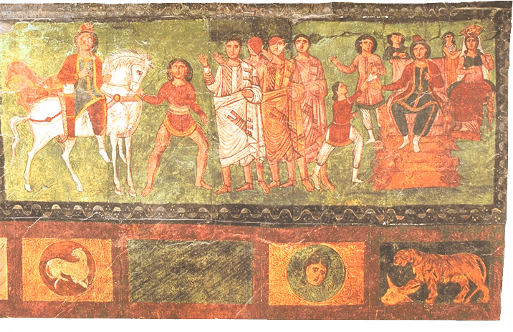
Scenes from the Book of Esther in Doura-Europos
Several synagogues dating from the first centuries of our era have been discovered in Palestine. We see there pavements of mosaic, where the signs of the zodiac are represented. This liberalism was vitiated by thrusts of rigorism. Some Jewish iconoclasts hammered the animal patterns of the relieves of Capharnaum, while the vegetable patterns were left unscathed; others demolished the mosaic of Ain Duk, close to Jericho, breaking the representation of zodiacal signs out of it without touching the Hebrew or Aramaic inscriptions; others reduced the signs of the zodiac in the synagogue of Ein Gedi to the Hebrew names.

6) Is there a modern Jewish art?
The second Commandment maintains its strength even in our time, causing distrust with regard to art. Rabbi Samson Rafael Hirsch said in the 19th century: "You must wherever and whenever you can, destroy all visible signs of idolatry. He who obtains possession of an idol… must destroy it, pulverize it and scatter in into wind or water". The American artist Maurice Sterne recalled that as a child living in a small Russian town he had been punished by his Rabbi for drawing a picture of the man on the ground with a stick. A great uncle of Chagall is said to have refused to give his hand to his young nephew on learning that he drew. Earlier in that century, a young sculptor, Joseph Engel, was instructed by his Rabbi to mutilate all the human faces that he had sculpted. An opinion of rabbi Abraham Isaac haKohen Kook, dating 1930, says: "In regard to your question on a matter of Torah, namely the placement and making of an image of a man's head with half his body, i.e., a bust: indeed, from Shulkhan Arukh it is clear that the prohibition of either creating a human image or keeping a prexisting image applies only to a complete image with all its limbs, but there is no prohibition against forming or keeping a head, or a torso alone". But he adds: "The holy spirit of Judaism is opposed to all idols of humans, and happy is the lot of he who is able to deter… those who wish to erect an idol, even in the form of a bust".
Paraphrasing Emmanuel Levinas, Anthony Julius writes that "The image is an idol. Images bewitch the most lucid writer; as for the artist, he practices idolatry. Every art work is in the end a statue; every statue denies time, that is, the historicity of our world. The denial of historicity, which is an embracing of fate, is pagan. Art is pagan, and it is also Christianity's concession to paganism, a concession that Judaism itself is not required to make. Great art is non-Jewish art, accessible to Jews thanks to that they live among Christians".Quoting the Midrash: "Who is a Jew? One who testifies against idols", he thinks that the Jewish art is one that respects the second Commandment. This attitude is seen in the following trends followed by Jewish artists:
1) Some prefer abstract art like Chagall, Soutine, Modigliani and Kitaj. Three of the leading abstract expressionists were Jewish by origin: Barnett Newman, Mark Rothko and Adolph Gottlieb. The absence of human representation, or the presence of inadequate human forms characterize Jewish painting. It is what one calls aniconic art.
2) Some resort to irony. Shulkhan Arukh (work of Caro, d. 1575) says "All kinds of mockery are forbidden, except mockery of idols which is permitted". Maryan S. Maryan's Personage with donkey ears (1962) is a good example of just this kind of sanctioned mockery.
3) Some practice creative iconoclasm. Instead of destroying the statues erected by the soviet system, they use them like artistic space. Marx's statue, rather than being evacuated, is put in a reversed position suspended from a crane. The statue of Felix Dzerzhinsky, founder of the soviet secret police, remains in front of the KGB headquarters, but is supplemented with bronze figures representing the people who climbed it, in 1991, to put a noose around its neck. It is therefore about making something new of what already exists. The goal is to retain the memory and to prevent that other gods come to replace them. Julius estimates that leftist Israeli artists are developing a political iconoclasm while tackling the idolatry of the land.

7) Maimonides, victim of his writings
May 25, 2005, the Israeli press reported a debate around installing a statue of Maimonides in Tiberias to mark the 800th anniversary of his death and burial in the city. The statue, created by an Israeli sculptor native of Fez in Morocco where Maimonides had lived for a certain time, was to be placed at Tiberias' "Cordoba Square". However, the plan for the statue in Tiberias was cancelled. The reason: objections on the part of local rabbis. "You shall not make for yourself any graven idol or any image", the rabbis ruled and threatened a political crisis. Maimonides himself, in his writings, prohibited the carving of graven images in a statue. Instead of erecting the statue in Tiberias, it was decided to place it in the city of Fez, with the blessing of the king of Morocco.
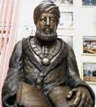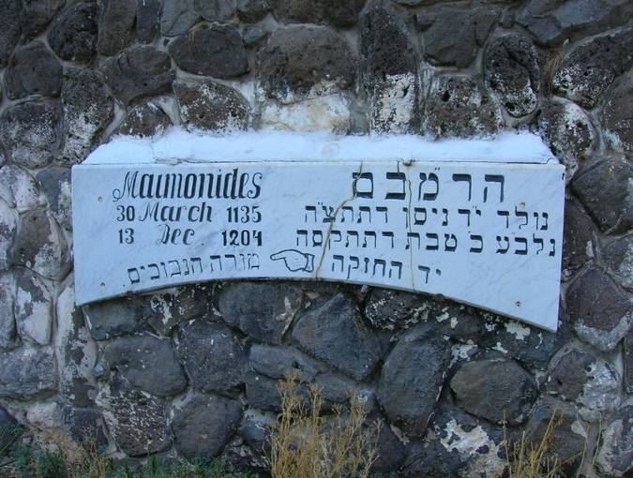
Statue of Maimonides replaced by his name on a wall in Tiberias

Chapter II. Christian norms

1) Sources of Christian norms
Christians accept the Jewish Bible, called Old Testament, to which they add the four Gospels, the Acts of the Apostles, a series of apostolic epistles and the book of revelation. These works are called the New Testament, which completes the Old Testament but repeals some of its norms. So the norms of crimes, inheritance and food in the Old Testament are not in use among Christians. The two Testaments constitute the first source of Christian norms. Added to this source are the acts of the councils, the writings of popes and fathers of the church. Christian norms are synthesized in the Canon law. Our question with regard to Christians is to know whether the New Testament maintains the norms of the Old Testament concerning figurative art, and if so, what is the interpretation to give to these norms.

2) Figurative art in the New Testament
The four Gospels do not refer to figurative art. However, we find a condemnation of idolatry in different texts of the New Testament. So Jesus tells Satan who tempted him: "Go, Satan! For it is written, `You shall worship the Lord your God, and serve him only'". The Acts of the Apostles indicate: "At that time they made a calf, offered a sacrifice to the idol, and revelled in the works of their hands. But God turned away from them and handed them over to worship the host of heaven, as it is written in the book of the prophets: 'Did you offer to me slain victims and sacrifices forty years in the wilderness, O house of Israel? No; you took along the tent of Moloch, and the star of your god Rephan, the images that you made to worship; so I will remove you beyond Babylon'". The apostles asked "to abstain only from things polluted by idols". Paul lifted this interdiction:
Hence, as to the eating of food offered to idols, we know that "no idol in the world really exists," and that "there is no God but one." Indeed, even though there may be so-called gods in heaven or on earth-- as in fact there are many gods and many lords yet for us there is one God, the Father, from whom are all things and for whom we exist, and one Lord, Jesus Christ, through whom are all things and through whom we exist. It is not everyone, however, who has this knowledge. Since some have become so accustomed to idols until now, they still think of the food they eat as food offered to an idol; and their conscience, being weak, is defiled... But take care that this liberty of yours does not somehow become a stumbling block to the weak. For if others see you, who possess knowledge, eating in the temple of an idol, might they not, since their conscience is weak, be encouraged to the point of eating food sacrificed to idols? So by your knowledge those weak believers for whom Christ died are destroyed.
The Acts of the Apostles report that Paul "sailed on an Alexandrian ship which had wintered at the island, and which had the Twin Brothers for its figurehead", without worrying. These are Castor and Pollux, Zeus' two Sons, protector of the sailors.
One can say therefore that the texts of the New Testament condemn idolatry, but tolerate the presence of idols to a certain extent, because idols are nothing. They do not comprise a general interdiction of pictures as the second Commandment of the Decalogue suggests it. For this reason, there is no Christian iconoclast who questions the legitimacy of making a statue or a picture for decorative purpose, if it respects decency. The debate among Christians crystallized only around the representation of divinity and saints for the purpose of worship.

3) Positions and practices of the first centuries
At all times, Christians refused the cult to pagan idols, including emperors considered to be living divinities. On the other hand, they were divided on the subject of making and honouring pictures of Jesus and saints.
Grabar considers that, like pagans at the end of antiquity, Christians favourable or opposed to pictures lived next to each other without conflict, the two attitudes being traditionally acceptable. This only changed when the imperial authority in Constantinople decided to interfer and make the icon question a State affair.
We have few written and archaeological testimonies to know the exact position of Christians in the first three centuries. This may be explained by the fact that until the third century, the waiting for Jesus' return made visual memory superfluous. On the other hand, authors like Justin (died toward 165), Clement of Alexandria (died 213), Tertullian (died 225) and Origen (died 254), by their reading and interpretation of prophet Isaiah, were all persuaded of Jesus' ugliness. Finally, the first persecuted Christian communities had no interest in identifying themselves with artistic works.
Literary texts as those of Clement of Alexandria (died 213), Tertullian (died 225), and Minucius Felix (text written around 210) show a clear objection to pictures, objection inspired by the biblical interdiction, but also by a will to be different from pagans. However, their attitude does not imply complete denial of pictures for non-worship purposes. Some Christian artists even worked for pagans. Tertullian recommends to them to change profession. Hippolytus (died about 235) declares: "If someone is a sculptor or a painter, let them be taught not to make idols. Either let them cease or let them be rejected". Clement of Alexandria lists the figures that Christians can use for their seals: "Let our seals be either a dove, or a fish, or a ship scudding before the wind, or a musical lyre, which Polycrates used, or a ship's anchor, which Seleucus got engraved as a device; and if there be one fishing, he will remember the apostle, and the children drawn out of the water. For we are not to delineate the faces of idols, we who are prohibited to cleave to them; nor a sword, nor a bow, following as we do, peace; nor drinking-cups, being temperate".
In one Greek apocryphal life of the apostle John, probably from the second century, there is question of John's portrait being conserved by one of his disciples who surrounded it with reverence, putting it on a special table, flanked with two candles. The apocryphal writing quotes the disciple to honour the picture not because it holds John's spiritual presence, but because it permitted him to evoke this saint. There is a legend according to which Mary's first picture was painted by Saint Luke who became protector of the painters. Another legend says that Mary painted Jesus' picture herself. A third, from the sixth century, attributes to Jesus self-portraits (achiropiites, not done by human hand) which found particularly fervid worshippers at the emperors of Constantinople. One of these portraits, an impression of Jesus' face, is said to have been sent by Jesus to king Agbar, king of Edessa. It is still celebrated by the Oriental church on August 16. The iconodules exploited these pictures to legitimize the use of religious pictures.
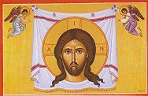
Christ's self-portrait
We have a small number of texts from the 4th century that rejects the use of pictures by Christians:
- The Canon 36 of Elvire's Council in Spain (around 313) says: "Pictures are not to be placed in churches, so that they do not become objects of worship and adoration".
- Between 313 and 324, when writing to Constantia, sister of emperor Constantin, who asked him to procure her Jesus' portrait, Eusebius was firmly opposed:
You wrote to me concerning some supposed image of Christ, which image you wished me to send you. Now what kind of thing is this that you call the image of Christ? I do not know what impelled you to request that an image of Our Saviour should be delineated. What sort of image of Christ are you seeking? Is it the true and unalterabe one which bears His essential characteristics, or the one which He took up for our sake when He assumed that form of a servant? [ …] can it be that you have forgotten that passage in which God lays down the law that no likeness should be made either of what is in heaven or what is in the earth beneath? Have you ever heard anything of the kind either yourself in church or from another person? Are not such things banished and excluded from churches all over the world, and is it not common knowledge that such practices are not permitted to us alone?.
- In a letter of 394 addressed to John of Jerusalem, Epiphanus, bishop of Salamine, writes, that while passing near Bethel, he saw a curtain hung to the doors of a church with a painted picture of Jesus or one of the saints. He adds: "After having seen this sacrilege - a human picture in the Christ's church, contrary to the authority of Scriptures, -, I tore the curtain and advised the caretakers of this place to make a shroud of it to envelop and bury the corps of a poor defunct". Quoting Deuteronomy 6:13; Matthew 4:10 and Romans 14:11, he considers the worship cult to the pictures a form of idolatry. He also advances the argument according to which the picture is untrue: the artists deceive us while representing Jesus, the apostles, the angels, not according to what they actually are, but to their own ideas. For this fact, Epiphanus asks emperor Theodosius to prescribe the removal of paintings from the churches and whitewashing frescos and mosaics.
On the other hand, we do not have texts that are favourable to the use of pictures, probably because pictures were so common that one did not feel the necessity to defend them. The phenomenon became more visible with the conversion of Constantin (died 337) and the Roman state. However, it did not prevent iconoclastic reactions. So Serenus, bishop of Marseille, destroyed all pictures in his city. At this occasion, Pope Gregorius the great addressed him remonstrance in a letter dated 600: if he praises him for having stopped the believers from adoring pictures, he blames him for having deprived them of the teachings that pictures represent:
To adore images is one thing; to teach with their help what should be adored is another. What Scripture is to the educated, images are to the ignorant, who see through them what they must accept; they read in them what they cannot read in books. This is especially true of the pagans. And it particularly behoves you, who live among pagans, not to allow yourself to be carried away by just zeal and so give scandal to savage minds. Therefore, you ought not to have broken that which was placed in the church not in order to be adored but solely in order to instruct the minds of the ignorant.
Various beliefs surround pictures. Some believe that they speak, cry, bleed, cross the sea, fly in the air, or appear in a dream. They are presented on coins and imperial seals. They preside over games at the hippodrome. And especially they walk in the battles over armies in a period marked by tensions between Byzantium and Persia. Heraclius (died 641) carries with him, in his military campaign, the picture of Jesus and Mary. Patriarch Sergius (died 638) carried an icon of Mary around the city walls during the Avar siege of Constantinople in 626.
Having become a public and state affair, the pictures had to find a consecration on behalf of the religious authorities. It was reached in the Quinisexte council, held in the imperial palace in 691-692. The Canon 82 asks for the replacement of the symbols by figures. So "the figure in human form of the Lamb who takes away the sin of the world, Christ our God, be henceforth exhibited in images, instead of the ancient lamb". The prescribed Canon 100: "there shall in no way be made pictures, whether they are in paintings or in what way so ever, which attract the eye and corrupt the mind, and incite it to the enkindling of base pleasures. And if any one shall attempt to do this he is to be cut off"".

4) Byzantian iconoclasm (725-843)
The situation reversed in the 8th century in the oriental part of the empire. In 725, Emperor Leo III began the iconoclastic movement that will last until 843, with a period of interruption from 780 to 815. He destroyed in 726 the picture of Christ, protector of Constantinople, placed above the door of the imperial palace. In 730, by an imperial edict, he barred the pictures and ordered the destruction of the icons, objects of popular devotion. In reaction, Pope Gregory III convened in 731 a council that excommunicates all those who oppose the reverence to holy pictures, destroy or desecrate them. But the iconoclastic movement continued under the reign of Constantin V. This one convened an Episcopal synod in 754 that judged that icons are human production, and men are unable to represent the sacred; consequently, the reverence to pictures is unacceptable and idolatrous. It was considered that "the only admissible figure of the humanity of Christ, however, is bread and wine in the holy Supper. This and no other form, this and no other type, has he chosen to represent his incarnation". The iconoclastic movement, however, did not prevent representation on coins of the emperor's effigy.
The reasons for the iconoclastic movement are multiple. Besides theological arguments and the excesses of picture cult, there are political, economic and social reasons. On one hand, the emperor wanted to centralize the power threatened by the division of the empire into provinces, division dedicated to the protector saints. On the other hand, the emperor had to take into account the presence in the empire's oriental part of an important Jewish community that was hostile to the pictures, as well as the military campaigns of Muslims who blamed Christians for being worshippers of idols. In the way of economy, the emperor longed for an agrarian reform made difficult by the monasteries, which were big producers and beneficiaries of pictures and at the same time big landowners. There was also a contradiction between the ideal of poverty and the luxury represented by the pictures.
The iconoclastic movement provoked a division between the oriental and western churches. A civil war resulted from it; immense ruins; great number of martyrs; destruction of the quasi-totality of the icons. Those that were saved are mainly those that were on Muslim territory. And it is in this part of the world that we find the most fervid defensor of the icons in the person of John Damascene (died 749). He affirms that a difference exists between Jews and Christians: the interdiction in the Old Testament can be explained by the trend of Jews to idolatry, whereas this interdiction has no reason to exist among Christians who know the spiritual nature of the religion. If it is impossible to represent God, one can represent Jesus who took human form. John establishes the distinction between the cult reserved to God alone and the reverence towards icons. He specifies that the function of the icon consists in assisting to obtain celestial graces and helps the believer. He makes a parallelism between writing and picturing: it is up to the speech to expand the truth, and to the picture to fix it. The picture is for the illiterate, what the letter is for those who can read.

5) Rehabilitation of art in Nicea II
After the death of Constantin V, in 775, and the accession to the throne of empress Irene who was favourable to the pictures, the movement of iconoclasm was no longer pursued with resentment by the imperial guards. The council of Nicea II of 787, convened by the empress, decided:
We, therefore, following the royal pathway and the divinely inspired authority of our Holy Fathers and the traditions of the Catholic Church (for, as we all know, the Holy Spirit indwells her), define with all certitude and accuracy that just as the figure of the precious and life-giving Cross, so also the venerable and holy images, as well in painting and mosaic as of other fit materials, should be set forth in the holy churches of God, and on the sacred vessels and on the vestments and on hangings and in pictures both in houses and by the wayside, to wit, the figure of our Lord God and Saviour Jesus Christ, of our spotless Lady, the Mother of God, of the honourable Angels, of all Saints and of all pious people. For by so much more frequently as they are seen in artistic representation, by so much more readily are men lifted up to the memory of their prototypes, and to a longing after them; and to these should be given due salutation and honourable reverence (aspasmon kai timhtikhn proskunh-sin), not indeed that true worship of faith (latreian>) which pertains alone to the divine nature; but to these, as to the figure of the precious and life-giving Cross and to the Book of the Gospels and to the other holy objects, incense and lights may be offered according to ancient pious custom. For the honour which is paid to the image passes on to that which the image represents, and he who reveres the image reveres in it the subject represented. For thus the teaching of our holy Fathers, that is the tradition of the Catholic Church, which from one end of the earth to the other hath received the Gospel, is strengthened. … Those, therefore who dare to think or teach otherwise, or as wicked heretics to spurn the traditions of the Church and to invent some novelty, or else to reject some of those things which the Church hath received (e.g., the Book of the Gospels, or the image of the cross, or the pictorial icons, or the holy reliques of a martyr), or evilly and sharply to devise anything subversive of the lawful traditions of the Catholic Church or to turn to common uses the sacred vessels or the venerable monasteries,[1] if they be Bishops or Clerics, we command that they be deposed; if religious or laics, that they be cut off from communion .
The access of Leo to the Byzantine throne in 813 provoked a rebirth of iconoclasm. He convened in 815 a council in Constantinople, which denounced the decisions of the council of Nicea II taken "by ignorant bishops" when "the empire fell from the hand of men in the one of a woman and that God's church was ruined by the feminine simplicity", reference to Empress Irene. This movement ended only in March 843 on decision of another woman, Empress Theodora, who gathered a synod guided by the patriarch of Constantinople, named by herself, which declared the return to the reverence to pictures. This event is celebrated annually by the Orthodox, the first Sunday of the fast, called Sunday of orthodoxy. Henceforth, one will not debate the legitimacy of making and honouring pictures, but only what kind of pictures are allowed. The fourth council of Constantinople, in its tenth session, February 28, 870, adopted again the decisions of the second council of Nicea.

6) Reform and figurative art
Iconoclasm returned in the West in the sixteenth century with the Reform. It has been preceded and influenced by the invention of the press, which gave more importance to writing than to pictures. It has been accompanied by a new form of faith. With the pictures disappeared the processions, the pilgrimages, the votive Masses, the protectors' feasts, the gestures of a piety that were often marked by superstition… the miters, the vestments, the surplices, the blessed crosses and medallions, etc. We will say here a word of the position taken by three main actors of the Reform with respect to picture: Luther, Zwingli and Calvin.
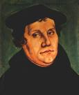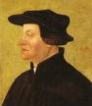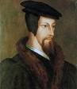
Martin Luther Ulrich Zwingli John Calvin
Martin Luther (1483-1546) interprets the biblical interdiction as interdiction of idolatry and not of the picture itself. He recalls that Moses had fixed a snake of bronze in the desert and placed two cherubim above the ark of alliance. Because of the abuse to which the pictures give place, he would have liked to abolish them all over the world, but this reason was not sufficient to destroy, remove and burn all pictures, since there are still people who know how to make good use of them. He used himself pictures to propagate his ideas. Good tactician, he considered that the best method to fight against the abuse of pictures was to preach that they are nothing, that God doesn't ask for them and that it is better to help poor people than to erect pictures, since God commanded the first thing, but not the second. So the pictures would fall dead by themselves, without many uproars. However, he legitimizes the iconoclasm in case of evident idolatry, provided that the civil authority undertakes it.
Ulrich Zwingli (1484-1531), the reformer in Zurich, decided in 1523 that all pictures should be out of the churches. The same for pictures of the saints, of the Virgin, of Jesus, and even of the crucifix. He affirmed that the material pictures can only be obstacles to the word, which is of spiritual nature. Thus, the faithfulness to the word implies a radical objection to the use of pictures as instruments of mediation between man and divinity. But Zwingli tolerated the use of pictures in the illustrations of the Bible.
John Calvin (1509-1564), the reformer in Geneva, was the most uncompromising of the three reformers. He developed his doctrine in the XI and XII chapters of the first book of Christian institution. According to him, all representations of the divinity incite the believers to idolatry and superstition. He rejects with contempt the second council of Nicea. God does not teach himself by simulacra, but by his own word. To say that pictures serve as books to ignorants, as Saint Gregory affirmed, is a betrayal by the church of its duty to transmit God's word. However, Calvin does not prohibit the picture, provided that it abdicates its pretension to represent the divinity: "I am not so much scrupulous to judge that one must endure and suffer no image; but as much as the art of painting and carving are grants of God, I require that its use remains pure and legitimate". The talent of the artists can be practiced on history, landscape or portrait: it is useful and in any case pleasing. But in the temple, nothing: "God's majesty, who is too high for the human eye, should not be corrupted by ghosts who are not suitable to divinity". Speaking of pictures of saints, he writes: "The prostitutes are dressed more modestly in their whorehouses, than the pictures of virgins painted in the temples of the papists".
Professor Bernard Reymond, of the Faculty of Protestant theology in Lausanne, writes that the Reform had for consequences the closing down and sometimes the demolition of churches and chapels, the eradication of numerous oratories and cross votives scattered everywhere in the landscape, and the extinction of the pictures, statuary and cross. He adds:
Without wanting to offend them, the amateurs of art who, today, moan on the damages caused by these patrimonial overhauls should consider that they judge according to criterias of the western cultivated elites of the XIX and XX centuries, and not according to the values that prevailed in the previous centuries. The protection of historic monuments, therefore of all what is cherished today by the friends of fine arts, is a recent invention.
He explains that the destruction of pictures was practiced because they were seen as idols, in the sense of the Bible. It was therefore an application of the second Commandment. But there were also social reasons. Reformers wanted to attack the supremacy of a corporation or the nobiliary privileges of a family. It was considered that these idols diverted to their profit (or to the one of their servers) amounts of money of which the service of the poor people would have had the biggest need.
In reaction to the teachings of the Reform, the Catholic Church issued a decree approved in 1563 by the Council of Trent. Referring to the council of Nicea II, the decree affirms the liceity of the representations of Jesus, Mary and saints. But at the same time, it underlines the educational role of the priests in order to move away the people from all superstition linked to pictures. It asks the episcopate to control the artistic production; in case of conflict, the bishops will first exercise this function with the help of experts, then in collegial manner, in provincial councils; one will recourse to the Holy See as last resort.

7) Sollicitudini Nostrae of Benedict XIV (1745)
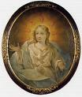
Mary Crescentia von Kaufbeuren and her vision of the Holy Spirit
A Carmelite nun in the diocese of Augsburg, Mary Crescentia von Kaufbeuren (1682-1744), had had a vision of the Holy Spirit under the aspect of a beautiful young man. She ordered and distributed small pictures representing him. Opposed to this attitude, Pope Benedict XIV asked for information. The bishop of Augsburg, unhappy with the interdiction of the pictures, named a commission of survey whose acts were sent to Rome with the bishop's letter. He expressed his puzzlement towards the reaction against the picture of the Holy Spirit painted as young man whereas many pictures exposed in churches represented in this way the 3rd person within the Holy Trinity. The Pope answered October 1st, 1745 in a long letter titled Sollicitudini Nostrae. He says that the Bible is the only criteria to determine the form allowed to represent the Holy Trinity. Reviewing the different existing representations of the Holy Spirit, the Pope considers that the only pictures truly legitimized by the Bible are those representing the Holy Spirit as dove appeared at the time of the baptism of Jesus or tongues of fire appeared at the time of Pentecost. Other pictures are tolerated, for example those representing the Holy Trinity as the three visitors appearing to Abraham. As for God the Father, he had to be represented under the form of an old man, according to Daniel's vision. Other pictures are prohibited, as those that represent the Trinity as a man with three faces or double-headed with a dove in the middle, an offending picture of a monster without biblical basis. And as the Bible does not say that the Holy Spirit had appeared under the form of a young man, the picture in question had to be barred and confiscated everywhere.
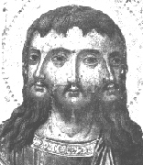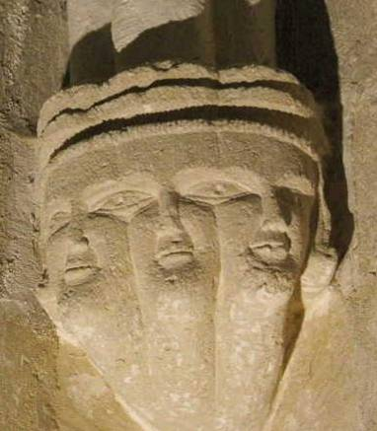
Tricephal Trinity in picture and in stone
The answer of Pope Benedict XIV in this affair had the force of universal law for the Catholic Church. Section 1279 of the Canon Code of 1917 considers it one of the sources, with the council of Trent, on the exhibition of pictures in sacred places. But it had little impact. If we except the confiscation of the incriminated picture, we find a relief of an altar of Saint Stefan's Cathedral in Vienna representing the Trinity by three identical men. In 1749 a Coronation of the Virgin represented like a ceremony of court where the Holy Spirit, a splendid young man, hurries to his wife, was painted in the Swabian church of Altdorf. The painting was successful as the artist received an order for a similar one in Schongau. This was not isolated case.

8) Second Vatican Council and Code of Canon law
The constitution on the sacred liturgy (Sacrosanctum concilium, 1963) emanating from the Second Vatican council declares: "The art of our own days, coming from every race and region, shall also be given free scope in the Church, provided that it adorns the sacred buildings and holy rites with due reverence and honour". It adds: "Ordinaries, by the encouragement and favour they show to art which is truly sacred, should strive after noble beauty rather than mere sumptuous display". The pastoral constitution on the church in the modern world (Gaudium et spes) (1965) adds: "The Church acknowledges also new forms of art which are adapted to our age and are in keeping with the characteristics of various nations and regions. They may be brought into the sanctuary since they raise the mind to God, once the manner of expression is adapted and they are conformed to liturgical requirements".
The Code of canon law of 1983 dedicates to art the sections 823 and 1188-1190 which we quote here:
Section 823 par. 1 - In order to preserve the integrity of the truths of faith and morals, the pastors of the Church have the duty and right to be watchful so that no harm is done to the faith or morals of the Christian faithful through writings or the use of instruments of social communication.
Section 1188 - The practice of displaying sacred images in churches for the reverence of the faithful is to remain in effect. Nevertheless, they are to be exhibited in moderate number and in suitable order so that the Christian people are not confused nor occasion given for inappropriate devotion.
Section 1189 - If they are in need of repair, precious images, that is, those distinguished by age, art, or veneration, which are exhibited in churches or oratories for the reverence of the faithful are never to be restored without the written permission of the ordinary; he is to consult experts before he grants permission.
Section 1190 § 1. It is absolutely forbidden to sell sacred relics.
§ 2. Relics of great significance and other relics honoured with great reverence by the people cannot be alienated validly in any manner or transferred permanently without the permission of the Apostolic See.
§ 3. The prescript of § 2 is valid also for images which are honoured in some church with great reverence by the people.
Having reviewed the Jewish and Christian norms and positions, it is necessary to expose now the situation of figurative art at Muslims, insisting notably on the Sunnite group that forms 90% of the Muslim community in the world.

Chapter III. Islamic norms

1) Sources of Islamic norms
Muslims inherited from Jews the belief that God dictated the norms according to which humanity must behave at all times and in all places. These norms are defined in the Koran and Muhammad's Sunnah. The Koran says:
No believing man or believing woman, if God and His messenger issue any command, has any choice regarding that command. Anyone who disobeys God and His messenger has gone far astray (33:36).
O you who believe, you shall obey God, and you shall obey the messenger, and those in charge among you. If you dispute in any matter, you shall refer it to God and the messenger, if you do believe in God and the Last Day. This is better for you, and provides you with the best solution (4:59).
Muhammad Mitwalli Al-Sha’rawi (died 1998), religious leader and Egyptian politician, explained that revelation is called upon to decide equivocal questions, thus freeing mankind of the anguish of solving a difficult case by discussion, or by exhaustive repetition of experiences. The Muslim does not have to look outside Islam for solutions to any problem, since Islam offers absolute eternal and good solutions. He adds: "If I were the person responsible for this country or the person charged to apply God’s law, I would give a delay of one year to anyone who rejects Islam, granting him the right to say that he is no longer a Muslim. Then I would dispense to him of the application of Islamic law, condemning him to death as apostate". Al-Sha'rawi expresses here the same idea expressed by his Jewish compatriot Maimonides eight centuries before him.

2) Koran and figurative art
The Koran mentions five times the term sanam (statue of idol), twice the term timthal (litt. a similar; it indicates the statue as well as the picture), and three times the term nusub (stone-altars). It also speaks of the sculpture in connection with idolatry: "How can you worship what you carve?" (37:95). These terms indicate figures, sometimes malformed, which have been worshiped, often called by the Koran alihah (plur. of Allah: divinities), indicating some of their names.
The Koran mentions Noah's hostility towards the idols and tells Abraham's history, model for the Muslim (60:4), who broke his tribe's idols to pieces (21:58), provoking its anger. He also mentions the condemnation of the idols by Moses:
We delivered the Children of Israel across the sea. When they passed by people who were worshipping statues, they said, "O Moses, make a god for us, like the gods they have." He said, "Indeed, you are ignorant people. These people are committing a blasphemy, for what they are doing is disastrous for them" (7:138-139).
Three passages of the Koran seem to make exception to this hostility with regard to statues. The first concerns Salomon:
They made for him anything he wanted - niches, statues, deep pools, and heavy cooking pots. O family of David, work (righteousness) to show your appreciation. Only a few of My servants are appreciative (34:13).
The two others concern Jesus:
As a messenger to the Children of Israel: "I come to you with a sign from your Lord - I create for you from clay the shape of a bird, then I blow into it, and it becomes a live bird by God's leave (3:49).
God will say, "O Jesus, son of Mary, remember my blessings upon you and your mother. I supported you with the Holy Spirit, to enable you to speak to the people from the crib, as well as an adult. I taught you the scripture, wisdom, the Torah, and the Gospel. Recall that you created from clay the shape of a bird by my leave, then blew into it, and it became a live bird by my leave (5:110).
In Arabic, the picture is called surah; to make a picture: sawwar; the one that makes the picture: musawwir (one of God's 99 names). The Koran uses these terms numerous times to indicate God giving a form to an object he creates:
He is the One who shapes you (yusawwirakum) in the wombs as He wills. There is no other god besides Him; the Almighty, Most Wise (3:6).
O you human being, what diverted you from your Lord Most Honourable? The One who created you, designed you, and perfected you. In whatever design (surah) He chose, He constructed it. (82:6-8).
He is the one God; the Creator, the Initiator, the Designer (musawwir). To Him belong the most beautiful names (59:24).
Nowhere the Koran prohibits drawing a picture, a form. But as this term is connected to the work of God, those who make a picture are perceived as competing with God's work, especially since the picture can be a subject of worship and promote polytheism (association of other divinities to God). Hence, the interdiction of the picture by Muhammad's narrations as we will see in the following point.

3) Sunnah and the figurative art
Many narrations of Muhammad indicate hostility to statues and pictures. We quote here the most important narrations from the Sunnite collections and we refer to them thereafter by their number:
1) Narrated Ibn-Abbas: The Prophet entered the Kaaba and found in it the pictures of (Prophet) Abraham and Mary. On that he said' "What is the matter with them (i.e. Quraish)? They have already heard that angels do not enter a house in which there are pictures; yet this is the picture of Abraham. And why is he depicted as practicing divination by arrows?" (Bukhari, Volume 4, Book 55, Number 570)
2) Narrated Ibn-Abbas: When the Prophet saw pictures in the Kaaba, he did not enter it till he ordered them to be erased. When he saw the pictures of Abraham and Ishmael carrying the arrows of divination, he said, "May Allah curse them (i.e. the Quraish)! By Allah, neither Abraham nor Ishmael practiced divination by arrows." (Bukhari, Volume 4, Book 55, Number 571)
3) Narrated Ayshah: I stuffed for the Prophet a pillow decorated with pictures (of animals) which looked like a Namruqa (i.e. a small cushion). He came and stood among the people with excitement apparent on his face. I said, "O Allah's Apostle! What is wrong?" He said, "What is this pillow?" I said, "I have prepared this pillow for you, so that you may recline on it." He said, "Don't you know that angels do not enter a house wherein there are pictures; and whoever makes a picture will be punished on the Day of Resurrection and will be asked to give life to (what he has created)?" (Bukhari, Volume 4, Book 54, Number 447).
4) Narrated Ayshah: I never used to leave in the Prophet house anything carrying images or crosses but he obliterated it. (Bukhari, Volume 7, Book 72, Number 836)
5) Narrated Ayshah: I purchased a cushion with pictures on it. The Prophet (came and) stood at the door but did not enter. I said (to him), "I repent to Allah for what (the guilt) I have done." He said, "What is this cushion?" I said, "It is for you to sit on and recline on." He said, "The makers of these pictures will be punished on the Day of Resurrection and it will be said to them, 'Make alive what you have created.' Moreover, the angels do not enter a house where there are pictures.'" (Bukhari, Volume 7, Book 72, Number 840).
6) Narrated Aisha: When the Apostle of Allah arrived after the expedition to Tabuk or Khaybar, the draught raised an end of a curtain which was hung in front of her storeroom, revealing some dolls which belonged to her. He asked: What is this? She replied: My dolls. Among them he saw a horse with wings made of rags, and asked: What is this I see among them? She replied: A horse. He asked: What is this that it has on it? She replied: Two wings. He asked: A horse with two wings? She replied: Have you not heard that Solomon had horses with wings? She said: Thereupon the Apostle of Allah laughed so heartily that I could see his molar teeth (Abu-Dawud, Book 41, Number 4914).
7) Narrated Ayshah: I used to play with the dolls in the presence of the Prophet, and my girl friends also used to play with me. When Allah's Apostle used to enter (my dwelling place) they used to hide themselves, but the Prophet would call them to join and play with me (Bukhari, Volume 8, Book 73, Number 151).
8) Narrated Abu Talha: I heard Allah's Apostle saying; "Angels (of Mercy) do not enter a house wherein there is a dog or a picture of a living creature (a human being or an animal)." (Bukhari, Volume 4, Book 54, Number 448)
9) Narrated Ayshah: Um Habiba and Um Salama mentioned about a church they had seen in Ethiopia in which there were pictures. They told the Prophet about it, on which he said, "If any religious man dies amongst those people they would build a place of worship at his grave and make these pictures in it. They will be the worst creature in the sight of Allah on the Day of Resurrection." (Bukhari, Volume 1, Book 8, Number 419 ).
10) Narrated Salim's father: Once Gabriel promised the Prophet (that he would visit him, but Gabriel did not come) and later on he said, "We, angels, do not enter a house which contains a picture or a dog." (Bukhari, Volume 4, Book 54, Number 450) .
11) Narrated Ibn Abbas: Abu Talha, a companion of Allah's Apostle and one of those who fought at Badr together with Allah's Apostle told me that Allah's Apostle said. "Angels do not enter a house in which there is a dog or a picture" He meant the images of creatures that have souls (Bukhari, Volume 5, Book 59, Number 338).
12) Narrated Muslim: We were with Masruq at the house of Yasar bin Numair. Masruq saw pictures on his terrace and said, "I heard 'Abdullah saying that he heard the Prophet saying, "The people who will receive the severest punishment from Allah will be the picture makers.'" (Bukhari, Volume 7, Book 72, Number 834)
13) Narrated Abu Talha: Allah's Apostle said, "Angels (of mercy) do not enter a house where there are pictures.'" The sub-narrator Busr added: "Then Zaid fell ill and we paid him a visit. Behold! There was, hanging at his door, a curtain decorated with a picture. I said to 'Ubaidullah Al-Khaulani, the step son of Maimuna, the wife of the Prophet, "Didn't Zaid tell us about the picture the day before yesterday?" 'Ubaidullah said, "Didn't you hear him saying: 'except a design in a garment'?" (Bukhari Volume 7, Book 72, Number 841)
14) Narrated Anas: Aisha had a thick curtain (having pictures on it) and she screened the side of her i house with it. The Prophet said to her, "Remove it from my sight, for its pictures are still coming to my mind in my prayers." (Bukhari, Volume 7, Book 72, Number 842).
15) Narrated Said bin Abu Al-Hasan: While I was with Ibn 'Abbas a man came and said, "O father of 'Abbas! My sustenance is from my manual profession and I make these pictures." Ibn 'Abbas said, "I will tell you only what I heard from Allah's Apostle. I heard him saying, 'Whoever makes a picture will be punished by Allah till he puts life in it, and he will never be able to put life in it.' "Hearing this, that man heaved a sigh and his face turned pale. Ibn 'Abbas said to him, "What a pity! If you insist on making pictures I advise you to make pictures of trees and any other unanimated objects." (Bukhari, Volume 3, Book 34, Number 428).
16) Narrated Abdullah: When the Prophet entered Mecca on the day of the Conquest, there were 360 idols around the Kaaba. The Prophet started striking them with a stick he had in his hand and was saying, "Truth has come and Falsehood will neither start nor will it reappear (Bukhari, Volume 5, Book 59, Number 583).
17) [Muhammad] reached near an idol by the side of the Kaaba which was worshipped by the people. The Messenger of Allah had a bow in his hand, and he was holding it from a corner. When he came near the idol, he began to pierce its eyes with the bow and (while doing so) was saying: Truth has been established and falsehood has perished (Muslim Book 019, Number 4395).
18) Narrated AbuHurayrah: The Apostle of Allah said: Gabriel came to me and said: I came to you last night and was prevented from entering simply because there were images at the door, for there was a decorated curtain with images on it in the house, and there was a dog in the house. So order the head of the image which is in the house to be cut off so that it resembles the form of a tree; order the curtain to be cut up and made into two cushions spread out on which people may tread; and order the dog to be turned out (Abu-Dawud Book 32, Number 4146).
19) Narrated 'Aun bin Abu Juhaifa: My father bought a slave who practiced the profession of cupping. (My father broke the slave's instruments of cupping). I asked my father why he had done so. He replied, "The Prophet forbade the acceptance of the price of a dog or blood, and also forbade the profession of tattooing, getting tattooed and receiving or giving Riba, (usury), and cursed the picture-makers." (Bukhari, Volume 3, Book 34, Number 299).
20) A'isha reported: We had a curtain with us which had portraits of birds upon it. Whenever a visitor came, he found them in front of him. Thereupon Allah's Messenger (may peace be upop him) said to me: Change them, for whenever I enter the room) I see them and it brings to my mind (the pleasures of) worldly life (Muslim Book 024, Number 5255).
To these narrations that are clearly hostile to figurative art, it is necessary to add a fact reported by the historian Al-Azraqi (died toward 865). He writes that when Muhammad conquered Mecca, he entered the Kaaba and found pictures of Abraham swearing by the divinatory arrows, of angels and of Mary with Jesus on her knees. He covered the pictures of Mary and Jesus with his hands and gave the order to erase everything else. Al-Azraqi affirms that Mary's picture with Jesus remained in the Kaaba until it burned in 683, more than half a century after the conquest of Mecca. This fact, which was never denied, but also never evoked by Muslim authors hostile to figurative art, casts a doubt on the authenticity of the aforesaid narrations.

4) Interpretation of the Koran and the Sunnah

A) Divergences among classic jurists
From the verses of Koran and Sunnah, classic Muslim jurists had to decide on the figurative representations that they knew: statues (called figures with shadow) and pictures. They came to divergent conclusions that one can summarize as follows:
a) They were unanimous on the interdiction of any object that is part of a non-Muslim cult! This is notably the case of the cross (see narrations 4 and 9).
b) They were unanimous on the interdiction of any complete statue of a human being or animal. The jurists explain that this interdiction aims to fight paganism. It does not matter in this context whether the statues represent idols or respectable religious celebrities. The jurists report that Wadd, Suwa'a, Yagout, Ya'ouq and Nasr, mentioned in verse 71:23, were originally devout celebrities that their tribes wanted to honour after their death by making sculptures for them, as suggested by the devil. The following generations forgot the sense of these statues and converted them into divinities.
c) The majority prohibits any picture of human beings or animals on any support (material or wall), with the exception of pictures placed in a degrading position: on a pillow used to sit on it, or on a carpet to walk on. Al-Nawawi (died 1277) writes in this regard:
The great authorities of our school and of other schools hold that painting picture of any living being is strictly prohibited and constitutes one of the capital sins, because it is threatened by the above stated punishments, as it is mentioned in the traditions, whether made on a vile object or not. So the production is forbidden in all circumstances, because it implies a duplicate of God's creative activity, be it on dress, carpet, money, gold, silver or copper, dish or wall. On the other hand, the painting of a tree or a saddle of camel and other objects that do not have life is not prohibited. Such is the decision with regard to the production itself. In the same way, it is prohibited to use any object on which is represented a living being, be it hung on a wall or carried as garment or turban, or on any other object of non-vile utility. But if it is on a carpet that one tramples with the feet, on a pillow or a bed or all similar object of vile utility, then it is not prohibited. In all these objects, there is no difference between what has a shadow and what does not have. This is the opinion of our school on the question. It is admitted by the majority of the Prophet's mates, their immediate successors and the scholars of the following generations.
d) The majority considers that a statue or a picture that has been decapitated or which lacks a vital part becomes lawful (see narration 18). Ibn-Abbas (died about 686) says that the picture is the head; if the head is cut, there is no picture anymore. Therefore, it is allowed to have a picture or a statue of human or animal beings under the following conditions:
- That it is in a form excluding all life, as being decapitated, cut up or hollowed of its internal organs.
- That it is in a vile position as on a carpet that one walks on it or on a pillow.
Ibn-al-Arabi (died 1148) thinks that these two conditions are cumulative. Others accept one of the two conditions. The Malikites permit to suppress a member of the statue or to pierce its abdomen. But today Al-Qaradawi, modern author, prohibits even the busts although they lack an important part of the body. He says: "If we ponder over the matter objectively, we will undoubtedly conclude that it is more haram [illicit] to set up busts in public places in order to perpetuate the memory of kings and great men than to have full figured statues in the home for the purpose of decoration".
e) The great majority permits to make a statue or a picture of inanimate objects: a tree, the moon, the sun or the waves (provided that they do not serve for worship). One evokes here notably narration 15.
f) A minority prohibits any statue and any picture, be it of animate or inanimate object, whatever the position in which it is. It draws this conclusion from the general terms of narrations prohibiting the figures and condemning the artists who do them, without specification of their object. They evoke also verse 27:60 which says:
Who is the One who created the heavens and the earth? Who is the One who sends down to you from the sky water, whereby we produce gardens full of beauty - you could not possibly manufacture its trees? Is it another god with God? Indeed, they are people who have deviated.
Abu-Hayyan (died 1344) writes in this respect: "Drawing is barred in our law. Heavy threats have been uttered against drawers. Some jurists make exceptions, but the narration "God cursed the drawers" made no exception". We can indicate here that the mosaics on the external wall of the Omayyade Mosque in Damascus, without any animate beings, had been covered with plaster by rigorist Muslims. These mosaics have been discovered only in 1927.
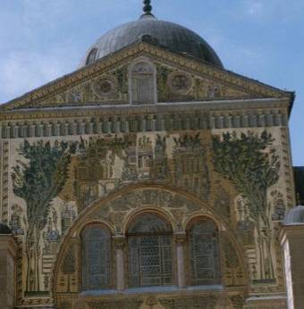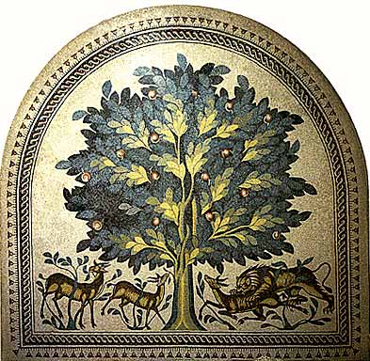
Omayyade Mosque Damascus Hisham Palace Jericho
One opposes to this narrow concept the advice that was given by Ibn-Abbas (died about 686) to the drawer: "Make pictures of trees and any other unanimated objects" (see narration 15). Such a restriction is excessive because it excludes all human activity: drawing of a machine or a house.
g) The jurists are unanimous to say that the angels of mercy do not enter a house in which there are pictures. For Muslims, there are different categories of angels. Among these angels, there is Gabriel who transfers the Koran to Muhammad, the angels of mercy who dispense mercy and divine blessing, and the accounting angels who write in a book the acts and accompany human beings step by step. The jurists consider that the figures do not prevent the entry of the accounting angels, otherwise one could steal or rape in presence of these objects without being held responsible in the other life.
h) The majority permits statues and pictures that serve as toys for children. This permission derives from narrations 6 and 7 related to the toys of Ayshah married by Muhammad at the age of six years. Al-Qurtubi (1272) says that girls' toys help educating them, and furthermore they do not last a long time. The same can be said about statuettes made of sweets or paste, which do not last. These objects are not destined to worship and, therefore, do not contravene to the interdiction of idols. But some jurists bar such objects, considering that the previously mentioned narrations have been abrogated. Today, modern jurists extend this exception to pictures or statues used in education, evoking the legal rule that says: "Things depend on intention".
i) A minority of writers permits statues and pictures of animate or inanimate object if they do not serve in the cult. They evoke the verses concerning Salomon (34:13) and Jesus (3:49 5:110). However, the majority rejects this argument considering that these verses tell a miracle decided by God confirming these two persons in their prophetic missions. Others say that the statues mentioned in verse 34:13 were of inanimate objects. Others finally argue that statues were probably allowed in Salomon's time (in a non-worship goal), but they were forbidden for Muslims.
j) Pictures and statues brought to Muhammad's mind (the pleasures of) worldly life (see narration 20). His attitude shows the austerity of the Bedouin. Islamic law forbids wasting, carrying gold rings or drinking in gold vases. The jurists conclude today that paintings and statues for which one spends his fortune uselessly are to be forbidden according to the verse: "Do not waste anything. He does not love the wasters" (6:141).
We note that Muslim jurists insist notably on the interdiction of the statues and then on the pictures of animate objects, contrary to the inanimate objects. The modern jurists explain their attitude by the fact that the artist becomes more easily proud with an animate object than with an inanimate one. They quote Michelangelo in this regard who, after sculpting Moses, struck the right knee commanding: "Now speak!" They add that Greek and Roman artists sculpted statues and then the people started adoring them like divinities. Therefore, it is necessary to close the door to temptation of paganism. Grabar considers that the interdiction of animated objects by Muslims is due to the superstitious, prophylactic and apotropaic concept admitting implicitly the possibility of consubstantiality of the representation and the represented, and consequently, a substitution of one to the other. So the lions, the dragons and the dogs are excluded from the list of possible subjects of art, because one lends them implicitly the ability to leave the statement of picture and to act as living beings.

B) Tendency in Muslim art
The position of classic Muslim jurists led to a particular tendency in figurative Muslim art:
a) Figurative art has not been used for the diffusion of Islamic faith, as it was the case with Christians. So it did not enter the decoration of religious books, mosques and tombs. Several narrations by Muhammad prohibit the decoration of the two places that are connected with religion, to avoid idolatry. On the other hand, it is necessary to avoid that these objects distract the prayors (see narration 14), the Koran prescribing a deep piety in the prayer: "Successful indeed are the believers who are reverent during their Prayers" (23:1-2). One finds drawings in scientific or literary works, notably under the form of miniatures, reserved to royal elite, far from the look of the masses. Out of respect for Muslim rules, drawings of animate objects were disproportionate and artists avoided shades and lights. This can be considered like a failure according to western artistic criterias, but it can be explained by the rigor of Islamic norms. Religious celebrities however were avoided. The rare times that we see Muhammad's picture, he has the face veiled.
b) Figurative art being excluded from religious domain, Muslims developed other artistic means as calligraphy, arabesques and geometrical forms.
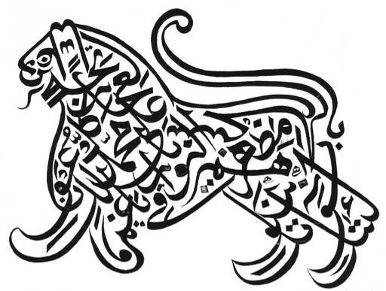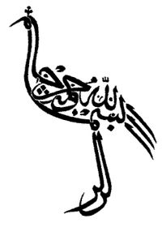
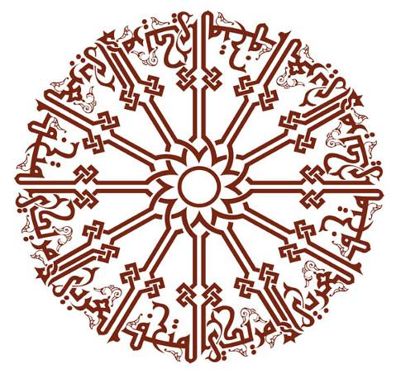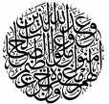
Arabic calligraphy
c) Religion being the most important element in the life of Muslims, the exclusion of figurative art from the religious domain had for result that drawers were respected less than calligraphers. We rarely find signatures of drawers in Arab manuscripts before the 13th century.

C) Practical applications of the Islamic norms
The religious prohibition concerning figurative art pushed Muslim jurists to discuss a large number of questions.
It is prohibited to pray with a dress comprising a cross, except if it is in a vile position. The book Al-fatawa al-hindiyyah (1664-1672) challenges the testimony of a person who wears a dress with a drawing. It considers as repugnant to pray in a place where a visible picture is between the hands of the prayor, above his head, on his right or left. This is not the case if a picture, which is too small, under the feet or of, unanimated object, or if it is decapitated. A big picture is considered to be a subject of devotion, not a small one. Can one pray in a church? The answer of jurists oscillates between permission and total interdiction, notably because of the presence of statues and pictures. It is reported that Ibn-Abbas (died about 686) prayed in churches without pictures.
Al-Nawawi (died 1277) forbids putting an effigy on coins. Al-Bahuti (died 1641) repels that the prayor carries a piece of money comprising a picture. But it is indicated that in Muhammad's time, Byzantian and Persian currency comprising effigies of kings were used in Arabia. The caliphs coined their own currency thereafter, sometimes with their effigy or animate figures. It is considered that by using money as a medium of exchange, figures are depreciated, and therefore the interdiction falls. One also advances that prohibiting currency with figures risks putting people in embarrassment. They add that it is allowed to pray with such currency in the pocket, since Muhammad made it. Some modern authors continue however to forbid animated figures on money, but permit using foreign currency even with such a figure.
The same problem arises with stamps. Than Afghan government had emitted a stamp representing Buddha's statues, but it was obliged to take it out of circulation because many Muslims were shocked with this representation of the human form.
Classic jurists also wondered if one could accept the invitation to a house where there are statues or pictures. They indicate that Muhammad refused to enter the house of his favourite wife because of such objects (see narration 5). They also report that Umar (died 644) declined an invitation to a notable of Damascus because his host's house comprised statues and pictures. They consider that one has the choice between accepting the invitation or refusing it to denounce the presence of these objects and punish the owner of the house. Nothing prevents entering a house whose carpet comprises a picture on the floor.
All profit realized by making or selling forbidden statues or pictures is illicit. Muhammad forbad selling wine, cadaver and idols. The interdiction is extended to the sale of the cross. Excepted are the toys for children as well as carpets and pillows with drawings on them. On the other hand, one can buy and sell currency with figures. It is not allowed to hire a painter services to draw a forbidden drawing, and he may not get remuneration. One who destroys a statue or a picture is not responsible for the artistic damage, but only for the loss of the material used to make the statue or the picture. One who steals a golden cross or statue cannot be amputated because these are forbidden objects. But if one destroys a picture on a piece of money, he is responsible for it because currency is legal.
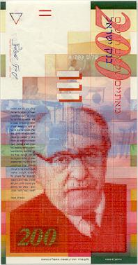
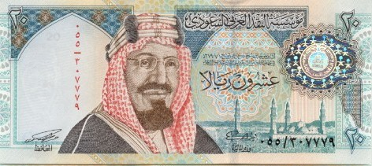
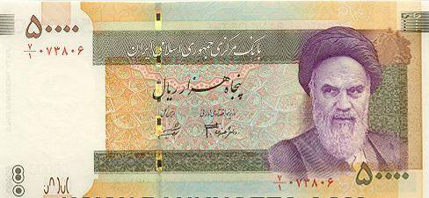
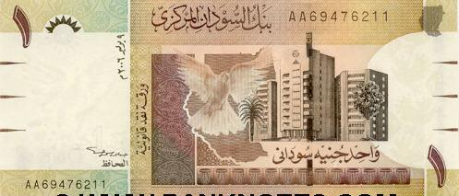
Banknotes from Israel, Saudi arabia, Iran and Sudan

D) Practices contrary to Islamic norms
Religious prohibitions did not prevent caliphs and Muslim governors to put statues and pictures in their palaces, to coin money and to carry rings with effigies. Also, popular art in Muslim countries did not hesitate to resort to devout pictures. Pierre and Michèle Centlivres indicate on the back of their book Imageries populaires en islam:
From Morocco to Muslim India and from Kabul to Cairo, in spite of the prohibition of the representation of animate beings in Land of Islam, innumerable illustrating of profane, political or religious themes are produced, printed and sold for very low price to a popular public.
They give many examples in their work. But one notes that the drawings comprising mosques represent them completely empty, without human presence. It is out of question to represent God, as did Michelangelo, showing him as an old person holding his hand out to Adam.
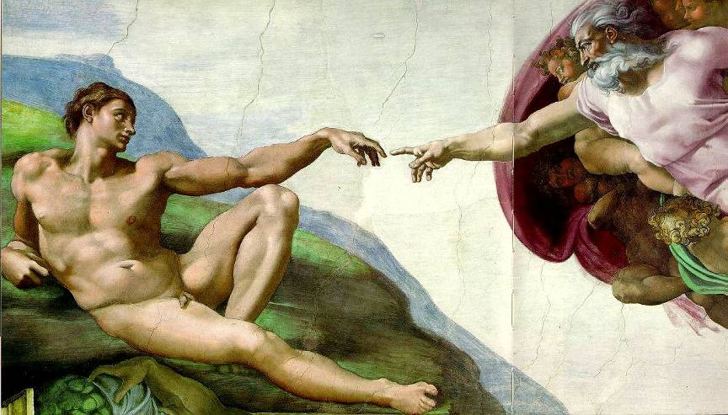
The creation according Michelangelo
Such anthropomorphism is forbidden for Muslims. God is only represented by his name calligraphed in Arabic. Muhammad is only evoked by his name, his genealogy, his turban or his footprint, by the mosque of Medina sheltering his tomb, or by the pigeon, holder of divine messages. Al-Buraq who carried Muhammad during the night on wings from Mecca to Jerusalem, from where Gabriel accompanied him to the seventh heaven at God, is one of the central figures of the popular religious imagery.
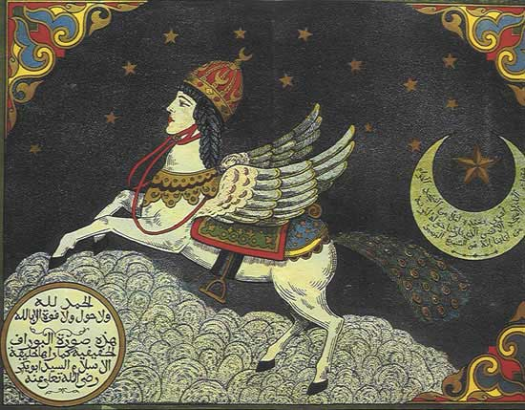
Al-Buraq
This figure is sometimes used by travel agencies or painted on trucks. One finds Abraham's picture sacrificing his son Ismael (according to Muslims), Adam and Eve eating from the forbidden tree, Noah's ark with the animals, Abraham thrown into the furnace for having destroyed the idols of the temple, but saved by God thanks to a source of cool water (according to the Koran 21:69).
Contrary to the Sunnites, the Shiites draw the picture of Muhammad, Fatima, Ali, his two sons and their religious leaders. These pictures are sold in the places of pilgrimage; one can see them also in Shiite coffee shops in Iraq and in Iran. I also noticed that Shiites visit Harissa above Beirut to honour Saint Mary. They do not hesitate to kiss her statue while whispering prayers.
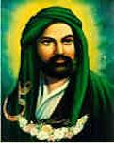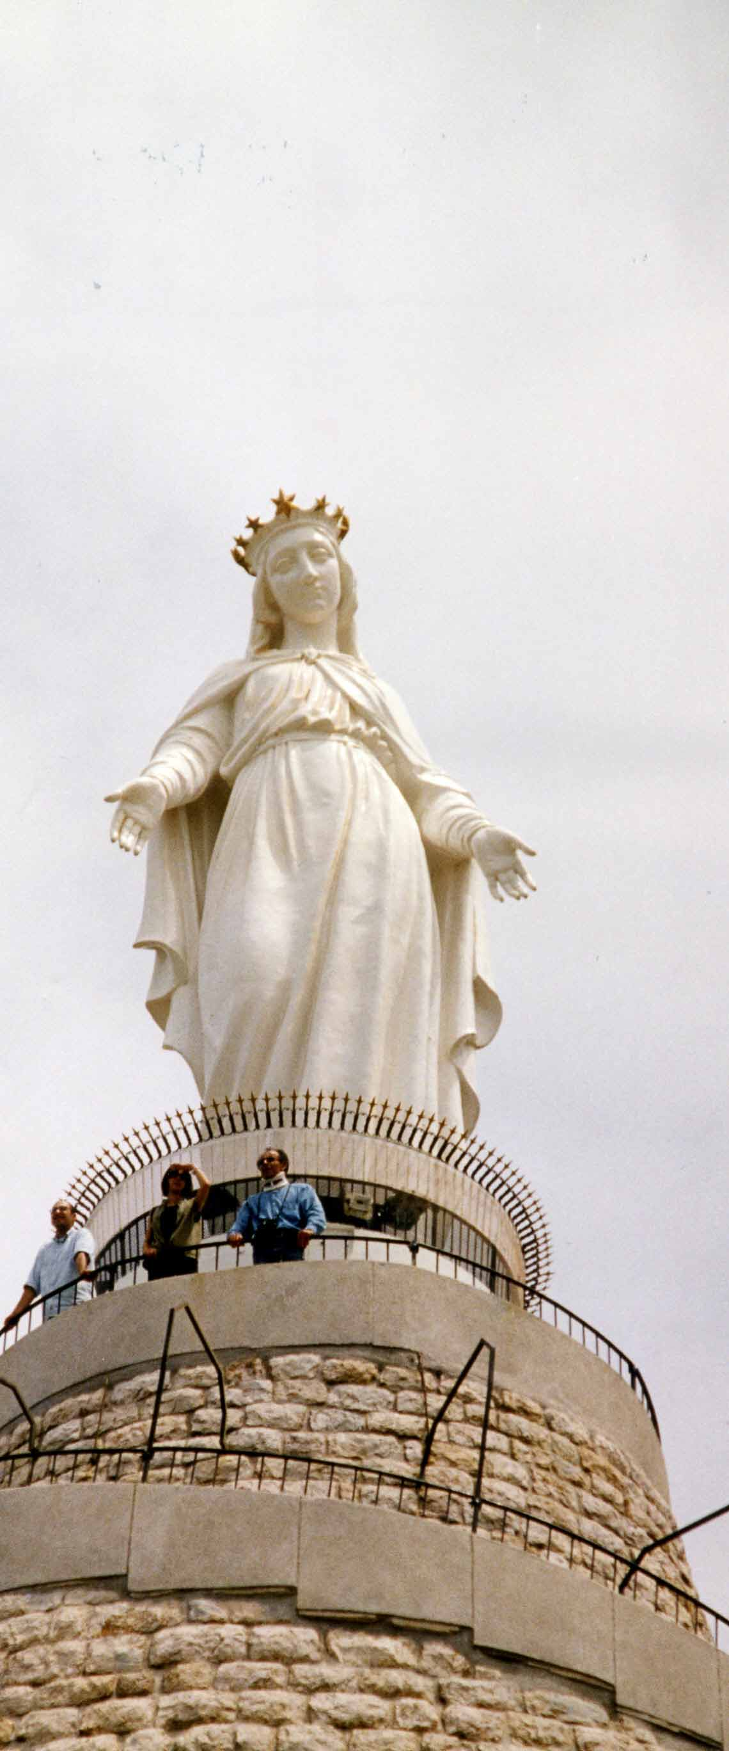
Imam Ali Saint Mary of Hairssa

5) Islamic figurative art today

A) Trend to reverse Islamic norms
We saw that only a minority of classic jurists allow statues and pictures as long as they are not used as objects of cult. This position is about to become a majority trend in Muslim societies, visible with portraits and statues of leaders and heroes exposed everywhere, on crossroads, offices, private houses and school books. Muslim historians of art tempt to explain the interdiction of statues and pictures in Muhammad's time by his will to end paganism and to incite his adepts to soberness (see narration 20) as well as to dedicate themselves to the duty of expanding Islamic religion. Since paganism is no longer an issue, they consider that the interdiction of figurative art has no reason anymore. Evoke verse 34:13 related to Salomon, Pasha writes:
We can say with serenity that Islam permitted picture as long as it is distant from paganism, does not compete with the Creator, and does not stop the nation from making its duty and assuming its responsibility.
Wafa' Ibrahim says that once the goal of eliminating paganism is achieved, the prohibition of figurative art disappears, because a prohibition cannot exist without reason. The prohibition of figurative art in Islamic law differs from the prohibition of stealing and murdering which is perpetual because there will always be such crimes. The Koran, which is valid for any time and place, does not prohibit figurative art. Wafa' Ibrahim questions the authenticity of the above-mentioned narration 3: "Whoever makes a picture will be punished on the Day of Resurrection and will be asked to give life to (what he has created)?" She considers that this narration is too faulty and illogical to be attributed to Muhammad who is known for his eloquence. She adds that Muhammad's house comprised pictures of human beings and animals; he wanted merely that these pictures do not distract him in his prayers (narration 14). She considers that the interdiction of pictures is a thermometer to know the periods of decadence in Muslim history.
This position, based on historic and teleological interpretation of the prohibition of figurative art, was defended by Muhammad Rashid Rida (died 1935), who permitted the statues, considering that the prohibition is only about idolatry and worship of idols.

B) Firm Position of modern Sunnite jurists
Modern Sunnite jurists remain firmly opposed to the practices of caliphs and present leaders, to popular representations and to Shiite attitude. They consider that Muslims must follow only Muhammad as model. They quote the Koran that says in this regard: "The messenger of God has set up a good example for those among you who seek God and the Last Day, and constantly think about God" (33:21).
According to these jurists, norms remain valid even though they are violated, and they must be respected without scrutinizing the reasons behind them. One cannot fail to the duty of submission unless there is a case of necessity. Therefore, one cannot say that all pictures or statues, which are not objects of worship, are permitted. One cannot either say that paganism is no more in use in Muslim countries and there is no risk that Muslims start adoring statues or pictures again. Muslim jurists say in this regard that we cannot exclude such a possibility in our century, as people continue to adore cows in India, as well as statues and pictures in the West. It is necessary to bar the path to everything that may lead to error (sad al-dhara'i') .
Criticizing Christians, Abd-al-Khaliq writes that they transformed their monotheistic religion transmitted by Jesus into a worship of idols, replacing the statues of Greek and Roman divinities by those of Jesus, his mother and his disciples. For this fact, they are unbelievers and "they will be the worst creature in the sight of Allah on the Day of Resurrection" (narration 9). In spite of their progress in material sciences and the extent of their civilization and knowledge, they remain poor ignorants in dogmatic matters. Communists did the same by adoring the statues of Marx and Lenin, replacing an idolatry by another.
Based on this reasoning, modern Muslim jurists forbid statues and pictures of statesmen, national heroes, scientists, artists, parents or beloved persons, either in public or at home. It is prohibited to make a monument for the Unknown Soldier, even though the statue is a lion symbolizing strength. The interdiction is even sterner when the represented celebrity is a leader who does not apply God's law, an unbeliever (non-Muslim) or a perverse. The presence of such statues and pictures prevents the entry of the angels of mercy. Ahmad Shakir (died 1939) denounces the fact that the supposedly Muslim Egyptian state filled the country with statues of national heroes and created an institute of fine arts, an institute of debauchery, where unbridled boys and girls go naked under the pretext that they practice art.
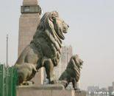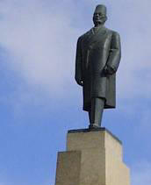
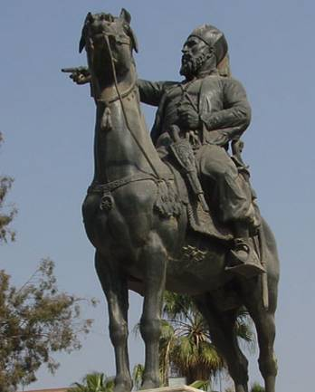
Lions, Saad Zaghloul and Ibrahim Pacha in Cairo
So Muslim jurists passed from prohibiting idolatry, which is the basis of the Islamic norm, to prohibiting the cult of personality and glorification of individuals. These jurists go farther by forbidding animal figures as the eagle on the coat of arms of some Arab countries.
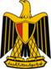
Coat of arms of Egypt, Jordan, Palestine and Kuwait
The Kuwaiti Commission of fatwa even prohibits handkerchief boxes comprising the engraving of a bird, unless its head is cut. The Saudi Commission of fatwa emitted several fatwas against figurative art concerning animate beings. Thus, answering a student who was interested in sculpting and drawing, it informed him that it is strictly prohibited to do such a thing (fatwa 8041). In another fatwa, it says that this interdiction applies to all times and concerns any statue that commemorates a king, a general, an unknown soldier or a devout man, or represents intelligence and strength as the Sphinx (fatwa 5068). In a third fatwa, it tells a young Egyptian who draws Pharaonic figures on papyrus that he should stop doing it (fatwa 6435).
Answering a question on the creation of museums, the Egyptian sheik Jad-al-Haq (died 1996), who was less strict, says in a fatwa of May 11, 1980 that statues, engravings and drawings of ancient nations, as long as they are not used for worship and glorification, are not prohibited. They must even be saved, because of their importance to the knowledge of history. He quotes verses of the Koran that encourage observations of the history of previous nations: "Have they not roamed the earth and noted the consequences for those who preceded them? They used to be more powerful, more prosperous, and more productive on earth. Their messengers went to them with clear signs. Consequently, God was not the One who wronged them; they are the ones who wronged their own souls" (30:9). This is an application of the necessity norm: "He has detailed for you what is prohibited for you, unless you are forced" (6:119). On the other hand, it is prohibited to put statues in the mosques or around them, to pray in a museum comprising statues, or to make statues to glorify persons. A fatwa of Al-Qaradawi forbids having statues of ancient Egyptians in houses, even as decoration. And if these statues are used like amulets, the interdiction is even more rigorous.
The Sunnite religious authorities oppose firmly all representation of the prophets and Muhammad's mates. So the Saudi academy of Islamic law considered illicit a booklet submitted by the government of Qatar in which appeared the picture of Muhammad and Ali. On decision of its religious authorities, Indonesia barred the distribution of an issue of Newsweek magazine, because it comprised Muhammad's picture. In reply to a Kuwaiti Minister, the Commission of fatwa prohibited the sale or importation of carpets comprising pictures of Jesus and the cross made of wood or gold, because they belong to a cult, which was annullated by Islam, undermine the dignity of the prophets and constitute publicity for a false doctrine, since the Koran (4:157) affirms that Jesus has not been crucified.
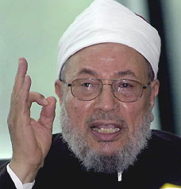
Al-Qaradawi
Al-Qaradawi, a very prolific and valued author in the Muslim world, summarizes the rules concerning figures and figure-makers as follows:
- The most strictly prohibited figures are those which are made to be worshiped in the place of or in addition to Allah. If the one who makes them does it intentionally for this purpose, he is going in the direction of unbelief (kufr). The most detestable among such figures are statues. Anyone who has a share in propagating or glorifying them will bear the sin proportional to his part.
- Next to this in sinfulness are figures which are not made to be worshiped but which are intended to imitate Allah's creation. If the artist claims that he originates and creates as Allah does, he is an unbeliever. This matter pertains solely to the intention of the artist.
- After this are statues which are erected in public places in order to commemorate great personalities such as kings, leaders and celebrities; this applies equally to full-length statues and to busts.
- Next are statues of living beings which are neither worshipped nor reverenced. There is general agreement that they are haram, except those which are not treated in a manner indicative of respect. Dolls or figures made of chocolate or sugar are clear exceptions.
- Next are portraits of great people such as rulers and political leaders, especially when they are displayed or hung on walls. Strongly prohibited among these are portraits of tyrants, atheists, and immoral individuals, for to respect them is to degrade Islam.
- Next are pictures of people or animals which are not accorded respect but constitute a display of luxury and high living, as, for example, when they cover a wall or the like. These are classified as detestable only.
- Making and acquiring drawings or paintings of trees, lakes, ships, mountains, and landscapes of this sort is permitted. However, if they distract from worship or lead toward extravagant living, they are disapproved.
- Photographic pictures are basically permissible. They become haram only when the subject matter is haram, as, for example, in the case of idols, individuals who are revered either because of their religious or worldly status, especially the leaders of idolaters, Communists or other unbelievers, or immoral individuals such as actors and entertainers.
- Finally, if the prohibited statues and pictures are defaced or degraded, their use becomes permissible; an example of this are figures on a rug or carpet, because they are walked upon.

C) Destruction of Buddha's statues
The Communist regime of Afghanistan had proposed to the UNESCO the gigantic statues of Buddha of Bamiyan in 1982 as part of world heritage. In July 1999, Omar issued a decree saying: "all historical cultural heritage is regarded as an integral part of the heritage of Afghanistan". In the decree, Mullah Mohammad Umar devoted considerable attention to the two giant statues of Buddha in Bamiyan. He said the Taliban government "regards the statues with serious respect" and that they are an example of Afghanistan's pre-Islamic history and "a potential major source of income for Afghanistan from international visitors." The decree warned of retaliatory actions from the Buddhist community if the statues were destroyed. "The Taliban government states that Bamiyan shall not be destroyed but protected".
Two years later, the position of the Taliban changed completely. On February 26, 2001, Mullah Mohammad Umar, of whom there are no photographs, issued the following decree:
Based on the verdict of the clergymen and the decision of the Supreme Court of the Islamic Emirate [Taliban] all the statues around Afghanistan must be destroyed. All the statues in the country should be destroyed because these statues have been used as idols and deities by the non-believers before. They are respected now and may be turned into idols in future too. Only Allah, the Almighty, deserves to be worshipped, not anyone or anything else..
On March 14, 2001, the Taliban announced the complete destruction of the Buddha of Bamiyan and the statues at the national museum, as well as those at the museums and sites in other cities of Afghanistan. On March 16, Mullah Umar commanded the sacrifice of hundred cows whose meat had to be distributed to the poor people, in order to expiate the delay brought by Muslims to the demolition of Buddha. On March 22, 2001, the Taliban opened the museum of Kabul to journalists who saw a building ridded of everything that represented a living being, including the birds on a decorative frieze which had been deprived of their head. The collections sheltered in the building of the Ministry of information and culture and other governmental buildings have also been purified of human representations by the Taliban.
Centlivres qualifies the destruction of the statues of Buddha as cultural terrorism. Koichiro Matsuura, director of the UNESCO, declared:
I was distressed to learn … that the destruction of the Bamiyan Buddhas was confirmed. In so doing, the Taliban have committed a crime against culture. It is abominable to witness the cold and calculated destruction of cultural properties which were the heritage of the Afghan people, and, indeed, of the whole of humanity. The Buddhas of Bamiyan were not inscribed on the World Heritage List but deserved to be and their destruction represents a true cultural crime. This crime against culture was committed while people throughout the world raised their voices to prevent it. The Taliban heeded neither the unprecedented scope of international mobilisation, nor the advice against their decision, spontaneously issued by the highest religious authorities of Islam.
We can interpret the changing of the Taliban's attitude in different manners. Some consider that it is due to their indignation and anger in front of the protests by the West and its exclusive concern for idols, contrasting with its callousness facing the misfortunes of Afghanistan. Others see the will to destroy the monuments symbolizing the country of Hazaras, iconoclasm pushed to its extreme, a reaction to the denial of recognition of the Taliban system by the international community, a camouflage for the depredation of antiquities at the national museum and archaeological sites undertaken by different Afghan factions. Without wanting to exclude these explanations, Centlivres writes:
In a good method, it is necessary to take seriously the word and the decree of Mullah. This last contains a strong assurance of the irrevocable character of the religious law as manifested by the recommendation of the ulemas of Kandahar according to a very fundamentalist interpretation of the Koran and the charia. The high religious, political and cultural personalities who came to Kabul to help the Afghan heritage received a polite but inflexible welcome. The Taliban pushed the borders very far beyond of which the representation of animate beings is an attack to God's privilege, the only creator. For them, the representation of a being, even deformed, even explicitly non-realistic is suspected of idolatry, or a product of the illegitimate pride of the artist. The Taliban banish in Afghanistan games, dance and music, that what Pascal calls, in the strong sense, the entertainment. They deny the legitimacy of this uncertain, temporal zone, that, belonging directly nor to God nor to the natural, distracts the man from God's thought. They condemn all what may introduce guilty thoughts and emotion susceptible to dominate the man while ruining his reason and his gravity, deviating him from the strait way.
Centlivres ends his book on the destruction of Buddha's statues as follows:
By destroying the Buddhas, the Taliban oppose all nationalistic, historic, humanist or spiritual anchorage in the pre-Islamic past. The militant hazaras of the Unity Party whose leaders believed to recognize in the statues of Bamiyan archetypical representations of their people, the nationalists who think that Afghanistan (Aryana) is the cradle of Aryans, or, beyond Afghanistan, the adepts of Buddhism lived not as a religion in the narrow sense of the term but as a spiritual current to which is connected an aesthetic and a wisdom, and all those who think in Afghanistan that their country is at the origin of the diffusion of a new form of art, see themselves deprived by the ideology of the Taliban from their legitimacy and their inheritance. To these concepts, the Taliban oppose a radically antagonistic heritage based exclusively on narrow interpretation of the Koran and the charia.
Professor Centlivres affirms in these two quotes that the gesture of the Taliban corresponds to a very fundamentalist and narrow interpretation of the Koran and the charia. However, in light of what we saw, we have to recognize that their gesture corresponds to the unanimous opinion of classic Muslim jurists.
Centlivres notices that "the high religious, political and cultural personalities who came to Kabul to help the Afghan heritage received a polite but inflexible welcome". Indeed, facing the general outcry provoked by the decision of the Taliban, decision that provoked the anger of Buddhists throughout the world who threatened to destroy the mosques, and gave Islam a bad picture, a delegation of the Organization of the Islamic conference, including the Mufti of Egypt Nasir Fayid Wasil and Sheik Al-Qaradawi, attempted to dissuade them from the announced destruction. The Mufti of Egypt declared that keeping these statues is not illicit, especially since they have been made before the entry of Islam into Afghanistan and since they didn't influence Afghans' faith; they only constitute a step in the history of this country and traces of the past from which Muslims can draw lessons about the precedent nations, adding that these statues can benefit the country on the level of tourism. A similar position was expressed by the sheik of Al-Azhar Muhammad Sayyid Tantawi and by Sheik Al-Qaradawi. The general secretary of the Egyptian agency for antiquities proposed to transfer these statues to Egypt and to make for them a suitable museum. However, some Muslims issued opposite opinions, approving the gesture of the Taliban, considering that it is in conformity with Islamic norms.

6) Modern inventions: Photographs, movies, television and theatre
Besides the problem of the statues and pictures treated by classic jurists, modern jurists are confronted with a profusion of pictures and representations due to photographs, movies and television, as well as theatre performances.

A) Controversial debate
Muslim authors consider that every nation has its values. So bank interests are prohibited by Islamic law, but it is part of the economic system of other groups. Islamic norms prescribing discretion and veil for women in order to preserve moral values are interpreted by non-Muslims as means to lock up women. The West conveys its values through its inventions, which are passed on to Muslims, creating conflicts with Muslims' values. Some Muslim authors are tempted to reject these inventions. But as the latter become necessities, authors attempts to filter out the illicit use that is made of the inventions.
A Muslim author says that Jews dominate theatre, movies and the press, and try in the name of art "to destroy civilization, faith, moral values and human feelings towards one's own country and towards human and religious causes". Another Muslim author is going as far as quoting The protocols of the sages of Zion (a forged book attributed to the Jews) which suggests amusing the public with games and art until it stops using its brain and begins to align on Zionist positions. Speaking of television, another author writes:
It is probably useless to insist on the destructive and hostile nature of television in its present form with regard to Islamic values and supreme human ideals, especially as media reality absolutely attests the negative aspect of this device and the extended of its crimes and misdeeds.
After having reviewed twenty one disadvantages of television, this author concludes that television is an illicit means in its present form.
Muslim authors defend themselves against the accusation that Islamic law is opposed to beauty and art in itself. They quote the Koran that says in this regard:
O children of Adam, you shall be clean and dress nicely when you go to the mosque. And eat and drink moderately; Surely, He does not love the gluttons. Say, "Who prohibited the nice things God has created for His creatures, and the good provisions?" Say, "Such provisions are to be enjoyed in this life by those who believe (7:31-32).
But according to these authors, art must have limits and be in the service of a cause, and not merely be art for art. Human beings must use things on this earth to get ready for the other life:
Indeed, you are preoccupied with this first life. Even though the Hereafter is far better and everlasting. (87:16-17).
These authors oppose Western art in this respect to Islamic art. The latter is defined as being:
Islamic expression of the existence, in the setting of Islamic norms, aiming to achieve a goal in conformity with the Islamic law and provoking a particular reaction in conformity with the Muslim expression of the world, human being and life.

B) A photograph is not a picture
We saw that Muhammad cursed those who make pictures competing with the work of God. Modern jurists consider that this malediction does not concern photography, since this is not an artistic work, but the reflection of an object on a support. Anyone can take a photo, including a child, by pressing on a button. The photo looks like the reflection on a mirror or on the surface of water. As one cannot prohibit the reflection on a mirror or on water, one cannot prohibit the reflection fixed on a film or another support.
Using the term surah for the photo, and the term musawwir for the photographer poses a problem since these two terms are used by the Koran and the Sunnah for pictures which are forbidden. Hence, some authors propose using other terms that do not recall the interdiction: for example aks (reflection) for photo, and akkas (the reflector) for photographer. These terms are used in some regions of Arabia, probably to solve the problem of the prohibition.
This reasoning can be extended to the statues executed by computers that, from reflections, actuate the devices producing their form. Muslim authors do not treat this question, either because they do not know this technology, or because statues are regarded in Islamic law with more suspicion than pictures.
Several fatwas have been issued concerning photographs. Thus, Egyptian pilgrims complained that their authorities request photos for the passport to go to Arabia. The Ministry of justice consulted sheik Abd-al-Rahman Qarra'ah. In his fatwa of July 24, 1921, Qarra'ah says that it is prohibited to put effigies of complete living beings, big or small, on a dress, coin, diner, wall or elsewhere. On the other hand it is not prohibited to have figures of living beings which are incomplete, or which are missing organs that are necessary to live, or too small to distinguish the organs. This sibylline answer means that partial photos for passport are permitted.
In a fatwa of August 6, 1980, Jad-al-Haq considers that it is allowed to hang photos of human beings or animals provided that they are not the subject of glorification or worship, and don't incite to debauchery and violation of Muslim prohibitions.
The Kuwaiti Commission of fatwa allowed a father to enlarge a photo of his deceased son, photo he wanted to hang in the house, but it recommended him to use a portrait photo in which the son does not appear in full.
The Saudi Commission of fatwa opposes any photo, complete or partial, except in case of necessity as the photos for passports or those of criminals. It forbids taking a souvenir photo of a wedding, family or friends. It says that the photos that are in newspapers, magazines or books must be destroyed. In a fatwa, it says that a woman does not have the right to have a photograph taken of here face because her face is awrah (faulty object) and may excite the passions. But the photo for a passport to go on a pilgrimage is permitted because of necessity.

C) Conditions for the liceity of the photograph
Although the photograph is dissociated from the picture, it produces an image that can be used like the picture in idolatry, glorification or debauchery. It is not sufficient to replace a picture by a photograph, or a term by another one, to lift the interdiction. For this fact, Muslim authors recall the following limits for the use of photographs:

a) Interdiction to represent God or certain persons
It is prohibited to draw God or to represent him in movies, be it in complete or incomplete form. In the same way, it is prohibited to produce a voice insinuating that it is God's voice. The Koran says: "There is nothing that equals Him. He is the Hearer, the Seer" (42:11). Therefore, any picture or representation of God is necessarily erroneous and risks to undermine the divine majesty and to ridicule it.
The same two reasons are evoked to prohibit the representation of prophets and certain persons, be it in a picture, statue or through actors playing their role in movies, and it is prohibited to produce voices attributed to them.
In addition to the general interdiction of representing animate objects, one evokes here the destruction by Muhammad of the pictures of Abraham and Ismael (narrations 1 and 2), and his disapproval of the pictures in the Ethiopian church (narration 9). It is also feared that the representation by a picture or a statue drives to idolatry. Finally, it is indicated that any representation of the prophets is necessarily untrue because it does not correspond to the original. It is a lie, and the lie is forbidden. One evokes here Muhammad's word: "Whoever lies voluntarily about me will occupy his place in hell". This narration applies to any lie either in speech or in drawing. It is also prohibited to represent Al-Buraq who transported Muhammad to Jerusalem in his nocturnal journey.
The Commission of fatwa of Al-Azhar emitted a fatwa February 3, 1955 in which it forbids any representation of the prophets. It invokes first that it is materially impossible to represent them. Therefore, a movie on Adam and Eve in Paradise poses problems as for the form to give to God or the kind of tree of which they ate, which is not indicated by the Koran. A movie on Moses cannot reproduce the miracles he made before Pharaoh. A movie on Joseph seducing the wife of Al-Aziz cannot tell of what consists this seduction, as it is not described in detail by the Koran.
Then the Commission indicates that it would be indecent to represent Muhammad with unbelievers insulting and treating him of being a lunatic and wizard. Such a movie could provoke brawls between those who respect the prophets and those who do not care about them, putting in danger the law and order. The Commission indicates that Muhammad had forbidden Muslims to consider him more important than other prophets so that it does not provoke disputes between Muslims and adepts of other prophets. It points out that a movie on the prophets could have ominous consequences:
- It could call in question the beliefs of people and destroy the esteem they have with regard to their supreme models.
- It could provoke discussions and comments around these noble persons, who are above all critique.
- It could divide the society and oppose religious communities against each other.
- It could constitute a lie on God and his messengers, because a movie can never correspond to reality. To lie about God is an act of misbelieving. Muhammad says: "Anyone who sees me in his dream really sees me, because even the devil is unable to imitate my picture". Hence, if the devil is unable to imitate Muhammad, what to say about humans?
The Commission concludes that it is necessary to leave the prophets with their glory and dignity, considering that producers can exercise their art of drawing in the large domain of literature and history. It finishes by the verse:
In their history, there is a lesson for those who possess intelligence. This is not fabricated Hadith; this (Quran) confirms all previous scriptures, provides the details of everything, and is a beacon and mercy for those who believe (12:111).
The interdiction to represent certain persons is integrated in the decree 220 of 1976 of the Egyptian Ministry of information and culture. Article 1 of this decree says that the control of artistic productions aims to raise the level of art and make it a means to affirm the religious, spiritual and moral values of society, to develop the general culture and to protect moral, law and order and the youth from the deviance. Article 2, section 2 indicates the productions prohibited for this goal:
It is prohibited to produce a picture of the prophet Muhammad, explicitly or symbolically, a picture of one of the caliphs, the people of Muhammad's house, and the ten annonciators of the paradise, as well as their voices. It is prohibited in the same way to produce a picture of Jesus or the prophets in general. It is necessary to refer in this field to the competent religious authorities.
The interdiction to represent the prophets is at the origin of the difficulties of Youssef Chahine at the time of producing his movie The emigrant. In the beginning, the movie was titled Joseph, presenting Joseph's presence in Egypt as reported by the Bible and the Koran. The initial scenario of the movie was refused by Al-Azhar that made the following reproaches in its letter of October 7, 1992:
- The scenario comprises pictures of prophets of God and Joseph's brothers. And the law forbids this.
- The movie comprises erroneous facts, contrary to what is reported in the Koran.
- The scenario paints Jacob and Joseph in a way unworthy of the prophets.
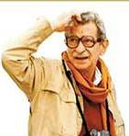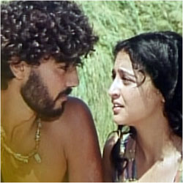
Youssef Chahine The emigrant
This denial has been reiterated on February 9, 1993, blaming the author of the scenario for not having taken into consideration the previous observations, for producing the Prophet Joseph, something that Al-Azhar does not permit, before or after his prophetic mission, and this out of respect for the message of the prophets. Youssef Chahine attempted to amend the scenario and to change the names of the persons. The title of the movie became The emigrant, and the name of the hero of the movie became Ram. In spite of these changes, Al-Azhar maintained its interdiction On January 27 and February 5, 1994, considering that the history of the movie looked like Joseph's history, and comprised suggestions and gestures that were incompatible with the dignity of the prophets. But the service in charge of controlling artistic productions allowed the realisation of the movie despite the objections of Al-Azhar.
After the launching of the movie and its large success, a lawyer, on October 5, 1994 asked the court to prohibit its projection and exportation. The plaintiff justified his claim by the fact that as a Muslim Egyptian citizen, he suffered a severe psychic and moral damage because of this movie that undermines the prophets, Egypt and the Egyptian people. Youssef Chahine answered that he did not represent the prophets, but that he was inspired merely by their history as models for humanity. One cannot forbid this type of inspiration. He added that the movie is an autobiography (Youssef in Arabic means Joseph). He emigrated to the United States to learn his profession there before returning to his country, as Ram emigrated to Egypt to learn the science of the Egyptians. He accused the lawyer of looking for notoriety by tackling the movie. The judge of injunctions, however, followed the reasoning of the attorney on December 29, 1994 and the movie was barred from projection and exportation. But the court of appeal lifted the interdiction in a decision of March 29, 1995, considering that the plaintiff was not qualitied to carry such a claim, not having sustained any personal damage because of the movie, and Egyptian law does not know class action lawsuit (hisba). The court evoked article 3 of the proceeding code that says:
No one can carry claim or formulate an objection unless there is a legitimate interest recognized by the law. However, the existence of an interest is sufficient if the goal of the demand is to avoid an imminent damage or to save a right whose proof risks disappearing in case of litigation.
Fearing a multiplication of lawsuits against artists and writers, the Egyptian parliament widened this article and completed it by article 3bis in 1996. These two articles read:
Article 3 - No one can carry claim or formulate an objection based on this law or any other law unless there is a personal, direct and legitimate interest recognized by the law.
However, the existence of a probable interest is sufficient if the goal of the demand is to avoid an imminent damage or to save a right whose proof risks disappearing in case of litigation.
If the conditions mentioned in the two previous paragraphs are not fulfilled, the court can decide itself, in any step of the lawsuit, to reject the demand.
Article 3bis - The previous provision does not apply to the public prosecutor's authority in the setting of the law to bring an action, to intervene and to make objection to a decision concerning it. In the same way, it does not apply in the cases where the law allows to a person who does not have the right to bring an action, to appeal or to complain to save a personal interest recognized by the law.
It is worth mentioning here that Mel Gibson's film The passion of the Christ was largely projected in movie theaters in Arab countries, including Egypt, and a DVD version can easily be bought in these countries, although it represents Jesus and his crucifixion, which denied by the Koran (4:157). Political reasons are certainly behind allowing this film, which is clearly in contradiction with Islamic, and State law.
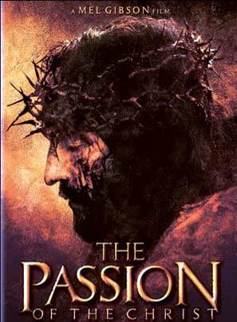
The passion of the Christ
The rigorist position of Muslim countries regarding movies on prophets is rejected by the Lebanese sheik Abd-Allah Al-Alayli (died 1996). He wonders why the religious authorities permit photographs and movies on the period posterior to Muhammad, but refuse to have movies produced on the Prophet's period. He asks:
Does the compensation of holiness consist in hiding it? Does the glorification of heroism consist in erasing and ignoring it? What is more communicating to the heard: the predication by the speech or the predication accompanied by a representation and a picture? I do not think that the answer of the religious authorities will be silly. Therefore, there is interest to make a movie on the prophetic period to reinforce the faith.
A fatwa of the Shiite imam Abd-al-Majid Al-Khu'i goes in the same direction. Asked about the possibility of making a movie on Prophet Muhammad and the imams, and representing these persons and previous prophets, he answered:
The answer to all these questions is the same, i.e. the liceity. Nothing bad in it if the work does not aim to undermine them and does not drive one day to such an attack.

b) Interdiction of the representations of idolatry or glorification
If the photograph, contrary to the picture, is permitted, an image that is barred as a picture is barred as a photo. One cannot take a photo of a statue or a devout picture to hang it at the wall. Qaradawi prohibits making or acquiring pictures of nude or semi-nudes, of those parts of the male or female body which excite lust, of a "great" man or leader who is an atheist and denies the existence of God; of an idolater who worships cows, fire, or anything else; of a Jew or Christian who denies the Messengership of Muhammad; of immoral individuals who propagate obscenity and lewdness in society, such as singers, actors, and other entertainers. The Syrian Al-Buti junior says that the photo would be assimilated here, by analogy, to the picture if it comprises a human or animal object which is not decapitated. The angel does not enter a house where there is such a photo. However, Al-Buti does not elaborate this very delicate question, probably because of the personality cult practiced in Syria. His father is even more prudent, considering that the photo cannot be compared to the picture. He says that the interdiction of the picture is bound to the cult, and an analogy is not possible in this domain.
The Saudi Commission of fatwa forbids exposing an effigy of a king, a scientist or a saint, be it a picture, a photo or a statue.

c) Respect of decency rules
Islamic law fixes strict norms concerning decency, forbidding mixity between men and women not having a parental relationship, and determining the parts of male and female bodies that one has the right to expose to others. These norms apply to the normal life, as wells as to the representation on picture, photo, television or in movies. It is even considered more dangerous to look at a photo than to look at a person represented in this photo, because the person looking at a photo is subject to less hindrance. It is forbidden to look at a woman's photo showing a prohibited part of her body, except in cases of necessity: teaching, security of the country, etc. In these cases, looking becomes obligatory.
Al-Buti permits the making of a documentary on women, but demands that the documentary is made by women only, and that women only see it. The same goes for documentaries addressed to men. It is prohibited on the other hand to make a movie on a marriage with women if it risks to be seen by men who do not have the right to look at these women.
According to Al-Qaradawi: "No doubt movies are important tools of instruction and recreation. Their situation is like that of any other tool which in it self is neutral and harmless, and any ruling concerning it will depend on how it is used". So, "portrayals which excite sexual desire or greed, glorify crime, or propagate deviant ideas, false beliefs, and the like are haram [illicit]. … The watching of movies should not result in the neglect of religious obligations or worldly responsibilities. … Physical intermingling and free mixing among men and women in movie theatres must be avoided in order to prevent sexual undertones and temptation, particularly because showing a film requires a darkened hall".
Answering a demand from students of fine arts in Alexandria, Jad-al-Haq said on March 24, 1979, that it is not allowed to draw a naked male or female model, even for educational purpose. He does not evoke here the Islamic norms on art, but those on decency.

D) Application of the Islamic norms to theatre
The previously mentioned norms concerning photos, movies and television apply also to the theatre, an actor playing the role of someone he represents.
A Muslim author explains that contrary to other domains of the Greek culture, Greek comedies were not translated into Arabic in the Middle Ages, because they did not correspond to the Arab mind. Such translations were done only when Muslims were occupied by force, and therefore deprived of their liberty of choice. Today, Muslim objection against the theatre results from "permissiveness and debauchery inherited from the Greek comedy by the West". This author allows a theatre production under the following conditions:
1) It must not put in stage historic personalities having acquired holiness in the mind of the believers, as the prophets and the first caliphs.
2) The theatre must discard debauchery, open sexuality and consumption of alcohol.
3) It must not comprise unveiled women or mixity between men and women.
4) It must serve the interest of religion, science, society and humanity.
5) It must not be in the service of a foreign power, destructive principles or an unbelieving ideology.
6) The actors must be good people, conscious of the problems of society and serving as models for the welfare of society.
He adds that these conditions are rarely respected by theatres in the Arab-Muslim world. Another author legitimizes production by the following facts:
- The angle Gabriel appeared to Mary as a man: "While a barrier separated her from them, we sent to her our Spirit. He went to her in the form of a human being" (19:17).
- The angels participated in two battles with the Muslim under various forms.
- The master who teaches his pupils how to make the ablution plays a role.
- The prophet sent to foreign authorities of his time diplomatic representatives to invite them to become Muslim.
However, this author adds that to be lawful, the theatre must be about a lawful subject in a lawful way. What one cannot do normally cannot be done on stage. So one would not trample on the Koran or commit adultery on stage, under pretext that it is a play. It is forbidden either to swear by another divinity than God or to make a perjury: "Do not subject God's name to your casual swearing" (2:224). One must respect the norms of decency and avoid mixity and travesty. It is forbidden to put on stage pagan statues, to play the role of a pagan divinity or Allah or to ridicule the religion (9:65-66). An actor cannot play a father's role, and a child a son's role, adoption being prohibited in Islamic law. He cannot repudiate his wife on stage because repudiation through joking is considered serious. It is prohibited to represent the prophets or Muhammad's mates.

7) Extreme position of the Saudi scholars
In Egypt, religious and civil authorities allow movies and theatre, under the condition not to represent determined persons, not to touch Muslim dogmas and to respect the rules of decency.
In Saudi Arabia, the religious authorities adopt a hostile position to movies and theatre even for expanding the Islamic religion. A Saudi author gathered their fatwas in a booklet published in Cairo. They say that Muslims find in their religion what the unbelievers find in the theatre which was created because of their spiritual vacuum, and it is prohibited by the Koran and Muhammad's Sunnah to be similar to unbelievers. The interpretation of one single verse of the Koran replaces all plays. The author in question puts 19 conditions for lawful movies and theatre. We summarize them in the following points:
1) Not to represent the prophet or his mates.
2) Not to lie, even for fun.
3) Not to put on stage religious rituals: pilgrimage, prayer, etc.
4) Not to imitate an animal by gesture or voice. The Koran says: "Walk humbly and lower your voice - the ugliest voice is the donkey's voice" (31:19).
5) Not to make travesty: a man playing a woman's role or imitating her, or the opposite.
6) Not to play a polytheist's role as Abu-Jahl or Pharaoh, or to represent the devil.
7) Not to play the role of a perverse who refuses to pray, consumes alcohol or makes the wizard.
8) Not to play the role of a devout religious person.
9) Not to pronounce words of misbelieve (unless to specify that it is about a speech that the unbeliever said).
10) Not to insult a Muslim or mention the name of someone who does not want to be mentioned, especially if he is absent.
11) Not to invent a a story (unless to say in the beginning: let us assume that such a thing happened). Muhammad says: "Misfortune to the one who tells stories, lying to make people laugh. Misfortune to him. Misfortune to him".
12) Not to prevent the achievement of the prayer or any other religious duty.
13) Not to lose time or money in the preparation of the production.
14) Not to look like people of the book as the Jews or Christians, be it in their dresses or other form.
15) Not to use an iron while indicating a Muslim.
16) Not to carry toupees or wigs.
17) Not to speak bad about dead persons or to ridicule them, except for valid reason.
18) Not to speak in an unfit or artificial way.
19) Not to believe that the production is a religiously deserving act, being part of the religion or permitted by the religion.
The author concludes that these conditions are impossible to fill, and therefore it is prohibited making theatre or movies.
We note, however, a change. Thus, ATS reported on October 15, 2005, that about twenty years after the interdiction of public projections, considered to be opposite to Islamic law, the first cinema theatre in Saudi Arabia will open in November. But it will be allowed to project only animated drawings. It will be open to women and children in a hotel of Ryad at the occasion of the Fitr, feast that marks the end of Ramadan. The newspaper Al-Hayat specified that the room, which has a capacity of 1400 seats, will organize every evening three sessions of one hour for the projection of movies of foreign animated drawings doubled in Arabic. The newspaper indicates that the project is a prelude to create real cinema theatres in Saudi Arabia. Several coffeeshops in main cities of the Kingdom already show movies, sports events and video clips on gigantic screens of television.

Conclusion: Hibernation and wakening of the religious norms
In positive law, a previous norm is repealed by a new norm decided by the sovereign. In Islamic law, norms remain congealed since the end of revelation with the death of Muhammad. Nobody has the right to change the fixed text, which is supposed to lead the society at any time and in any place. One can exploit the contradictions of the text and use the permissions (in case of necessity for example), but one cannot declare it null, even though it may hibernate during centuries. It is sufficient for someone to dust it, so the religious text recovers all its vigour. This has been confirmed with the destruction of Buddha's statues in Afghanistan, and it may happen again at any time if Muslim fundamentalists take the power elsewhere.
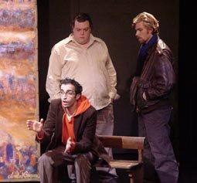
Slimane Benaïssa in Prophets without God
Slimane Benaïssa, an Algerian author, producer and actor, wrote a comedy titled Prophets without God, which focused on the question of the representation of prophets. He unites a Jew, a Christian and a Muslim playing the roles of Moses, Jesus and Muhammad. However, the Muslim refuses to play Muhammad's role because his religion prohibits it. In a telephone conversation I had with Slimane Benaïssa, he indicated that if tomorrow Muslim fundamentalists take the power in Egypt or elsewhere, they will do exactly what the Taliban did in Afghanistan and destroy all the statues they can find.
The problem of the wakening of the religious norms does not only arise in relation with art, but extends to practically all aspects of religious law.

Christian Arab of Palestinian origin and Swiss citizen, holding a doctorate in law from the University of Fribourg, and a diploma in political sciences from the Graduate Institute of International Studies of Geneva. Responsible for Arab and Islamic law in the Swiss Institute of Comparative Law in Lausanne. Invited Professor at the Faculties of Law of Aix-Marseille III and Palermo. Last book: Introduction à la société musulmane: fondements, sources et principes, Eyrolles, Paris, 2005. Email: saldeeb@bluewin.ch. Some of his writings in: http://www.sami-aldeeb.com/ and http://groups.yahoo.com/group/sami/. This article, available on my websites, was originally written in French and partially published under the title: L'art figuratif en droit musulman: passé, présent et avenir, in: Passerelles, no 26, 14th year, 2003, p. 15-43, and L'art figuratif en droit juif, chrétien et musulman, in: Liberté de l’art et indépendance de l’artiste, Publications de l'Institut suisse de droit comparé, no 50, Schulthess, Zurich, 2003, p. 113-151. It is translated and updated in English by the author, with references to existing English sources, mainly available on internet. The opinions expressed in this article engage only the author's responsibility.
http://speakingoffaith.publicradio.org/programs/buddhaintheworld/images/buddha-taliban.jpg
http://www.rawa.org/statue2.jpg
http://www.monnaiesdumonde.net/pedagogie/images%20pedago/nouvelles%20dem%201.jpg
http://www.sfgate.com/c/pictures/2003/04/10/mn_saddam_statue1.jpg
http://www.tourism.egnet.net/culture/images/11g129.jpg
http://mythologica.fr/egypte/pic/aton.jpg
Van der Plas, Dirk: L’image divine et son interdiction dans les religions monothéiste, 17 juin 2000, in: http://www-aeg.montaigne.u-bordeaux.fr/PASSE/Dirk.htm.
Strabo, The Geography, book XVI, chap. II, par. 34, in: http://penelope.uchicago.edu/Thayer/E/Roman/Texts/Strabo/16B*.html
Freud, Sigmund: L'homme Moïse et la religion monothéiste, Gallimard, Paris, 1986, p. 92-98.
http://www.greatdreams.com/moses.jpg
http://www.greatdreams.com/akhena.jpg
Deuteronomy 13:1
Deuteronomy 29:28
Leviticus 23:14
Maimonides, Moses: The book of knowledge, transl. Russell and Weinberg, Royal College of Physicians, Edinburgh, 1981, p. 23-25.
http://www.therefinersfire.org/images/ten_commandments5.gif
Exodus 20:2-5.
Exodus 20:23; Deuteronomy 5:8-9 and 27:15; Leviticus 19:4 and 26:1.
Deuteronomy 4:15-18.
Deuteronomy 7:1-2, 5. See also Exodus 34:13; Deuteronomy 12:3.
Numbers 33:51-52.
Jewish Encyclopedia says: "Plastic art in general was discouraged by the Law; the prohibition of idols in the Decalogue (Exodus 20:4) being in olden times applied to all images, whether they were made objects of worship or not", in: http://www.jewishencyclopedia.com/view.jsp?artid=1823&letter=A&search=plastic%20art%20in%20general .
Exodus 25:17-22; 37:7-9.
Numbers 7:89; 1 Samuel 4:4; 2 Samuel 6: 2; 2 Kings 19:15; Psalms 99:1.
Exodus 26:1 and 31; 36:8 and 35.
2 Samuel 22:11.
Numbers 21:9.
2 Kings 18:4.
Exodus 35:30-35. See on this point: Sed-Rajna, Gabrielle: L'argument de l'iconophobie juive, in: F. Boespflug and N. Lossky (éd.): Nicée II 787-1987, douze siècles d'images religieuses, Cerf, Paris, 1987, p. 82; Prigent, Pierre: Le judaïsme et l'image, Mohr, Tübingen, 1990, p. 1.
1 Kings 6:23-29.
2 Chronicles 4:2-6.
2 Chronicles 9:18-19.
See I Kings 11:1-10.
Ezodus 41:18-19.
This episod is recalled in Exodus chap. 32; Deuteronomy 9:16-21; Psalms 106:19; Acts of the Apostles 7:41.
1 Kings 12: 28.
Hosea 8: 5-6. See also Hosea 10:5; Tobit 1:5.
The teraphim are mentioned in Judges 17:5 and 18:14-20; I Samuel 19:13 and 16; Hosea 3:4; Zechariah 10:2. See on this term: http://www.jewishencyclopedia.com/view.jsp?artid=150&letter=T
The ephod as representations are mentioned in Judges 8:27, 17:5, 18:14; 1 Samuel 2:28; Hosea 3:4. See on this term: http://www.jewishencyclopedia.com/view.jsp?artid=401&letter=E
I Maccabees 1:43.
II Maccabees 12:40.
Finkelstein, Israël and Silberman, Neil Asher: La Bible dévoilée: les nouvelles révélations de l'archéologie, trad. Patrice Ghirardi, Bayard, Paris, 2002, p. 315-317.
Ibid., p. 276-277.
Ibid., p. 327.
http://itwasjohnson.impiousdigest.com/asherah.jpg
Finkelstein and Silberman, op. cit., p. 330-331.
Babylonian Talmud, translated by Michael L. Rodkinson, Tractate avoda zara, in: http://www.jewishvirtuallibrary.org/jsource/Talmud/avodahzara_toc.html
Ibid., 1.4-5.
Ibid., 1.6.
Ibid.,1.8.
Ibid., 2.3-6.
The Talmud of the Land of Israel, translated by Jacob Neusner, University of Chicago press, Chicago and London, 1982, vol. 33, Abodah zarah, 3:1.
Babylonian Talmud, op. cit., Tractate avoda zara 3:2.
Ibid. 3:3.
Ibid., 3:5.
Ibid., 4:4.
Ibid., 4:6.
Tacitus: The histories, Translated by Alfred John Church and William Jackson Brodribb, book V, in: http://classics.mit.edu/Tacitus/histories.5.v.html .
Flavius Josephus, Antiquities of the Jews , Translated by William Whiston, book VIII, chap. 7, par. 5, in: http://www.ccel.org/ccel/josephus/works/files/ant-8.htm
The Life of Flavius Josephus, Translated by William Whiston, par. 12, in: http://www.ccel.org/j/josephus/works/autobiog.htm .
Flavius Josephus Against Apion, Translated by William Whiston, book II, par. 6, in: http://www.ccel.org/ccel/josephus/works/files/apion-2.htm .
Flavius Josephus: The wars of the Jews, Translated by William Whiston, Book II, chap. 10, par. 1-5, in: http://www.ccel.org/ccel/josephus/works/files/war-2.htm ; Flavius Josephus, Antiquities of the Jews , op. cit., book XVIII, chap. 8, par. 1, in: http://www.ccel.org/ccel/josephus/works/files/ant-18.htm
Ibid., book XVII, chap. 6, par. 2, in: http://www.ccel.org/ccel/josephus/works/files/ant-17.htm . See also Flavius Josephus: The wars of the Jews, op. cit., Book I, chap. 33, par. 2-3:, in: http://www.ccel.org/ccel/josephus/works/files/war-1.htm
Flavius Josephus, Antiquities of the Jews, op. cit., book XVIII, chap. 3, par. 1, in: http://www.ccel.org/ccel/josephus/works/files/ant-18.htm . See also Flavius Josephus: The wars of the Jews, op. cit., Book II, chap. 9, par. 2-3, in: http://www.ccel.org/ccel/josephus/works/files/war-2.htm
Flavius Josephus, Antiquities of the Jews, op. cit., chap. 6, par. 3, in: http://www.ccel.org/ccel/josephus/works/files/ant-18.htm
Ibid., Book XV, chap. 2. par. 6, in: http://www.ccel.org/ccel/josephus/works/files/ant-15.htm
Prigent, op. cit., p. 8-9.
Ibid., p. 10-11.
Ibid., p. 30-32.
http://content.answers.com/main/content/wp/en/e/e9/Duraeuropa.gif
See on this synagogue Prigent, op. cit., p. 174-263.
Ibid., p. 34.
Julius, Anthony: Idolizing pictures: idolatry, iconoclasm and Jewish art, Thames & Hudson, London, 2000, p. 58.
Ibid., p. 37.
Mann, Vivian, B.: Jewish texts on the visual arts, University Press, Cambridge, 2000, p. 34-36.
Julius, op. cit., p. 71.
Ibid., p. 85.
Ibid., p. 39-41.
Ibid., p. 42.
Ibid., p. 58-59.
Ibid., p. 65-68.
Ibid., p. 88.
http://www.haaretz.com/hasen/spages/579964.html
http://www.haaretz.com/hasite/images/iht_printed/P250505/tn.2505.44.1.jpg
http://upload.wikimedia.org/wikipedia/commons/thumb/0/0b/Israel_-_Tiberias_-_Maimonide_grave_001.jpg/200px-Israel_-_Tiberias_-_Maimonide_grave_001.jpg
Matthew 4:10.
Acts of the Apostles 7:40-43. See also Romans 14:11; 1 Corinthians 12:2; I Thessalonians 1:9; I P 4:3; I John 5:21; Revelation 2:14; 9:20.
Acts of the Apostles 15:20 and 29; 21:25; 1 Corinthians 10:18-21.
1 Corinthians 8:4-13.
Acts of the Apostles 28:11.
On the position of the pagans, see Grabar, André: L'iconoclasme byzantin, le dossier archéologique, Flammarion, Paris, p. 21 and 25.
Grabar, op. cit., p. 19.
Isaiah 52:14 and 53:2-3.
Martin, Pierre: La résurrection en images, Editions Saint-Augustin, Saint Maurice, 2001, p. 23.
Clement of Alexandria: Exhortation to the Heathen, Chapter I, in: http://www.earlychristianwritings.com/text/clement-exhortation.html ; Clement of Alexandria: The Stromata, or Miscellanies, Book VII, chapter V, in: http://www.earlychristianwritings.com/text/clement-stromata-book7.html .
Felix: Octavius, chapter XXIII, in: http://www.earlychristianwritings.com/text/octavius.html .
Tertullian: On idolatry, translated by S. Thelwall in: http://www.earlychristianwritings.com/text/tertullian02.html, chapiters IV and V.
Hippolytus of Rome: The Apostolic Tradition, translated by Kevin P. Edgecomb, par. 16, in: http://www.bombaxo.com/hippolytus.html
Clement of Alexandria: Paedagogus, Book III, in: http://www.earlychristianwritings.com/text/clement-instructor-book3.html .
Grabar, op. cit., p. 17-18.
Grabar, op. cit., p. 18-19.
Besançon, Alain: L'image interdite, une histoire intellectuelle de l'iconoclasme, Fayard, 1994, p. 153.
Menozzi, Daniele: Les images: l'Église et les arts visuels, Cerf, Paris, 1991, p. 16.
http://www.ladyofroses.org/chiimg.jpg
http://faculty.cua.edu/pennington/Canon%20Law/ElviraCanons.htm
See the letter in: Cyril Mango: The art of the Byzantine Empire: 312-1453: sources and documents, Englewood Cliffs New Jersey, Prentice-Hall, 1972, p. 16-18.
Menozzi, op. cit., p. 17-18 and 83-84.
Grabar, op. cit., p. 19-20.
http://216.239.59.104/search?q=cache:GgNcP_RTuRIJ:www.mcah.columbia.edu/arthumanities/pdfs/arthum_amiens_reader.pdf+serenus+gregory+marseille&hl=fr&ct=clnk&cd=14&gl=ch
Besançon, op. cit., p. 157-158. See also Grabar, op. cit., p. 34-43.
http://www.ccel.org/ccel/schaff/npnf214.xiv.iii.ci.html
See the text in Menozzi, op. cit., p. 96-99.
See Grabar, op. cit., p. 135-143.
Ibid., p. 116-132.
Menozzi, op. cit., p. 23-24. Text of John Damascene in Menozzi, op. cit., p. 90-94.
http://www.fordham.edu/halsall/source/nicea2-dec.html
Menozzi, op. cit., p. 111-113.
See the text in Menozzi, op. cit., p. 115-116.
Reymond, Bernard: Le protestantisme et l'image: pour en finir avec quelques clichés, Labor et fides, Genève, 1999, p. 12.
http://www.saintpeters.org/images/Martin_Luther_(1483-1546).jpg
http://biblia.com/christianity2/zwingli-12.jpg
http://huguenots-france.org/france/celebrites/images/calvin.jpg
Menozzi, op. cit., p. 38-39. See texts of Luther in Menozzi, op. cit., p. 163-169.
Ibid., p. 39.
Ibid., p. 39-40. See the text of Calvin in Menozzi, op. cit., p. 172-179. See also Wencelius, Léon: L'esthétique de Calvin, Slatkine reprints, Genève, 1979, p. 161-188.
Reymond, op. cit., p. 15-16.
Ibid., p. 15-16.
Ibid., p. 22-25.
Ibid., p. 25-26.
Menozzi, op. cit., p. 41. See the text in Menozzi, op. cit., p. 190-192.
http://www.ewige-anbetung.de/Zeugen/Crescentia/a_Kreszentia_2.jpg
http://web246m.dynamic-kunden.ch/Maria/images/crescentia2.jpg
See on this affair the excellent book of Boespflug, François: Dieu dans l'art. Sollicitudini Nostrae de Benoît XIV (1745) et l'affaire Crescence de Kaufbeuren, Paris 1984.
Saint Theresa of Avila had similar vision (Boespflug, op. cit., p. 149-152).
Latin text and french translation in Boespflug, op. cit., p. 22-59.
Matthew 3:16; Mark 1:10; Luke 3:22; John 1:32.
Acts of the Apostles 2:3.
Genesis 18:1-2.
Daniel 7:9.
http://perso.orange.fr/les.barbus/images/trinite.jpg
http://chapiteaux.free.fr/TROIS-TRIFFRONS_fichiers/TRIFRONS_AUJAC_2.JPG
Boespflug, op. cit., p. 153-160.
Boespflug, op. cit., p. 166.
http://www.vatican.va/archive/hist_councils/ii_vatican_council/documents/vat-ii_const_19631204_sacrosanctum-concilium_en.html par. 123 and 124.
http://www.vatican.va/archive/hist_councils/ii_vatican_council/documents/vat-ii_cons_19651207_gaudium-et-spes_en.html par. 62.
http://www.vatican.va/archive/ENG1104/__P4D.HTM
Numbers in the text and footnotes without other indication refer to the Koran, mainly as translated by Rashad Khalifa, in: http://www.submitters.org.uk/quran/
Al-Sha‘rawi, Muhammad Mitwalli (d. 1998): Qadaya islamiyyah, Dar al-shuruq, Beirut & Cairo, 1977, p. 25-26, 28-29 et 35-39.
6:74; 7:138; 14:35; 21:57; 26:71.
21:52; 34:13.
5:3, 90; 70:43.
6:74; 7:138; 17:42; 18:15; 19:81; 21:21, 22, 24, 43, 99; 25:3, 43; 36:23, 74; 37:86; 38:5; 43:45; 46:28.
Al-lat (53:19), Al-'Uzza (53:19), Manat (53:20), Wadd, Suwa'a, Yagout, Ya'ouq and Nasr (71:23).
71:23-27.
On the hostility of Abraham towards the idols, see: 6:74; 14:35-36; 21:52-69; 26:69-77.
English translation in: http://www.usc.edu/dept/MSA/reference/searchhadith.html
Al-Azraqi (died about 865): Akhabar Makkah wa-ma ja' fiha min al-athar, in: http://www.alwaraq.com/, p. 82-84.
Bukhari Volume 6, Book 60, Number 442; Ibn-Kathir, Isma'il (died 1373): Tafsir al-Qur'an al-adhim, Dar al-ma'rifah, Beirut, 1980, vol. 4, p. 426.
Al-Nawawi, Abu-Zakariyya (died 1277): Al-minhaj fi sharh sahih Muslim, Dar al-khayr, Beirut, 1994, vol. 14, p. 267.
Al-Bayhaqi, Abu-Bakr (died 1066): Al-sunan al-kubra, Dar al-kutub al-ilmiyyah, Beirut, 1994, vol. 7, p. 270.
Ibn-Hajar, Ahmad (died 1449): Fath al-bari bi-sharh sahih al-imam Al-Bukhari, Idrat al-buhuth al-ilmiyyah, Riyadh, s.d, vol. 10, p. 388.
Al-Dardir, Ahmad Ibn-Muhammad (died 1786): Al-sharh al-saghir, Dar al-ma'arif, Cairo, 1991, vol. 2, p. 501.
Al-Qaradawi, Yusuf: The Lawful and Prohibited in Islam, in: http://www.witness-pioneer.org/vil/Books/Q_LP/ch2s3pre.htm#Islam%20Prohibits%20Statues.
Abu-Hayyan, Muhammad Ibn-Yusuf (died 1344): Al-bahr al-muhit, Matba'at al-sa'adah, Cairo, 1328 h, vol. 7, p. 165.
Ibid., vol. 7, p. 265.
Pacha, Hasan: Funun al-taswir al-islami fi Masr, Al-Hay'ah al-masriyyah al-'ammah lil-kitab, Cairo, 1994, p. 39.
http://ic.ucsc.edu/~langdale/arth139/damascus1.jpg
http://www.atlastours.net/holyland/tree_of_life_mosaic.jpg
Voir les versets 17:13; 50:18; 82:10-12.
Jabr, Dandal: Hukm al-islam fil-suwar wal-taswir, Maktabat al-manar, Zarka, 3rd edition, 1986, p. 118-122.
Hasan, Yasin Muhammad: Al-islam wa-qadaya al-fan al-mu'asir, Dar al-albab, Damascus and Beirut, 1990, p. 113-115.
Al-Buti, Muhammad Tawfiq Ramadan: Al-taswir bayn hajat al-asr wa-dawabit al-shari'ah, Préface de Muhammad Sa'id Ramadan Al-Buti, Maktabat Al-Farabi, Damascus, 2nd edition, 1996, p. 84. The abrogation is mentioned in Ibn-Hayyan, op. cit., vol. 6, p. 265.
Al-Qaradawi, op. cit., in: http://www.witness-pioneer.org/vil/Books/Q_LP/ch2s3pre.htm#Islam%20Prohibits%20Statues; Hasan, op. cit., p. 111.
Al-Buti, op. cit., p. 88-92.
Grabar, op. cit., p. 159.
Al-Tibi, 'Akashah Abd-al-Minan: Ibadat al-awthan: al-asnam, al-tamathil, al-taswir, al-sinama, al-television, Maktabat al-turath al-islami, Cairo, 1990, p. 236-238; Al-Qudat, Ahmad Mustafa Ali: Al-shari'ah al-islamiyyah wal-funun: al-taswir, al-musiqa, al-ghina', al-tamthil, Dar al-jil, Beirut, and Dar Ammar, Amman, 1988, p. 144-146.
Al-Tibi, op. cit., p. 229-235; Al-Qudat, op. cit., p. 136-144.
Farghali, Abu-al-Hamd Mahmud: Al-taswir al-islami, nash'atuh wa-mawqif al-islam minhu wa-usuluh wa-madarisuh, Al-dar al-masriyyah al-lubnaniyyah, Cairo and Beirut, 1991, p. 25-26.
http://www.tate.org.uk/britain/exhibitions/eastwest/images/calligraphylion.jpg; http://upload.wikimedia.org/wikipedia/commons/thumb/6/6a/Caligrafia_arabe_pajaro.jpg/200px-Caligrafia_arabe_pajaro.jpg; http://www.oweis.com/dome-design.jpg; http://arab-esque.cz/img/kaligrafie/Thuluth.jpg
Ibid., p. 26-27.
Al-Qudat, op. cit., p. 154-157.
Al-fatawa al-hindiyyah (1664-1672), Dar ihya al-turath al-arabi, Beirut, 3rd edition, 1980, vol. 3, p. 469.
Ibid., vol. 1, p. 107. See also Jabr, op. cit., p. 116-117; Al-Qudat, op. cit., p. 135-136; Al-Tibi, op. cit., p. 243-244.
Ibn-Hajar, Ahmad (died 1567): Al-fatawa al-kubra al-fiqhiyyah, Dar Sadir, Beirut, s.d., vol. 4, p. 115; Al-Qudat, op. cit., p. 134-135.
Al-Nawawi, op. cit., vol. 14, p. 267.
Al-Bahuti, Mansur (died 1641): Kashshaf al-qina an matn al-iqna, Alam al-kutub, Beirut, 1983, vol. 1, p. 432.
Husayn, op. cit., p. 115-149.
On the currency of Abd-al-Malik, see Grabar, op. cit., p. 77-84.
Al-Qudat, op. cit., p. 128-131; Jabr, op. cit., p. 116-117.
Al-Qudat, op. cit., p. 168-170.
See the stamps in Centlivres, Pierre: Les Bouddhas d'Afghanistan, Editions Favre, Lausanne, 2001, p. 158.
Al-Bayhaqi, op. cit., vol. 7, p. 268.
Al-Qudat, op. cit., p. 158-167.
Ibid., p. 147-149.
Al-Ansari, Shams-al-Din Al-Ramli (died 1596): Nihayat al-muhtaj fi sharh al-minhaj, Maktabat Al-Halabi, Cairo, s.d, vol. 5, p. 272; Al-Qudat, op. cit., p. 149.
Al-fatawa al-hindiyyah, op. cit., vol. 5, p. 131 and vol. 2, p. 177; Al-Kasani, Abu-Bakr Ibn-Mas'ud (died 1191): Bada'i' al-sana'i' fi tartib al-shara'i', Matba'at al-imam, Cairo, s. d., vol. 9, p. 4241. Al-Mardawi, Ala-al-Din (died 1480): Al-insaf fi ma'rifat al-rajih min al-khilaf, Dar ihya al-turath al-arabi, Beirut, 2nd edition, 1986, vol. 6, p. 248.
Al-Qudat, op. cit., p. 151-154.
http://www.banknotes.com/il.htm
http://www.banknotes.com/sa.htm
http://www.banknotes.com/ir.htm
http://www.banknotes.com/sd.htm
Centlivres, Pierre; Centlivres-Demont, Micheline: Imageries populaires en islam, Georg, Genève, 1997.
http://sergecar.club.fr/Dessins/michelangelo-creation.jpg
Koran, chapter 17.
http://hyperfrank.com/oddsnends/wp-content/uploads/2006/01/buraq.jpg
See Centlivres, Pierre; Centlivres-Demont, Micheline: Une étrange rencontre: La photographie orientaliste de Lehnert et Landrock et l'image iranienne du prophète Mahomet, in: Études photographiques, n° 17, novembre 2005, p. 4-15, p. 4-15.
http://www.cemevi-gooi.nl/images/imamlar/Imam_Ali_small.jpg
http://www2.ac-lille.fr/arabe/images/pays_arabes/Liban/vierge_du_liban_Harissa_dvh.jpg
Pacha, op. cit., p. 12-13.
Ibrahim, Wafa': Falsafat fan al-taswir al-islami, Al-Hay'ah al-masriyyah al-'ammah lil-kitab, Cairo, 1996, p. 18-20.
Ibid., p. 21-22.
Rida, Muhammad Rashid (died 1935): Fatawa, Dar al-kitab al-jadid, Beirut, 1970, vol. 3, p. 106; Al-Qudah, op. cit., p. 84.
Hasan, op. cit., p. 112-113.
Al-Sabuni, Muhammad Ali: Rawa'i' al-bayan tafsir ayat al-ahkam min al-Qur'an, Manahil al-'irfan, Beirut and Maktabat Al-Ghazali, Damascus, 3rd edition, 1981, vol. II, p. 422.
Abd-al-Khaliq, Abd-al-Rahman: Ahkam al-taswir fil-shari'ah al-islamiyyah, 2nd edition, 1415 h, in: http://salafi.net/books/hbook18.html.
Al-Qudat, op. cit., p. 116-121.
Commentary by Ahmad Shakir on the narration 7166 of Musnad Ibn-Hanbal, quoted par Al-Sabuni, op. cit., vol. II, p. 418.
http://fixedreference.org/2006-Wikipedia-CD-Selection/images/6/640.jpg
http://www.coptichistory.org/image/496.jpg
http://www.galen-frysinger.ws/egypt/military01.jpg
http://fdata.over-blog.com/0/10/12/52/thumbs/flags---maps/125px-coat-of-arms-of-egypt.png
http://www.jordanembassyus.org/coatofarms_big.jpg
http://en.wikipedia.org/wiki/Image:Palestine_COA.svg
http://en.wikipedia.org/wiki/Image:Kuwait_coa.png
http://www.awkaf.net/fatwaa/part2/hdr-rassem.htm
http://www.al-eman.com/Islamlib/viewchp.asp?BID=262&CID=18
http://www.elazhar.com/Ftawa/Default.asp?Lang=a&ViewNo= &Action=View&Doc=Doc1&n=3327&StartFrom=3240&Total=97
http://www.qaradawi.net/site/topics/article.asp?cu_no=2&item_no= 394&version=1&template_id=8&parent_id=12
http://www.taiba.org/entry3/fatawa/tasuir.htm
http://news.masrawy.com/masrawynews/11022002/72802news.htm
http://www.awkaf.net/fatwaa/part2/hdr-rassem.htm
http://img.dailymail.co.uk/i/pix/2006/07/yusufPA130706_228x238.jpg
Al-Qaradawi, op. cit., in: http://www.witness-pioneer.org/vil/Books/Q_LP/ch2s3pre.htm#Islam%20Prohibits%20Statues
http://archives.cnn.com/2001/WORLD/asiapcf/central/03/15/taleban.buddha/index.html .
http://www.trincoll.edu/depts/csrpl/RINVol4No2/Idol%20Threats.htm
Centlivres: Les Bouddhas, op. cit., p. 81.
Centlivres: Les Bouddhas, op. cit., p. 8.
http://www.unesco.org/bpi/eng/unescopress/2001/01-38e.shtml
Centlivres: Les Bouddhas, op. cit., p. 139-140.
Ibid., p. 164.
http://khayma.com/ahlan/q1.htm; http://www.elakhbar.org.eg/issues/15246/0503.html; http://www.suhuf.net.sa/2001jaz/mar/12/wt2.htm
http://khayma.com/ahlan/80.htm; http://www.aljazeera.net/programs/shareea/arti cles/2001/3/3-14-1.htm
Hasan, op. cit., p. 12-13.
Al-Qudat, op. cit., p. 26-27.
Rashid, Madun: Qadaya al-lahuw wal-tarfih bayn al-hajah al-nafsiyyah wal-dawabit al-shar'iyyah, Dar Tibah, Riyadh, 1998, p. 221-222.
Ibid., p. 222-244.
Al-Qudat, op. cit., p. 31.
Al-Buti, op. cit., p. 197. See also Abd-al-Khaliq, op. cit.
Al-Buti, op. cit., p. 177-183.
http://www.elazhar.com/Ftawa/Default.asp?Lang=a&ViewNo=&Action=View&Doc= Doc1&n=3295&StartFrom=3240&Total=97
See this fatwa in: http://www.elazhar.com/Ftawa/Default.asp?Lang=a&ViewNo=&Action=View&Doc=Doc1&n=3285&StartFrom=3240&Total=97
http://www.awkaf.net/fatwaa/part2/hdr-rassem.htm
http://www.al-eman.com/Islamlib/viewchp.asp?BID=262&CID=18 (fatwas 2151; 2296; 4636; 7903; 2922; 2961; 4679; 1452; 1377; 2742; 3208; 3703; 4885).
http://www.al-eman.com/Islamlib/viewchp.asp?BID=262&CID=18 (fatwa 2595).
Al-Sabuni, op. cit., vol. II, p. 416-417.
Al-Qudat, op. cit., p. 109-110.
Majallat al-Azhar, vol. 26, February 1955, p. 690-700. See also the fatwa of Jad-al-Haq, August 17, 1980 in: http://www.elazhar.com/Ftawa/Default.asp?Lang=a&ViewNo=&Action=View&Doc=Doc1&n=3274&StartFrom=3240&Total=97; Fatwa of Hasanayn Muhammad Makhlouf, May 7, 1950 in: http://www.elazhar.com/Ftawa/Default.asp?Lang=a&ViewNo=&Action=View&Doc=Doc1&n=3306&StartFrom=3240&Total=97; Decision of Al-'Azhar, February 11, 2002 in: http://news.masrawy.com/masrawynews/11022002/72802news.htm
Al-Sulayman, Abd-Allah Ibn Abd-al-Rahman: Al-bayan al-mufid 'an hukm al-tamthil wal-anashid, Maktabat al-tarbiyah al-islamiyyah, Cairo, 1990, p. 95-101
On these persons see: http://www.khayma.com/alsahaba/list/best.HTML
Text in Al-Sawi, Muhammad: Youssef Chahine amam al-mahakim, Maktabat al-ma'arif al-hadithah, Alexandrie, 1998, p. 156-164.
http://thawra.alwehda.gov.sy/images/NEWS/M12/D09/16-6.jpg
http://www.melodyaflam.com/docs/film_img/film798.jpg
Ibid., p. 165.
Ibid., p. 170-175.
Ibid., p. 176-204.
Interview of Youssef Chahine by Majallat adab wa-naqd, June 1995, in Al-Sawi, op. cit., p. 205-211.
Shumayt, Walid: Youssef Chahine, Riad El-Rayyes, Beirut, 2001, p. 223-233.
Al-Sawi, op. cit., p. 135-139.
http://www.dvdzap.ca/dvd-imgs/3345d0/passion-du-christ-pochette-avant.jpg
Al-Alayli, Abd-Allah (died 1996): Ayn al-khata'? Dar al-jadid, Beirut, 1992, p. 128.
http://www.al-shia.org/html/ara/books/sirat/1/s30.html, fatwa 1203. Cet Imam fut assassiné à Najaf le 10 avril 2003, sous occupation américaine.
Al-Qaradawi, op. cit., in: http://www.witness-pioneer.org/vil/Books/Q_LP/ch2s3pre.htm#Islam%20Prohibits%20Statues
Al-Buti, op. cit., p. 198, 223-224.
Ibid., préface, p. 10.
http://www.al-eman.com/Islamlib/viewchp.asp?BID=262&CID=18 (fatwa 3059).
See 7:26-27; 24:27 and 30-31; 33:32-33, 53 and 59.
Al-Buti, op. cit., p. 200-205.
Ibid., p. 198, 208, 219-221.
Ibid., p. 235.
Al-Qaradawi, op. cit., in: http://www.witness-pioneer.org/vil/Books/Q_LP/ch4s3pre.htm#Movies .
http://www.elazhar.com/Ftawa/Default.asp?Lang=a&ViewNo=&Action=View&Doc= Doc1&n=3272&StartFrom=3240&Total=97
On the position of Christians regardint the theater, see Reymond, Bernard: Théâtre et christianisme, Labor et fides, Genève, 2002.
Hasan, op. cit., p. 257-265.
Ibid., p. 268-271.
Ibn-Kathir, Isma'il (died 1373): Al-sirah al-nabawiyyah, Dar al-ma'rifah, Beirut, 1976, vol. 1, p. 633.
Al-Qudat, op. cit., p. 345-372.
Ibid., p. 379-380.
The Koran says: "This is My path - a straight one. You shall follow it, and do not follow any other paths, lest they divert you from His path" (6:153); "Do not be like those who forgot God, so He made them forget themselves. These are the wicked" (59:19). Muhamad sais that those who do like others are part of them Some Muslim jurists forsee death penalty for such persons unless they retract (See on this subject Al-Luwayhiq, Jamil Habib: Al-tashabbuh al-munha anh fi al-fiqh al-islami, Dar al-Andalus, Jeddah, 1999, p. 126-127).
Al-Sulayman, op. cit., p. 107-112.
http://jeunesdumaroc.com/breve2708.html. See the information in Arabic in: http://www.alarabiya.net/Articles/2005/10/16/17745.htm
http://denis-carpentier.topgame.be/images/de-pro.jpg
Benaïssa, Slimane: Prophètes sans dieu, Lansman, Carnières-Morlanwelz, Lansman, 2001.

