مركز القانون العربي والإسلامي

Centre de droit arabe et musulman
Centre of Arab and Islamic Law
Centro di diritto arabo e musulmano
Ochettaz 17
Ch-1025 St-Sulpice
Tél. fixe: 0041[0]21 6916585
Tél. portable: 0041[0]78 9246196
Site: www.sami-aldeeb.com
Email: sami.aldeeb@yahoo.fr

Islamic concept of law and its impact on Human rights
by
Sami A. Aldeeb Abu-Sahlieh
(provisional text)
Conference given in the Graduate Institute of International and Development Studies
Geneva, 23 April 2013
www.sami-aldeeb.com

Part 1. What are the reasons behind the problems? 5
Part 2. What are the problems? 11
Part 3. What are the remedies? 21

Introduction
This conference aims to answer three questions:
- What are the reasons behind the problems in the field of human rights in the Muslims world?
- What are these problems?
- What are the remedies?
Please notice three things:
1)

2) An intellectual or researcher must be as a sentinel and see farer than others. Otherwise he is useless.

3) He must surprise and irritate his audience; otherwise he is just repeating what others already said.


Geopolitical importance of Islam
Muslims represent 20% of World population. They live mainly in 57 States which constitute the Organization of the Islamic Cooperation. This number plays an important role in the votes inside the United Nations Organization that counts 192 member States.
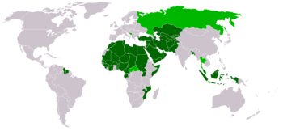
There are also growing Muslim minorities living in other non-Muslim States:
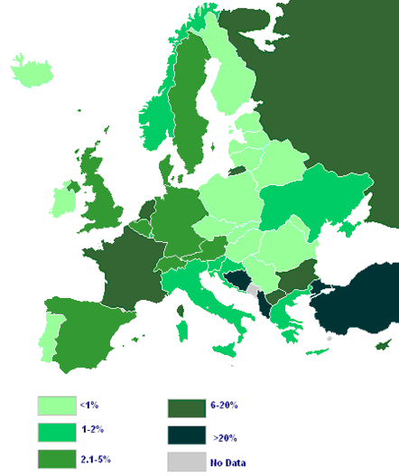

Importance of religion in the Muslim countries
We must divide the Muslim world in two categories: Arab countries and non-Arab countries:
There are 22 Arab countries which constitute the League of the Arab States.
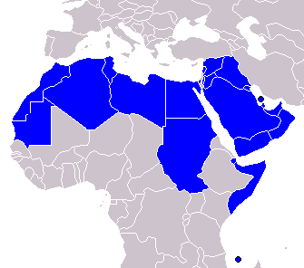
Lebanon excepted, the constitutions of the Arab countries indicate that Islam is the religion of state and/or Islamic law, the main source of law.
I give you two examples:
Egypt:
Article 2 - Islam is the religion of the state, and the Arabic language is its official language. The principles of Islamic law are the chief source of legislation.
Morocco 2011:
Article 3 - Islam is the religion of the State, which guarantees to all free practice of the cults.
Yemen
Article 2 - Islam is the religion of the state, and Arabic is its official language.
Article 3 - Islamic Shari'ah is the source of all legislation.
Besides the Arab countries, there are 35 non-Arab countries
Afghanistan Albania* Azerbaijan*
Bangladesh Benin* Brunei
Burkina Faso* Cameroon* Ivory Coast*
Gabon* Gambia* Guinea*
Guinea Bissau* Guyana* Indonesia
Iran Kazakhstan* Kirghizstan*
Malaysia Maldives Mali*
Mozambique* Niger* Nigeria*
Uganda* Uzbekistan* Pakistan
Senegal Sierra Leone Suriname
Tajikistan* Chad* Togo*
Turkmenistan* Turkey*
Among the 35 non-Arab countries, 24 countries (with *) mention secularism of the state in their constitution in one form or another.
The Arab world, although numerically a minority, constitutes the center of Islam for historical, linguistic and cultural reasons.

Part 1. What are the reasons behind the problems?
Islamic concept of human rights differs from Western concept of these rights because Muslims and the West have different concepts of the law itself. After explaining these two concepts and their impact on human rights, I will show the remedies proposed by liberal Muslims and those proposed in the West. These remedies prove that without fundamentally changing the Islamic religion itself, there is no progress in the field of human rights.
When a British driver goes to France, he drives on the right side without complaining.

When Malian family goes to France, it practices female circumcision although forbidden.

In France, burqa is forbidden, nevertheless, some Muslim women continue wearing it.
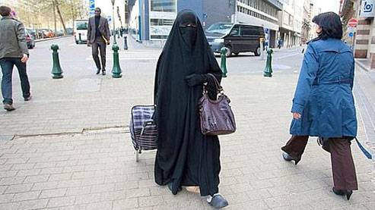
Why the English driver has no problem respecting French law, while some Muslims do not respect it? The answer is very easy: they have a different concept of law. In fact, we can say that there are three concepts of law: dictatorial, democratic and revealed.

Three concepts of law
The democratic law
According to this concept, people decide its law and change it, according to their interests and tastes… as they do with the cheese.

The dictatorial law
In this system, law is done by a dictator. Either you obey or he cuts off your head.

The revealed law
We find this concept of law among the Jews and Muslims. Let us now compare between the Jewish, the Christian and the Islamic concept of law
Jewish concept of law
We read in the Bible:
Everything that I command you, you shall be careful to do; you shall not add to it or take from it (Deuteronomy 13:1).
This shall be a perpetual statute for you and your descendants wherever you dwell (Leviticus 23:14).
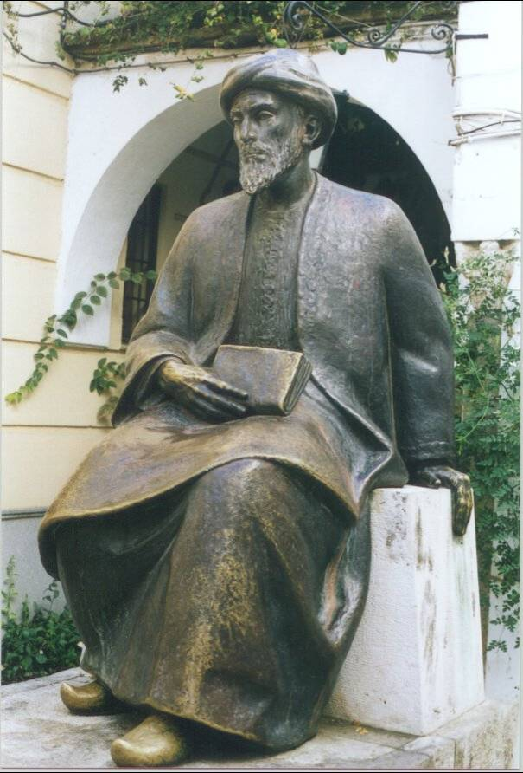
Quoting these verses, Maimonides (d. 1204) writes: "It is clearly stated in the Torah that it contains the Law which stands for ever, that may not be changed, and nothing may be taken from it or added to it". According to Maimonides, if one pretends the opposite, "he shall die by hanging".
Christian concept of law
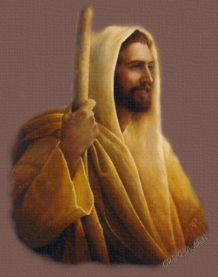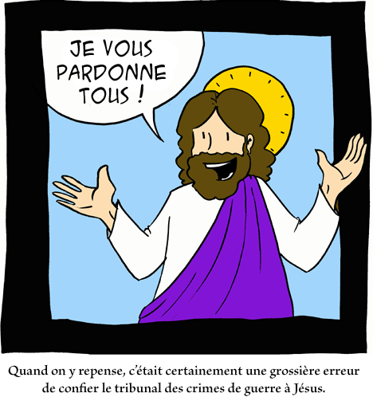
Jesus was not a jurist; he has never practiced a political function. He was a hippy: "Foxes have dens and the birds in the sky have nests, but the Son of Man has no place to lay his head" (Matthew 8:20).
- He refused the stoning against the adulterant woman (John 8:4-11)
- He refused to divide the succession between the two brothers (Luke 12:13-15).
- He abolished the law of retaliation (Matthew 5:38-39).
Because of the absence of legal norms in a sufficient number in the Gospels and the writings of the apostles, the Roman Empire after its Christianization kept following the Roman law. The jurist Gaius (d. v. 180) defines the law as being "what the people prescribes and establishes" (Lex est quod populus iubet atque constituit) (Gaius: Institutes, I.3). The modern democratic system is based on this concept of the law.
Islamic concept of law
Muslims have the same concept of law as the Jews. Islam means submission to God's will as expressed in the Koran and the Sunnah of Mohammed, the two principal sources of Islamic law:
It is not for a believer man or woman, when God and his messenger have decided on a matter, to claim freedom of choice in their matter: whoever disobeys God and his messenger is manifestly misguided (33:36).
In a case of adultery among Jews, Mohammed stoned the faulty persons as prescribed by the Bible, saying: "Those who do not judge by that which God descended, they are the perverse".
The Egyptian Muhammad Mitwalli Al-Sha'rawi (d. 1998) said:
If I were the person responsible for this country or the person in charge of applying God’s law, I would give a delay of one year to anyone who rejected Islam, granting him the right to say that he is no longer a Muslim. Then I would apply Islamic law to him by condemning him to death as an apostate.
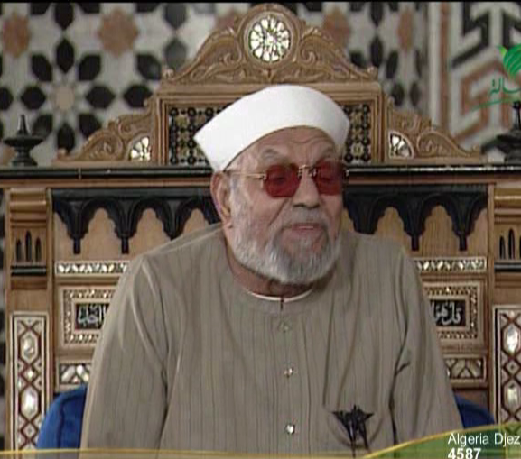
The obligation of implementing Islamic law, with the risk of fatal consequences in case of refusal, can cover an unlimited amount of material which can even be very controversial. To give an extreme example, Jad al-Haq, the Shaykh of Al-Azhar (d. 1996) had declared in a fatwa issued in 1994:
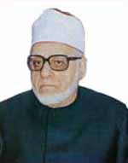
If a region, out of a common accord, ceased to practice male and female circumcision, the Head of State should declare war against it because circumcision is part of the rituals of Islam and its specifities. This means that male and female circumcision is obligatory.
He would like to wage war just to impose male and female circumcision! You may imagine to what extend such an ideology can be devastating.
For Muslim authors:
- If the question to regulate has been the subject of an authentic and clear text of the Koran or of the Sunnah, the nation has to obey to it; it could not establish a contrary rule.
- If the meaning can have various interpretations, the nation can try to deduce a solution starting from the comprehension of the text, by preferring an interpretation to another.
- In the absence of text, the nation is free to establish the norm which is appropriate to it, if this norm respects the spirit of Islamic law and its general rules and that it is not contrary to another Islamic norm.
This concept of law originates from the fact that Muslims do not have trust in human reasoning, and therefore they refer to God. The problem is that God is not accessible with our human means.

Where do Muslims find God's will?
The Koran, God's word according to Muslims, says:
O you who believed! Obey God, and obey the messenger and those charged with authority among you (4:59).
The Islamic law has two principal sources: the Koran and the Sunnah (tradition) of Muhammad.
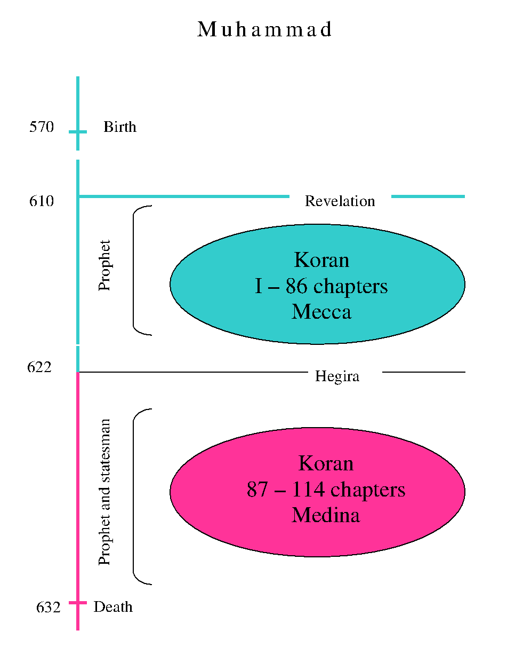
The Sunnah
Muslims grant a particular attention to six collections.
- Collection of Al-Bukhari (d. 870). The most important work after the Koran, it has more than 300 exegeses. It contains 9'082 narrations.
- Collection of Muslim (d. 874). It contains 7'563 narrations.
- Collection of Abu-Da'ud (d. 888). It contains 5'274 narrations.
- Collection of Al-Tirmidhi (d. 892). It contains 3'956 narrations.
- Collection of Al-Nasa'i (d. 915). It contains 5'761 narrations.
- Collection of Ibn-Majah (d. 886). It contains 4'341 narrations.

System of personality of law
Concerning non-Muslim monotheists living in Muslim countries, except Arabia, the Koran foresees the maintenance of their laws in certain fields, but with restrictions, particularly in the field of marriage and succession.
Unfortunate are the apostates and the polytheists! Non-Muslims in Arabia have no right to stay there or to practice their religion.

Application of Islamic law in the time and the space
A Muslim is obliged, in virtue of his faith, to apply Islamic law anywhere he lives. That is the ideal, which is in contrast to reality. This is why we have conflicts between fundamentalists and Muslim regimes. In fact, the juridical system of Muslim Countries is composed:
- mainly from laws inspired by Western law;
- from Muslim norms in the field of the personal statute and, for certain, of the penal law (as it is the case in Saudi Arabia);
- from the laws and sometimes the courts of the religious communities in the field of personal statute.
But Islamic law influences numerous fields:
- sexual ethics
- clothing
- alimentary prohibitions
- restrictions in the field of art and liberty of expression, economics (interests on debts and banking activity, bets and games), insurances, religious tax, etc.
- job of the woman and her participation in political life
- physical integrity (male and female circumcision), etc.

Part 2. What are the problems?

Problems inside the Arab and Islamic countries

If we take the Universal Declaration of Human Rights, we notice that it is proclaimed by the General Assembly. No mention of God in it. He was intentionally excluded.
There are several declarations issued in the Arab and Muslim countries. We would like here to mention one of them, the Universal Islamic Declaration of Human Rights promulgated in 1981. This declaration affirmed repeatedly that human rights are founded on divine will. The first passage of the preamble states, “For fourteen centuries, Islam defined, by divine law, human rights, in their entirety as well as in their implications”. The preamble adds:
- Strong of our faith in the fact that God is the sovereign master of all things in this immediate life as in the ultimate life...
- Strong of our conviction that human intelligence is incapable to elaborate a better way in view to assure service of life without God’s guidance and revelation:
We, Muslims, ... we proclaim this Declaration of Human Rights made in the name of Islam, as one can understand them of the very noble Quran and the very pure prophetic Tradition (Sunnah).
This declaration has been published in Arabic, English and French versions, but the last two versions were different from the Arabic original. In this declaration, human rights are accepted only as long as they are not in contradiction with Islamic law, and interpretation of these rights should be done in the light of Islamic law. We find the same problem with the other Arab and Islamic declaration of human rights which do not contradict existing laws in these countries. While signing the UN documents on human rights, these Arab and Islamic countries mentioned that they do not accept norms which violate Islamic norms.
This concept of human rights generates norms which are contrary to the international standards as accepted in the United Nations:
- Inequality between man and woman in the field of marriage: polygamy, repudiation, and in dress norms. These two cartoons explain the fear of some muslims
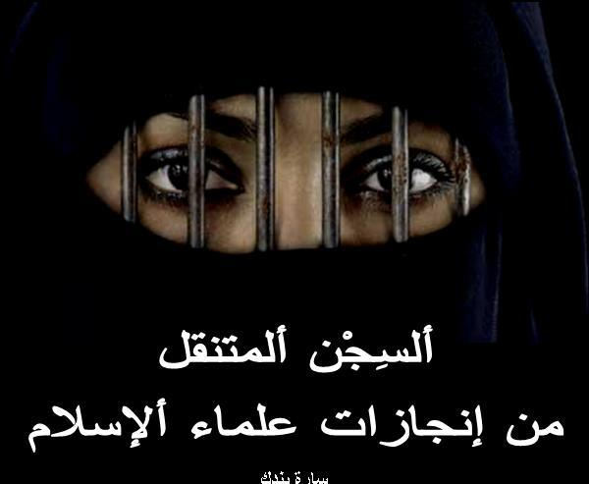
Ambulatroy prisons as invented by religious scholars
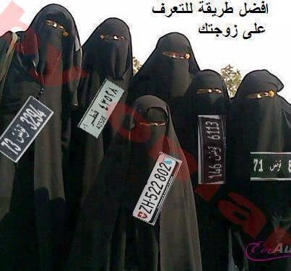
Best way to recognize your wife
- Inequality between Muslims and non-Muslims in the field of marriage: a Muslim man can marry a monotheist woman, but a monotheist man cannot marry a Muslim woman; prohibition of marriage between Muslims and non-monotheists.
- Inequality in the field of succession and testimony: the woman generally receives half of what the man receives, and the testimony of two women is equivalent to the testimony of one man.
- Inequality in the field of religious liberty: it is permitted to convert to Islam, but a Muslim who leaves Islam is punished with the death penalty and/or deprived of his civil rights (interdiction to get married or to inherit, etc.). A man married to a Muslim or non-Muslim woman cannot choose the religion of his children who must obligatorily be Muslims. In Saudi Arabia it is prohibited to practice any other religion than Islam or to build churches, although this country builds many mosques in the West. In other countries as Egypt, the situation of non-Muslims is getting worse and worse. If you like to repair even a WC of a church you need the permission of the President of the Republic. Many churches have been attacked by Muslims. Last week the Moroccan press published a fatwa of the supreme religious council presided by the king saying that every muslim who leaves islam should be killed. This fatwa provoked a huge reaction and two days ago a sheikh said in a mosque in front of the king that Islam guarantees religious freedom. But one should know that according to Islamic law there are two sanctions: civil sanctions (an apostate cannot get married; he is deprived of this children and inheritance) and penal sanctions. To what extend Morocco will guarantee religious freedom in both fields? Nobody knows.
- Severity of the penal norms: death penalty, stoning, amputation of a limb, whipping.
We should here mention that the Arab League has issued daft laws which should be regarded as models for the laws of the Arab countries. We find in them the same violations of human rights which exist in the laws of the Arab and Islamic countries. Even worse. For example, the criminal code proposed by the Arab league foresees stoning for adultery, cutting the hand of the thief and killing the apostate, norms which are not mentioned in many Arab laws.
After the recent events in some Arab countries, fundamentalist Muslims expressed clearly their will to apply Islamic law.
Even before these events, the fundamentalists used many methods to force the application of Islamic law:
- Proposals of law drafts
- Contestation of the constitutionality of the existing laws
- Call for civil disobedience by the judges
- Trial and physical threat against the opponents
- Military revolt, as what happened in Algeria with thousands of murders.
This situation create a climate of fear:
- among the local regimes
- among Muslim liberal intellectuals
- among women
- among non-Muslim minorities whose situation becomes worse with attacks against churches and kidnapping Christian girls.
This fear is justified by
- the implicit or explicit intentions of the Islamic movements, through the models of Constitution and laws already prepared;
- the experiences in fundamentalist Countries (as Saudi Arabia), or those who became fundamentalist (as Afghanistan, Iran, etc.).
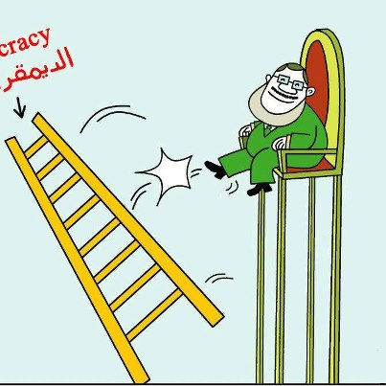
The question is to what extend Muslim fundamentalists will apply Islamic Law? Let us take some fields:

Art
There is a risk that what happened in Afghanistan with the destruction of Buddha's statutes will be repeated in Egypt. Al-Qaradawi, the main ideologist of the Muslim brothers, wrote many years ago that statutes are forbidden in Islam, and his book is available on his website in English and in Arabic. And now some Muslim leaders in Egypt would like to put into application this prohibition.
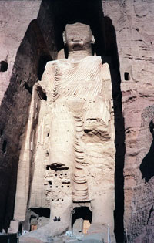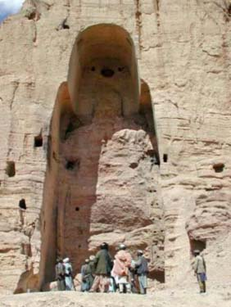
Buddha before and after 2001
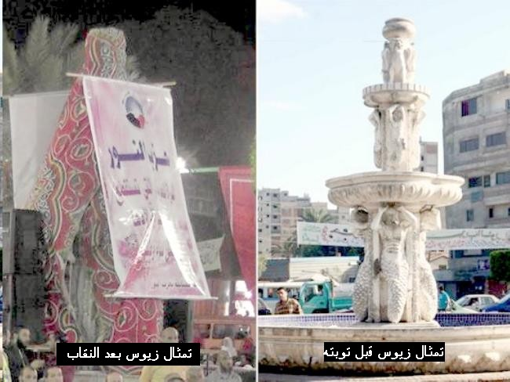

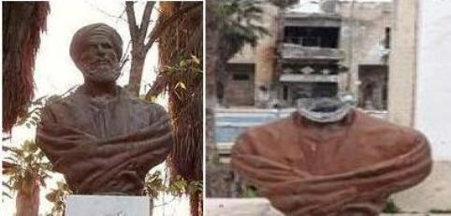
Abu-al-Alaa Al-Ma’arri decapitated in Syria
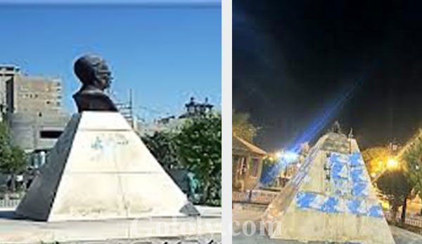
Taha Hussain decapitated in Egypt
Circumcision
One of the Egyptian clerics went to Tunisia where he promoted female genital mutilation, although Tunisia does not have such a practice which prevails in Egypt (95% of Egyptian women are excised).
Death penalty and stoning
The abolition of death penalty in these countries is extremely difficult to obtain as the Koran itself prescribes this penalty. The reason behind these attitudes is that Islamic norms are of divine origin, and human being has no right to establish a law which abolishes them. When Hani Ramadan was asked on the Swiss television whether he condemns the stoning for adultery, he said that he cannot do that because God dictated this punishment as did the Bible.
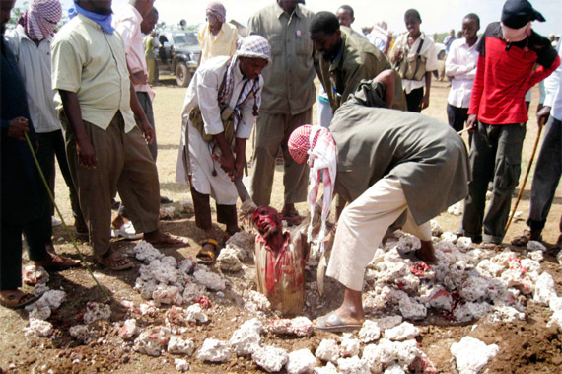
Slavery
Al-Mawdudi (d. 1979), the greatest Pakistani religious scholar, does not forbid slavery. Retorting to an author who denies slavery in Islam, he says: “Is the honorable author able to indicate only one Koranic norm which suppresses slavery in an absolute manner? The answer is no".
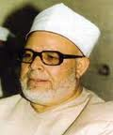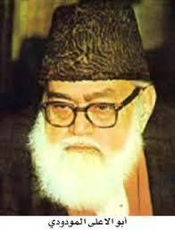
Sheikh and parliamentary Salah Abu-Isma'il (died 1990) defends the return of slavery for the captured women of the enemies. An Egyptian professor, Ph.D. in law from La Sorbonne, proposes an Islamic law that should replace the Conventions of Geneva, allowing slavery. There are videos on youtube where Muslims consider slavery in conformity with Islam, and do not object returning to slavery. In fact, slavery is an integral part of Islamic law; it was abolished by Islamic countries because Western countries obliged them to do so.

Problems inside Western countries
What happens in the Muslim countries has influence on Muslim minorities in the West.
Islamic law divides the world mainly in two parts: Dar al-islam (land of Islam) and Dar al-harb (land of war). Muslims should conquer all the world to impose Islamic rules. There can be a period of peace which should not be more than ten years, and only in case of superiority of the enemy. This is the classical concept of Islamic law.
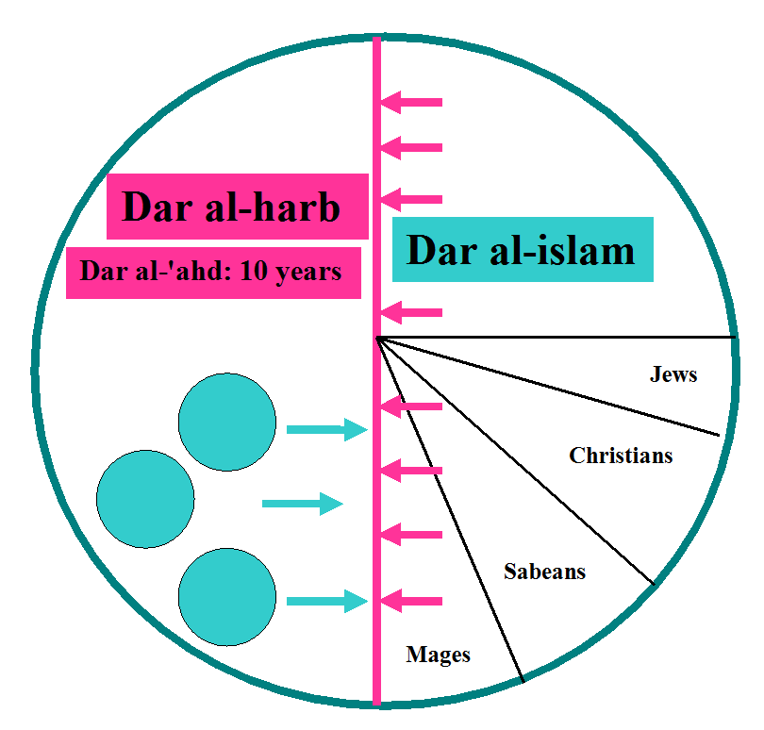
Every Muslim, living in Country of unbelief, must leave his Country to reach the Muslim community. This is why Sicily and Andalusia have been emptied from their Muslim inhabitants on request of the Muslim jurists.
- During the Western colonization, Muslim jurists discussed the question whether to leave or to remain?
- Post-colonial period: many Muslims emigrated to the colonizing Countries, but Muslim jurists continue saying that it is forbidden to stay in these countries, except in case of necessity (but then a Muslim must live according to the Islamic law and to convert non-Muslims). Some even say that Muslims should not opt for non-Muslim nationality.
Muslims’ claims in the West are growing
- Wearing veil in school.
- Halal butcheries.
- Separate cemeteries.
- Separation between men and women on the level of the hospital services.
- Creation of courts for Muslims.
- Etc….
There is now fear of the repetition of the case of Kosovo in France, in Belgium, in Germany, in England and elsewhere, putting in danger their territorial integrity, in conformity with the Islamic principle according to which Muslims must submit only to Muslim authority, to Islamic law and to Muslim judge. Islamic extremists have launched a poster campaign across the UK proclaiming areas where Shariah law enforcement zones have been set up. They ask autonomy for three regions:
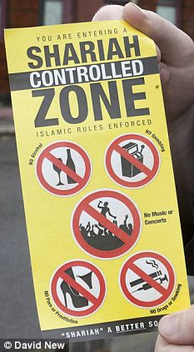

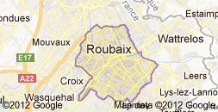
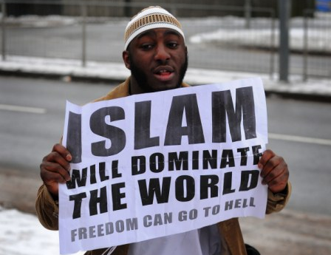
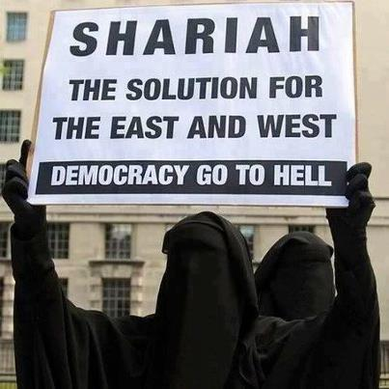

Part 3. What are the remedies?
We are moving ineluctably towards a generalized conflict between the Western secularized concept and the Judeo-Islamic concept of law. How can we solve this situation? Both Muslim and Western countries are urged to answer this question if they are not willing to find themselves confronted to a situation similar to Algeria (internal religious war) and ex-Yugoslavia (disintegration of the country on the basis of religion).

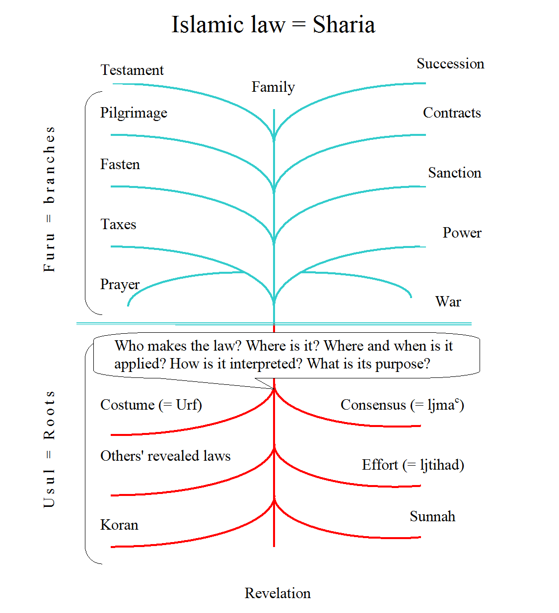
When a tree is sick, it is not sufficient to treat the leaves; it is necessary to take care of the roots. When a house threatens collapsing, it is not sufficient putting some nails; it is necessary to see the foundations. Similarly, it is not sufficient criticizing the violations of human rights; it is necessary to understand the cause of these violations.
Therefore the bases of the Islamic law must be treated, and not only its effects. Here are some methods proposed by liberal Muslims.

3.1. Remedies proposed by liberal Muslims

To cut the Koran in two
Some Muslim liberals think that the true Islam is represented in the chapters of Mecca while the chapters of Medina represent a political conjunctural Islam. They consider therefore that the first chapters of the Koran abrogates the seconds. So they empty the Koran of its juridical subsistence. The human beings find again so the freedom to legislate according to their temporal affairs without submitting to the norms of the Koran. The Sudanese thinker Mahmud Muhammad Taha has been hung January 18, 1985 because of this theory.
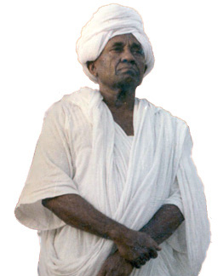

To keep the Koran and to throw out the Sunnah
The Sunnah (Mohammed's tradition) is the second source of Islamic law. It serves to interpret, to complete, and to abrogate some norms of the Koran. Some liberals think that they have only obligations toward the Koran, word of God, and they refuse the Sunnah, judged as human manufacture and unreliable, having been compiled longtime after the death of Mohammed.
This group, often called Koranists, tries by so doing to limit the effects of Islamic law. For example, the death penalty against the apostate and the stoning for adultery are not indicated in the Koran, but in the Sunnah. The followers of this group are defined as apostates by the Muslim religious authorities. One of them, Rashad Khalifa, has been murdered, in the United States in 1990, because of this theory. Among their leaders we mention Ahmed Subhi Mansour, now living in the United States, and Gamal Al-Banna, the youngest brother of Hassan Al-Banna.
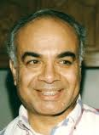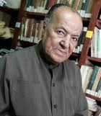

To distinguish between the Shari'ah and the Fiqh
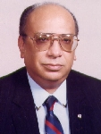
The two Arabic terms Shari'ah and Fiqh are indiscriminately used for designating Islamic law. But according to the Egyptian judge Muhammad Sa'id Al-'Ashmawi, the Shari'ah does not mean the "law" but "the way to be followed", as revealed by God in the Koran. The Fiqh covers all the writings of the jurists, based on the Koranic text: comments, opinions of the doctrine, fatwa, etc. These writings have been considered wrongly as forming the Shari'ah. The Koran warns not to follow any religious authority (9:31; 2:165; 3:64) or to grant the holiness to a norm which does not derive from the revealed text. Today Al-'Ashmawi lives isolated in his house, fearing to be murdered by the fundamentalist.

To consider Mohammed as the last prophet
For the Tunisian jurist Muhammad Charfi (d. June 2008), the Koranic norms concern only the period in which they have been established. They cannot be applied in every period and everywhere.
Muhammad Ahmad Khalaf-Allah goes further: according to him, by declaring that Mohammed is the last of the prophets (33:40), the Koran grants the liberty and the independence to the human reason to decide for the matters of this life, in conformity to the general interest. Muhammad is to be considered as the last baby bottle; after him, humanity does not need prophets or holy books.


To cut the umbilical cord
The Egyptian philosopher Zaki Najib Mahmud (died 1993), an adept of scientific positivism, believes that one should take from the Arab past or the Western present only what is useful to the Arab society. To judge what is useful and what is not. This attitude supposes the dismissal of all holiness from the past.
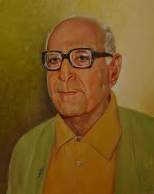
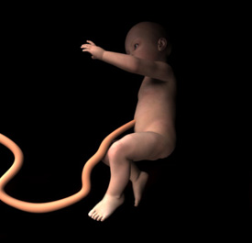

What if God were in Rimini to tan?
Husayn Fawzi (d. 1988) is a free Egyptian thinker, scientist, author of numerous works. He has occupied numerous academic and cultural functions. He introduced classical music to the Radio of Cairo. For him, "God created the world in six days and took a rest the 7th day, and he is still resting. Therefore, God could not send the prophets who came after the 6th day".


What if we call God?
During the International congress on the Egyptian civil Code, organized from 14 to 16 April 1998: the Ministry of justice says that it cannot abolish the laws of personal statute (which discriminate women and non-Muslims), because they are revealed laws. Only another revelation can repeal a preceding revelation.


What do fundamentalists think about liberal Muslims?
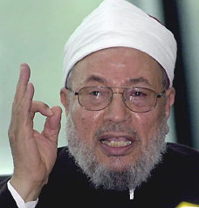
Liberal Muslims would like to change the religious norms which violate human rights. This means that they would like to create new norms. Their position is condemned by Al-Qaradawi, qualified as moderate. He says:
A secular [Muslim] who rejects the principle of applying Islamic law has from Islam only the name. He is undoubtedly an apostate. He must be invited to repent, exposing him, with evidences, the points on which he doubts. If he doesn't repent, he is considered as apostate, deprived from his membership in Islam - or so to say from his "Muslim nationality", he is separated from his wife and children, and one applies to him the norms concerning recalcitrant apostates, in this life and after his death [which means that he should be buried like a dog in a hole].

3.2. Remedies proposed by the West

Interreligious dialogue
It serves only to travel and to eat.
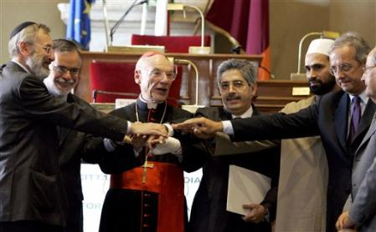

To prepare experts and imams
Europe is too late. Few universities teach Islamic law. Muslims generally are normal persons who look for work and a peaceful life. The problem is their religious authorities. If the Western countries take imams from Saudi Arabia, they will risk transforming their countries according to the Saudi model. Therefore, it is important to educate imams in the West in conformity with the Western norms and principles.

To redefine the revelation
For Hebrews, Muslims and Christians, God has gone to menopause. He has produced prophets for a determined period, and then nothing more.

We should absolve God from this serious hindrance. As first footstep, I suggest that the West starts to teach in its Faculties of Theology and in its schools:
- that "revelation", understood as definitive and valid text forever is a wrong and dangerous concept for humanity;
- that "revelation" is not the word of God to man but the word of man on God, made of human imperfection;
- that everyone has a mission to fulfill on this Earth, that the divine spirit has not stopped blowing, and that God has not gone to menopause, incapable to give life to other prophets.
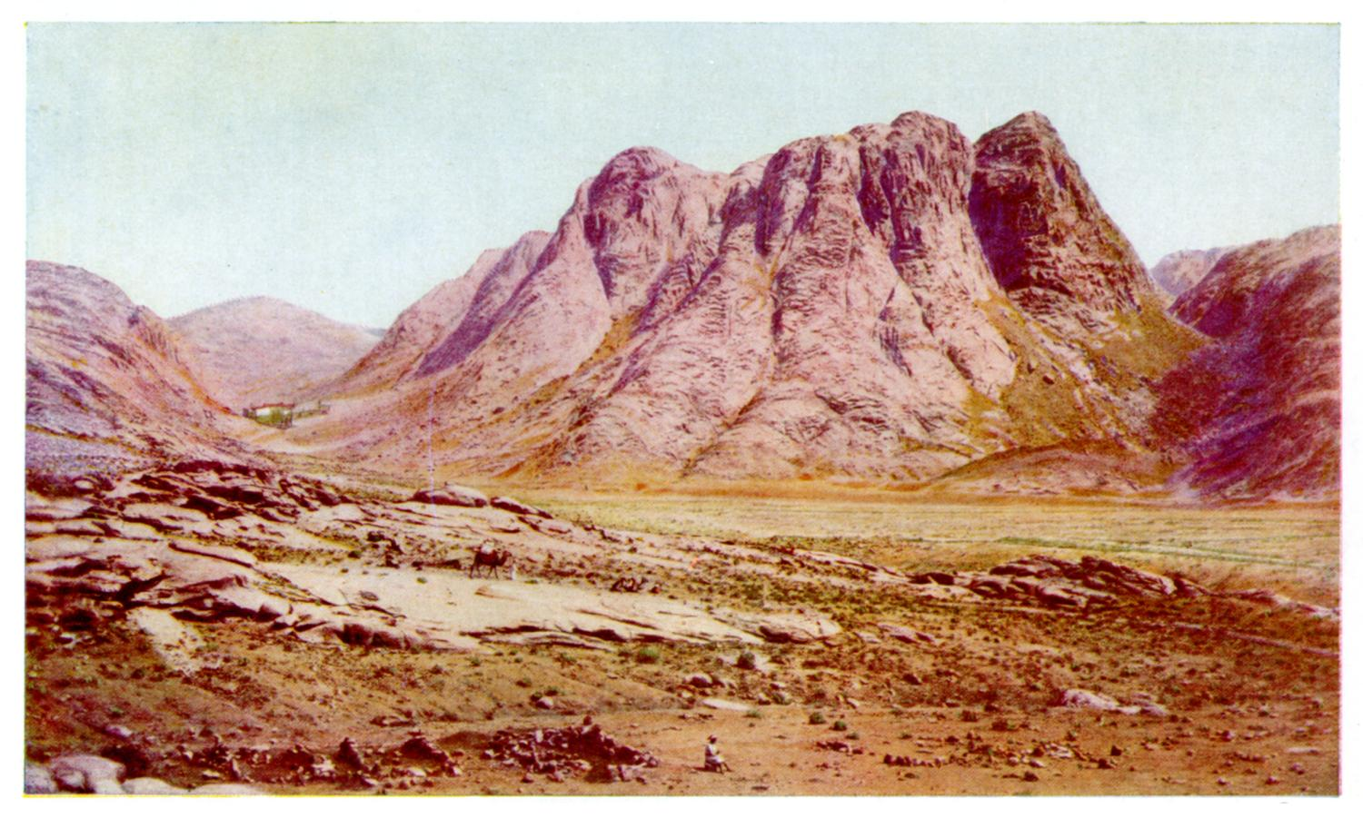
Mount Sinai (2285 meters) place of the revelation to the prophet Moses

Mount Hira (642 meters) place of the revelation to the prophet Mahomet

Mount Rosa in Switzerland (4633 meters) where no revelation descended. Does the cold weather prevent the revelation?
According to Benny Shannon, a professor at the Hebrew University in Jerusalem, High on Mount Sinai, Moses was on psychedelic drugs when he heard God deliver the Ten Commandments. Such mind-altering substances formed an integral part of the religious rites of Israelites in biblical times.

To be firm and coherent
Do not preach water and drink wine on the political plan: to be correct. At the same time: do not accept "the politics of the salami".


Mixed marriages
Mixed marriages are one of the major problems. Muslim men get married with non-Muslim women and impose their religion to their children, but they do not allow non-Muslim men to marry a Muslim woman. This is a violation of the constitution. Western countries must find a solution to this problem. One of the conditions of nationality, immigration and political asylum should be the acceptance of the respect of the constitutional principle in this field.

Religious liberty: the right to change religion
Muslims invite people to become Muslims, but do not allow the conversion of Muslims to other religions. This is also a violation of the constitution. We know the case of Magdi Allam which provoked a great debate. Here again, West countries should not give nationality, immigration or political asylum to those who do not accept the freedom of religion.
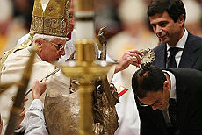
"I am not afraid of the death; I am convinced that we must go ahead. All of us must continue on the road of the truth, of the liberty and of the affirmation of the life.
In Italy, there are thousands of converts to Islam that serenely live their new faith. However, there are also thousands of Muslim converts to Christianity forced to hide their new faith for fear of being murdered by Islamic extremists that nest among us. If we won't be able, here in Italy, in the crib of the Catholicism, in our home, to guarantee to everybody the full religious liberty, how could we be credible when we report the violation of such liberty in the world elsewhere?"

Integration or disintegration… up to the death
Separate cemeteries are the sign of racism manifested even after the death. Western countries should refuse such cemeteries if they like all groups to live in harmony during their life, whatever be their religion.


Naturalization and immigration in the respect of the laws
The Convention relating to the Status of Refugees July 28, 1951 says:
Art. 2 - Every refugee has duties to the country in which he finds himself, which require in particular that he conform to its laws and regulations as well as to measures taken for the maintenance of public order.
Western countries should refuse nationality, immigration or political asylum to any person who does not accept their principles.

Christian of Palestinian origin. Swiss citizen. Graduate and Doctor in law (Fribourg). Graduated in political sciences (Geneva). Habilitated to direct researches (HDR, Bordeaux 3). Professor of universities (CNU-France). Responsible for Arab and Islamic Law at the Swiss Institute of Comparative Law (1980-2009). Visiting professor in different French, Italian and Swiss universities. Director of the Centre of Arab and Islamic Law. Author of around thirty books and many articles on Arab and Islamic Law. See his website: www.sami-aldeeb.com and his curriculum vitae.

