مركز القانون العربي والإسلامي
Centre de droit arabe et musulman

Centre of Arab and Islamic Law
Centro di diritto arabo e musulmano
Sami Aldeeb, dr en droit
Ochettaz 17
Ch-1025 St-Sulpice
Tél. fixe: 0041[0]21 6916585
Tél. portable: 0041[0]78 9246196
Site: www.sami-aldeeb.com
Email: sami.aldeeb@yahoo.fr

Interests and the banking system in Jewish, Christian and Muslim law
between ethics and language abuse
by
Sami Aldeeb

1)
2) An intellectual or researcher must be as a sentinel and see farer than others. Otherwise he is useless.
3) He must surprise and irritate his audience; otherwise he is just repeating what others already said.
4) No social, scientific or technical progress whatsoever without critics

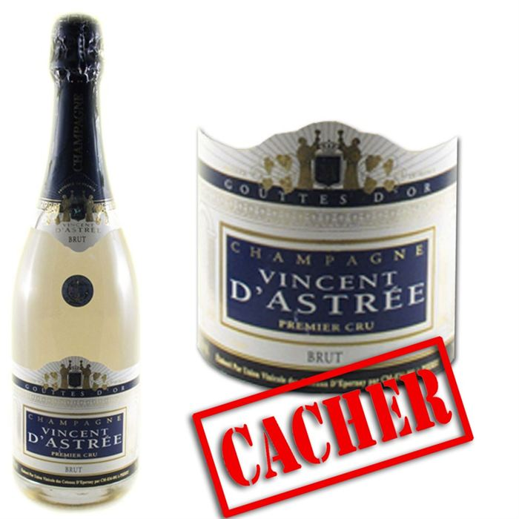

Colossal economic stakes
This issue affects vast sums. The debate concerns primarily Islamic finance but we will se it in a comparative perspective to see the link between the Jewish, Christian and Muslim standards.
Some indicative figures:
- Today, Islamic banks drain funds estimated to 1000 billion dollars in 2010
- 40% to 50% of the savings of the Muslims will be managed by Islamic finance within 8 to 10 years, compared to 10% to 2007.
- But Islamic banks represent not more than 4% of global banking.
- 20% growth per year.

Different opinions

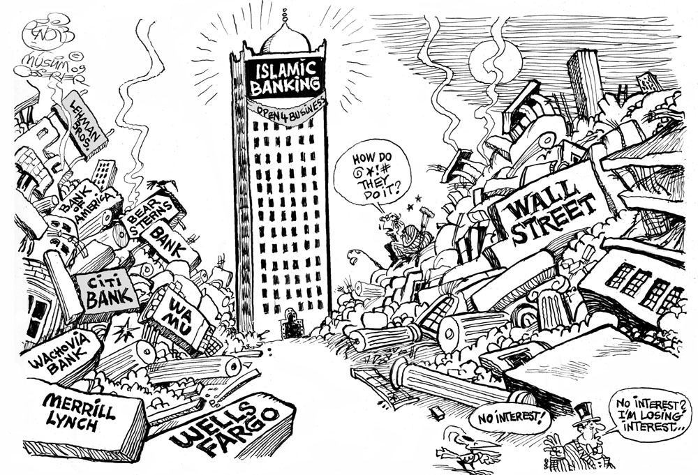
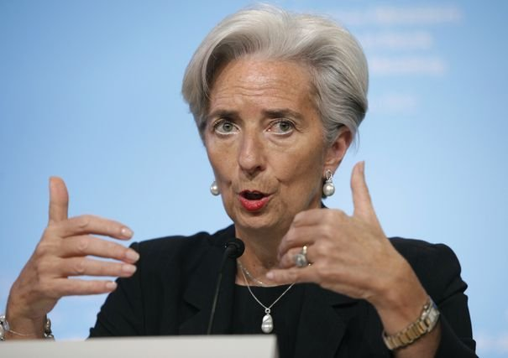
Christine Lagarde 2008 praised Islamic finance
Lebanese Sheikh Al-Alayli (died in 1996) considers that the dispute concerning the interests is a deception on the words (Khida Pass ' al-alfaz)
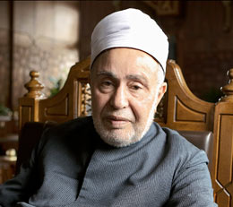
Muhammad Sayyid Tantawi (deceased in 2010), Grand Egyptian Mufti and grand Imam of Azhar: gains by Muslim banks and the interest distributed by conventional banks differ only in name
Mustafa Kamal Al-Mahdawi, Libyan justice retired, calls Islamic banks of the thieves.

Rapports économiques réglées par les normes religieuses
In any economic system there are abuses, and the legislator tries to reduce such an abuse

A) Interests among the Jews
Jewish law has two main sources: the Bible and the Talmud which is a commentary on the Mishnah
In the antiquity, the creditor had exorbitant power over the debtor. the second book of Kings relates a tragic episode: on the death of the debtor, the creditor seized his children and enslaved them because of the debts of their father (2 R 4:1-7).
This is in order to react against this situation that biblical legislation repeatedly intervened to prohibit the imposition of interest Israelites. We give here the most important passages:
You must not charge interest on a loan to your fellow Israelite, whether on money, food, or anything else that has been loaned with interest. You may lend with interest to a foreigner, but not to your fellow Israelite; if you keep this command the Lord your God will bless you in all you undertake in the land you are about to enter to possess. (Deuteronomy 23:20-21).
If you lend money to any of my people who are needy among you, do not be like a moneylender to him; do not charge him interest (ex. 22:24).
If your brother becomes impoverished and is indebted to you, you must support him; he must live with you like a foreign resident. Do not take interest or profit from him, but you must fear your God and your brother must live with you. You must not lend him your money at interest and you must not sell him food for profit. (Leviticus 25: 35 - 37).
This prohibition applies to all loans, regardless of the rate of interest
It makes no distinction between the loan made to a wealthy and made a poor.
According to the Talmud, violate the prohibition of interest the creditor who lends money against interest, the debtor who agrees to pay interest, the witness and the notary who drafted the contract. The ban covers the interest for the loan in money, but also the interest for the loan in kind, or even for a service.

Ways to circumvent the ban
Jeish law prohibits partnership in which a creditor finances a deal in which he would take part in the benefit while the debtor would assume only the loss.
If however the creditor and the debtor profit and loss, such an agreement is considered valid
Today, to validate religiously a loan with interest between Jews, you have just to add to the contract a clause indicating that the loan is done as a partnership.
It is permitted to lend money to a non-Jew, which in turn lends the money to a Jew, or instruct an agent to borrow money, the two operations being associated with a clause fixing the rate of interest.
It is permissible to lend 100 units of money to a businessman by indicating in the contract that the gain realized by the latter will be paid to the creditor against payment of a salary to the businessman for his work.
The law enables a Jew to borrow money from a non Jew against interest where there is no other way to get money.

No penalty
The Bible contains none, but simply a divine blessing, as in Deuteronomy 23:21.
Ezekiel classify among serious offences:
[The one] who oppresses the poor and needy, commits robbery, does not restore the pledge, lifts up his eyes to the idols, commits abomination, lends at interest, and takes profit; shall he then live? He shall not live. He has done all these abominations; he shall surely die; his blood shall be upon himself (Ezekiel 18:11-13).
Here, too, this sanction is of divine order.
But rabbinical courts seem to have exercised the power to penalize the creditor by refusing to respond to his claim for his capital. They also reject the testimony and the oath of money lenders.

B) Interest among Christians

Jesus is not a lawmaker
New Testament is moralistic text. It contains very little legal norms, including just a passage concerning the loan, interpreted as a prohibition of interest, without distinction between Jews and non-Jews, regardless of the rate of interest:
“If you love those who love you, what benefit is that to you? For even sinners love those who love them. And if you do good to those who do good to you, what benefit is that to you? For even sinners do the same. And if you lend to those from whom you expect to receive, what credit is that to you? Even sinners lend to sinners, to get back the same amount. But love your enemies, and do good, and lend, expecting nothing in return, and your reward will be great, and you will be sons of the Most High, for he is kind to the ungrateful and the evil. Be merciful, even as your Father is merciful. (Luke 6:32-36).

Position of the Church
As we will see shortly with the social credit system, the Church encourages the free gift.
- creation of Mount of piety which lent interest-free or at a low rate (less than 5%) was going in this direction, born in 1462 originated in Italy and was developed in cities as a reform against money lending.
- Ten years later, the Monte dei Paschi di Siena was established in Siena with the same objective.
Aristotle: The most hated sort, and with the greatest reason, is usury, which makes a gain out of money itself, and not from the natural object of it. For money was intended to be used in exchange, but not to increase at interest. And this term interest, which means the birth of money from money, is applied to the breeding of money because the offspring resembles the parent. Wherefore of any modes of getting wealth this is the most unnatural.
Saint Ambrose died in 397: "What is lending at interest, if not killing a man?"
St. John Chrysostom died in 407: "Nothing is more shameful nor cruel than usury."
Saint Leon (around 450): "usurious profit is the death of the soul."

Ways to circumvent the ban
Saint Thomas Aquinas died in 1274: "He who loans a sum of money to one sailing or going to market, since he has assumed upon himself a risk, is not to be considered a usurer who will receive something beyond his lot. He also who gives ten solidi (a monetary unit), so that at another time just as many measures of grain, wine and oil may be paid back to him, and although these are worth more at the present time, it is probably doubtful whether at the time of payment, they will be worth more or less, for this reason, should not be considered a usurer.
In 1311, at the Council of Vienne, Pope Clement V considered as void any legislation in favor of usury, and 'if someone falls into this error to dare boldly saying that it is not a sin to do usury, we ordain that he shall be punished as a heretic and we order all the ordinaries and inquisitors to proceed vigorously against all those who are suspected of this heresy'.
The encyclical Vix pervenit, addressed on 1 November 1745 by Pope Benedict XIV to the Bishops of Italy, is the latest doctrinal position of the Catholic Magisterium about interest. Against the Liberal opinion of a patrician of Verona, the Pope reaffirms the traditional doctrine of the Church. First, it is not allowed to receive compensatory interest under a loan agreement. Secondly, it is permissible to receive compensatory interest under extrinsic title to the loan agreement (for example damage suffered by the lender). Thirdly, it is allowed to get earnings under contracts other than the loan. This is particularly the case of the partnership agreement, which allows to make a trade or lawful business by entrusting his money to others to make a legitimate profit.
The Catechism of the Catholic Church published by Jean-Paul II in 1992, mentions the prohibition of the loan at interest among the legal measures "from the Old Testament" to help to the poor (para. 2449) and denounced "abusive if not usurious financial systems" between nations (para. 2438) as well as "Those whose usurious and avaricious dealings lead to the hunger and death of their brethren in the human family indirectly commit homicide, which is imputable to them" (by. 2269).

Position of Calvin
Calvin (1509-1564) was the first theologian of the modern era to morally legitimize the practice of lending at interest.
Up to the time of Reformation, it was forbidden to charge interest in Europe, not least due to the prohibition of taking interests in the Old Testament (Exodus 22, 25; Deuteronomy 23, 20f.). However, this prohibition was actually eroded by many exceptions. The renowned Reformer John Calvin of Geneva (1509-64) got to a fundamentally positive attitude as to the charging of interests. He justified his attitude by maintaining that the intention of the biblical prohibition was to protect one’s neighbor and especially the poor and weak. Hence, also in matters of charging interest servicing one’s neighbor was vital: He was led by the 8th commandment “Do not steal” (Ex. 20,15) and by the Golden Rule “Do for others what you want them to do for you!” (Mt. 7, 12). Thus, he developed the seven criteria (“exceptions” in French; “restrictions” in English – a kind of qualifying exception) as a guideline to charging interest:
1) you are not allowed to charge interest from the poor and that nobody may be forced to pay interest when being in a plight or visited with misfortune.
2) anybody who lends money should neither be so anxious about profit that he neglects his duties, nor should he – by safely investing his money – disrespect his poor brothers.
3) one should not allow anything to interfere that would not correspond to natural understanding (what is naturally just and proper). And if the matter is checked according the rules of Christ, i.e. what you want others to do for you etc., then it should be considered as generally valid.
4) whoever borrows should profit as much or even more from the borrowed money (than the creditor).
5) we should neither judge according the usual and traditional customs (concerning the charging of interests) what we are allowed to do, nor measure injustices against what is right and proper; much rather should we draw our behavior from the word of God.
6) we should not only consider the personal benefit of those with whom we have to deal with, but also should we take into account what may be in the public interest and serve the community as a whole. Because it is manifest that the interest paid by the merchant equals a public attainment. Therefore, great care has to be taken to make the agreement serve the public good more than it may damage it.
7) one should not overstep the limits set by the local or regional laws, although this is not always enough, as they often allow what cannot be amended or restricted by law. Hence, one needs to give preference to what is just and proper under the circumstances and restrict whatever may go beyond.”

(C)) interest among Muslims

Position of the Quran and hadith
Like the Gospel, and contrary to the Old Testament, the Quran prohibits interest for debt without discrimination of groups. Muslim lawyers distinguish an evolution of its norms in this area.
The first step: exhortation to give alms instead of wear
Hence, give his due to the near of kin, as well as to the needy and the wayfarer; this is best for all who seek God’s countenance: for it is they, they that shall attain to a happy state! And [remember:] whatever you may give out in usury so that it might increase through [other] people’s possessions will bring [you] no increase in the sight of God whereas all that you give out in charity, seeking God’s countenance, [will be blessed by Him:] for it is they, they [who thus seek His countenance] that shall have their recompense multiplied! (30: 38 - 39).
The second step: warning to Muslims, pointing to the example of the Jews:
So, then, for the wickedness committed by those who followed the Jewish faith did We deny unto them certain of the good things of life which [aforetime] had been allowed to them; and [We did this] for their having so often turned away from the path of God, and [for] their taking usury although it had been forbidden to them, and their wrongful devouring of other people's possessions. And for those from among them who [continue to] deny the truth We have readied grievous suffering (4: 160 - 161).
The third stage: partial ban which concerns only the anatocism, joining the interests to the capital to form a new capital bearing interest:
O YOU who have attained to faith! Do not gorge yourselves on usury, doubling and re-doubling it - but remain conscious of God, so that you might attain to a happy state; and beware of the fire which awaits those who deny the truth! (3:130-131).
The fourth step bans categorically everything that exceeds the capital, requesting the rebate of interest already planned, a reprieve for debtors in difficulties and an admonition to give up the debt by charity, foreseeing the war against recalcitrant:
THOSE who gorge themselves on usury behave but as he might behave whom Satan has confounded with his touch; for they say, "Buying and selling is but a kind of usury" - the while God has made buying and selling lawful and usury unlawful. Hence, whoever becomes aware of his Sustainer's admonition, and thereupon desists [from usury], may keep his past gains, and it will be for God to judge him; but as for those who return to it -they are destined for the fire, therein to abide. O you who have attained to faith! Remain conscious of God. and give up all outstanding gains from usury, if you are [truly] believers; for if you do it not, then know that you are at war with God and His Apostle. But if you repent, then you shall be entitled to [the return of] your principal: you will do no wrong, and neither will you be wronged. If, however, [the debtor] is in straitened circumstances, [grant him] a delay until a time of ease; and it would be for your own good -if you but knew it -to remit [the debt entirely] by way of charity. And be conscious of the Day on which you shall be brought back unto God, whereupon every human being shall be repaid in full for what he has earned, and none shall be wronged. (2:275 - 281) .

Ways to circumvent the ban
In Classical Muslim law, lending at interest is prohibited. The term Arabic riba, which means increase, includes any benefit, without counterpart, stipulated by the Contracting Parties during a loan without making any distinction between the interest and usury, which today means the excessive interest.
- What is prohibited is the fixed interest in advance.
- The formula for alternatives to the fixed interest rate is the participation in the profits and sharing losses.
- It is not forbidden that a debtor voluntarily pay a surplus to the creditor. A companion had made a loan to Muhammad. The latter gave him more that he had lent him. And after the hadeeth: "the best of you is the one that best repays his debt".
- Muslim law allows to borrow at interest in case of necessity. But the state of necessity is strictly defined by Muhammad who says: "the state of necessity is when from morning to evening you not find enough to eat".
- Double sale, called bay' al-'inan: I lend you money without interest and I sell you an object at a very high price.
- Contract of salam : olives

No penalty
Usury is classified among the great sins. Sanctions for the violation of the prohibition of usury in the Quran are the following:
-The loan sharks are fought by God and his Prophet.
-The loan sharks will be agitated by the daemon.
-Their fortune will be annihilated.
-The loan sharks will be doomed to hell.
Three syaings of Muhammad indicate the punishments that will be imposed on the loan sharks:
During my night journey, I have seen people who have big bellies, in which crawl snakes who are seen from the outside. I asked Gabriel: who are these people, he answered me, these are individuals who have experienced usury.
Will be cursed by God who takes usury, one who gave the loan, the clerk of the usurious contract, as well as the witnesses of this contract.
The punishmend of one dirham taken in usury will be more severe than that of 36 adultary.
Despite virulent position of the Quran and the Sunnah against usury, the sanctions remain purely religious.
But lawyers have provided a sanction ta'zir, discretionary, left to the choice of the authority, which can go up to death penalty. A companion of Muhammad said: "he who transgresses the prohibition of usury and continues to do so, it is imperative to the imam to intimidate him; If he perseveres, he must condemn him to death".

Legislative and doctrinal debate in Muslim countries

Interests in the Arab civil codes
Currently, most Arab countries accept interest loans and interest on arrears. This is enshrined in their laws.
Article 542 of the Egyptian civil code, which has inspired several Arab codes, says:
The borrower shall pay the interests stipulated upon their maturity, if no agreement on interests exists, the loan shall then be considered made without a price.

Article 544: If an interest on the loan is agreed upon, the debtor, after the lapse of six months from the date of the loan may announce his wish to cancel the contract and refund the object borrowed, provided returning the object shall take place within six months from announcing his wish, in which case, the debtor shall pay the interest due on the six months which follows the said announcement.
He may not in any way be obligated to pay interest or anything in exchange, because of expediting the settlement. Nor shall agreement be made on dropping the right of the borrower to refund, or to restrict that right.

Article 226 When the object of an obligation is the payment of a sum of money of which the amount is known at the time when the claim is made, the debtor shall be bound, in case of delay in payment, to pay to the creditor, as damages for the delay, interest at the rate of four percent in civil matters and five percent in commercial matters. Such interest shall run from the date of the claim in court, unless the contract or commercial usage fixes another date. This Article shall apply, unless otherwise provided in law.

What has just been said concerns relations between private persons. In the relations with the banks, the Central Bank determines the interests taking into account the international market, the local market and the economic policy of the State. Article 233 of the civil code says: "The legal rate of commercial interest on current accounts varies according to the local market rate applicable, and capitalization is effected on current accounts according to commercial usage".

Opinion in favor of the interests
The doctrine is divided into two camps: there are those who are in favour of maintaining the current system, and those who are against the interests. Here, we give a reflection of this debate through representative personalities.

(A) Position of the Egyptian ' Abd-al-Razzaq Al-Sanhuri
Al-Sanhuri (d. 1971) is the Egyptian father of the civil Code. He considers that the prohibition of interest, whatever their form, must be the rule, to prohibit people to exploit the needs of others or to speculate. But some forms are more serious than others. This is the form prescribed by the Koran which, according to him, should correspond today to the interest on interest. However, he allows simple interest for social need. He also allows the investor to receive interest for money deposited in the Bank because he is the weaker party to protect.

B) Position of the Egyptian judge Muhammad Sa'id Al-Ashmawi
The most noted defender of the system of interest is the Egyptian judge Al-Ashmawi. This judge begins with a distinction between the shari'ah and the fiqh and gives his view on interest:
- The Koran gives no precision the the content of the verses prohibiting interest leaving to the people the possibility to do so and to establish penalties for abuse.
- Prohibition of the interests mentioned in the Koran does not relate to the contract of loan, but the barter contract. What says Islamic law is part of fiqh, the work of lawyers who are fallible. However, even the fiqh allows the loan which includes interest if it is not an original condition.
- Those who banned such interests sought to make an ideal society, a society of ascetics, an ideal that is not for an average man.
- The Koran forbids to eat the meat of the dead beast, but allows to do so if necessary.
- The prohibition of interest concerned the case of a needy who wanted to support herself. Having ignored the social realities, fiqh failed to establish a limit that the lender should not exceed. And this is only the Egyptian civil code which established this limit between 4 and 7%. Instead of tricks and mocking God who is supposed to see and know everything, it is better to have a system of interest with a control of abuse.
- Certainly, there are still today people who borrow to meet their immediate needs: feeding and care. These cases should be the responsibility of State social agencies such as the social Bank Nassir or the Ministry of waqf.
- Interest on the deposit of money in any form whatsoever (deposit, bonds, certificate of investment) are regarded by Islamists as unlawful. These are modern institutions. On the other hand, this kind of interest cannot lead to exploitation or slavery that the Koran wants to avoid.
The Court of appeal presided over by this same judge Al-Ashmawi Egyptian dismissed in 1986 a decision of a Court of first instance which had refused to award interest. The decision said that the judge must apply the positive law under his oath of investiture. It adds that it would be wrong to say that the interests, admitted in Egypt since 1883, are contrary to Islamic law. The judge may not invoke the constitution. It considers as the main source of law not Islamic law, but the principles of Islamic law, without specifying the content. Due to the differences of opinion, it is the Egyptian legislature and not the judge to choose one in accordance with the requirements of the situation and the judge is obliged to apply the law of the legislator. The contrary would create fluctuating norms and undermine confidence of litigants.

C) Position of the Tunisian Professor Mohamed Charfi
Citing the verse 3:130 "O YOU who have attained to faith! Do not gorge yourselves on usury, doubling and re-doubling it", Professor Mohamed Charfi said this verse refers to characterized usury rather than to reasonable interest.
In interpreting the concept of interest in an overly broad way, forbidding any loan interest, the scholars have created a social and economic problem. Subsequently, to solve the problem they created tricks such as sale salam to meet economic requirements... which was provided for in articles 712 to 717 of the code of obligations and contracts: the farmer sells his crop that he will deliver after picking while he will collect the price immediately, giving him the cash he needs. But the remedy has proved to be much more harmful than the disease. Farmers who were very needy and who were afraid that their harvest rotted had to sell this crop under the contract of salam at any price, often for half of its value. What constitutes a real usury.
After independence, the Tunisian legislator has repealed by Act of 28 January 1958 the section of the code of obligations and contracts on the contract of salam. This was a beneficial measure for farmers.
The system of Islamic banks is an another trick to divert the banned lending at interest. These banks operate on the basis of contracts such as ta'jir, mucharaka, mudaraba, murabaha which are disguised interest loan contracts, with the particularity that interest is not clearly established in advance. The alleged association between the Islamic Bank and its client allows all the surprises. Sometimes the behavior of these bankers is real scams, as proved by the scandal of Islamic banks in Egypt in the 1980s.

Opinion against the interests

(A) Position of religious organizations
Not all Muslims are familiar with islam. The ignorant shall enquire of the religious scholars to adapt his behavior to Islamic norms. There are the opinions of groups and individual opinions. We start with groups.
The Academy of Islamic Research of Azhar, in Cairo, took the following decision in its Congress of 1965 in which were represented scientists from 35 Muslim countries:

- Interests on all kinds of loans is prohibited Riba. There is no difference between loans for consumption or that is described as a productive loan as the texts in the Book and Sunnah are definite in outlawing both kinds.
- Large or small amounts of Riba are both unlawful as is well understood by Allah's saying: "O Believers, devour not usury, doubling its rate many times. Have fear of Allah, and you shall prosper.
- Lending of riba is prohibited; It is not justified by any need or necessity. Usurious borrowing is also prohibited. This sin is forgiven only if committed for necessity. Every peson is given the discretion to judge this necessity, according to his belief.
- Bank operations (current accounts, payments of cheques, letters of credit, bills which are handled internally by merchants and bankers) are legal banking operations. Any taken in return for these operations is not riba.
- Fixed term deposits, interest are usurious operations. They are forbidden.
- Consideration of bank operations concerning external bills has been postponed for further study.
- As the bankiing system has a clear effect on modern economic activity, and as Islam is keen on preserving useful innovations – while avoiding their burdens and sins, the Council of islamic studies will study an Islamic alternative for the present banking system. The council calls upon Muslim Ulema, investors, and those concerned with the economy to submit their suggestions in this field.
The Council of Islamic Fiqh Academy, dependent of the Organization of the Islamic conference, which is headquartered in Jeddah, also voted against the interests in its 1985 decision:
First: All increments (or interest) in return for the postponement of paying a debt on its due date even though the borrower is unable to repay it on time, and all increments (or interest) on the loan from the date it was first made, are considered legally prohibited.
Second: The alternative, which guarantees financial liquidity and helps economic activity in a form that is acceptable to Islam, is to transact according to Islamic law, particularly after what has been published by concerned organizations on the various aspects of operations which are actually implemented by Islamic banks.
Third: The Council has decided to call upon Islamic governments to encourage the existing Islamic banks, enabling their establishment in all Islamic countries to answer the needs of Muslims, so that a Muslim does not have to live in a state of contradiction between actual conditions and the tenets of this creed. Allah, the Almighty, knows best.
A similar decision was taken in 1986 by the Council of Islamic Fiqh of the Muslim world League, which is headquartered in Mecca.

What to do with the money deposited in the conventional banks?
A similar decision was taken in 1986 by the Council of Islamic Fiqh of the Muslim world League, which is headquartered in Mecca.
Everything that comes from usurious interest is forbidden by law. No Muslim may benefit from it for any of his needs or for those of anyone whom he supports. Such interest must be spent for the general good of all Muslims, (such as for schools, hospitals, etc.) and doing so is not charity, but, rather, is cleansing oneself from unlawfulness and impurities. Such interest must not, on any account, be left to usurious banks, because it will strengthen them and help to spread sins elsewhere as this money is usually spent on Christian and Jewish institutions. In this way, Muslim money becomes a weapon to fight Muslims and to lead their children away from their creed. It should be known that investing any money with these usurious banks, whether interest is paid or not, is forbidden.

Banks and Islamic investment companies

Islamic banks as a right and duty
The condemnation of the system of interest is a call for the creation of Islamic banks and the boycott of the so-called banking system loan shark.
Some Muslim authors do not hesitate to propose death penalty against a person who engages in transactions with interest. Sheikh Isma'il ' it Khalil says that who denies the prohibition of interest denies a prescribed prohibition clearly prescribed by the Koran and, so, he is a kaafir.

Creation of Islamic banks: new wine in old barrels
The pioneer in this area was Ahmed El-Naggar, who studied in Germany and created with the help of the German Government in July 1963 in the village of Mit Ghamr a savings bank without interest on the model of the German savings banks. This project has been developed by Egyptian students at the University of Cologne. During the four years of life, 9 sections have been opened, with one million clients. These savings were governed by Act No. 17 of 1961. They were able to distribute gains amounting to 8%. These cases were regional. But the government tried to centralize them, they failed. They were then annexed to traditional banks.
The Nasser Bank was established, in 1971, as public company placed under the authority of the Minister of insurance and Social Affairs. It is both social and commercial. In social matters, it consents loans without interest for weddings, funerals, studies, the pilgrims and the poor. Its resources, in addition to its capital, are formed by its own profits, customer deposits and 2% of the net profits of public enterprises. In addition, the Bank may obtain interest-free loans from the State. It distributes the profits to investors. Then was created in 1977, the Egyptian Faisal Islamic Bank by law 48 of 1977. The Egyptian Central Bank and other traditional banks have opened branches who work according to the Muslim method.
Islamic banking began with the creation of the Dubai Bank in 1975, followed in the same year by the Islamic Development Bank in Jeddah, grouping the OIC member countries.
In Saudi Arabia there is no Islamic Bank although most capital funding Islamic banks come from this country. This country still has the system of traditional banks, but solves the problem of interest through the term revenue (dakhl) instead of interest (fa'idah). There are however Sharikat al-Rajihi al-masrifiyyah lil-istithmar, which became an Islamic Bank in February 1988, with sections in different Western and Arab countries.
The Islamic Development Bank was established in Saudi Arabia, and that country is the principal shareholder. It is an international bank created for political reasons, on October 20, 1975, in Jeddah.
We should also mention Dar al-mal al-islami, created in Switzerland on February 27, 1981, which is a holding company, dealing with 22 banks and society. Then the Muslim group Al-Barka, subject to the laws of the Bahamas.
The first Islamic Bank to be established in Europe is the international Islamic Bank in Denmark in 1983.
In some Arab countries Islamic banks coexist with traditional banks as Egypt, Bahrain, United Arab Emirates, Sudan, Jordan, Kuwait, Tunisia and Mauritania.
There are also many investment companies created by businessmen recommending Islamic practice and bringing capital on the basis of this reference. These companies perform their activities in areas as transport by taxi, raising chickens, food or plastics industry. Some of these companies have on their head members of the Muslim Brotherhood converted back into the business.

Activities of Islamic banks
Islamic banks offer services including most of those offered by traditional banks: opening of accounts, payments, receipts, foreign exchange transactions, granting of guarantee, etc. These operations do not involve the payment of interest, but are subject to the collection of commissions.
They grant credits especially in three forms:
- Mudaraba: agreement whereby Islamic banks provide financial capital, other partners, human capital. It corresponds roughly to the partnership. Here, the Islamic Bank acts as sponsor. It finances totally an industrial or commercial project for the benefit of the customer, and brings his work and experience. The benefits resulting from the project are divided according to a previously fixed proportion. In the event of loss which is not due to bad management, the Bank supports the injury. Otherwise, the customer also assumes the loss without having to compensate the Bank of profit which has not been achieved.
- Moucharka: Islamic banks and the contractor are pooling their financial resources, to provide the capital necessary to start an activity. This contract confers on each of the partners the right to administer the Affairs of the company, as well as the right to participate in profits and contribute to losses proportionally to the input.
- Murabaha: it consists in the purchase of a property for cash and its resale to term, with its purchase price, increased to a benefit determined in advance.
- Interest-free loans: (the good loan: notion repeated verses 2:245; 5:12; 57 and 18; 64:17; 73:20). These banks have accounts that stakeholders agree to lend to this title. But some banks require commissions covering costs... not to exceed 4%.

Use of the label religious to attract customers
Traditional banks have existed for centuries, and they have their customers. Despite this, Islamic banks have no difficulties to attract Muslim customers taking advantage of the Islamic label. This phenomenon occurs in the case of halal meat.
It should be noted in this regard that Islamic banking activities have all Arabic names that differ from those in use in the Arab countries. Aware that such terms may be misleading and unfair competition to the normal banking transactions, the Morocco refuses to use them and prefers to call them alternative operations. And Islamic banks Bill calls "the participatory banks. Saudi Arabia denied the use of "Islamic banks". Then why call them Islamic banks in France?
If Western countries impose to the Islamic banking institutions the use of terms in local languages, Islamic banks will be less attractive for Muslim customers.
The Islamic label is so effective that Islamic banks have become dangerous concurrent to traditional banks. For this reason both in the Muslim world than in the Western world, traditional banks felt compelled to open bank branches to offer Islamic finance services. Then arises the problem of conformity between the slogan and the goods, both for banks than for States.

Control of Islamic banks
Islamic banks create problems for Governments insofar as they are beyond the control of the monetary authorities. The Muslim system escape the control of the monetary authorities (remuneration of deposits, cost of credits, bank liquidity, volume of permanent capital). Each Islamic Bank decides itself profits (or losses) sharing among stakeholders. No rule governing this sharing that differs from one bank to another and one operation to another.
The operations of Islamic banks are supervised by a religious Council composed of one or more members chosen from among the scholars and specialists in comparative law believing in the idea of the Islamic Bank. Thus the Statute of the Bank Islamic Faisal of Egypt provides in article 40 a Board consisting of up to five members. The Islamic Bank of Jordan or Denmark has only a single Councillor. Its members have the same resources and the same powers as those of accounting censors. A representative of the religious Council may attend any meeting of the Board of Directors, without right to vote. Members of the religious Council can request a special meeting of the Board of Directors to explain their point of view on a religious issue.
In order to unify the views of members of the religious councils of different Islamic banks, a supreme religious Council is created at the level of the federation of Islamic banks created in 1977. It is composed of the presidents of the religious councils of different Islamic banks, as well as a number of Jurists, with an in-depth knowledge of Islamic law. Fatwas taken by this Council unanimously are binding for member banks. But a bank may request a reconsideration of the decision. In some countries like the United Arab Emirates, the Act provides for the establishment of a religious superior Control Committee which depends on the Ministry if Islamic Affairs. There are therefore three controls; control within the Bank, on the part of the supreme religious Council of the federation of Islamic banks, and control of a national Committee.
In addition to advice of religious supervision of Islamic banks there are specialised bodies in the development of Islamic financing. We major in include:
(1) The Accounting and Auditing Organization for Islamic Financial Institutions (AAOIFI): this organization, which is headquartered in Manama (Bahrain), is supported by institutional members (155 members of 40 countries so far) including central banks, financial institutions Islamic, and other actors banking and financial world..
(2) international Islamic Financial Market (IIFM): this organization, which is headquartered in Manama (Bahrain), was founded with the collective efforts of the central banks and monetary agencies of the Bahrain, Brunei, the Indonesia, the Malaysia, the Sudan and the Islamic Development Bank in Saudi Arabia. It is mandated to take part in the establishment, development, self-regulation and promotion money market and Islamic capital.
(3) General Council for Islamic Banks and financial Institutions: this organization, which is headquartered at Muharraq (Bahrain), includes banking organizations of 18 Muslim countries: Azerbaijan, Benin, United Arab Emirates, Bahrain, Bangladesh, Jordan, Turkey, Tunisia, Algeria, Saudi Arabia, Sudan, Syria, Palestine, Qatar, Kuwait, Lebanon, Egypt and Mauritania.
(4) Liquidity Management Centre (LMC): this organization, which is headquartered in Manama (Bahrain), was established to facilitate the investment of the surplus in the banks and Islamic financial institutions in accordance with the principles of Islamic law. It is owned by the following banks: Bahrain Islamic Bank, Dubai Islamic Bank, Kuwait Finance House and the Islamic Development Bank.
(5) Islamic Financial Services Board (IFSB): created in November 2002, it has its headquarters in Kuala Lumpur, Malaysia, and began its activities in 2003. It has 178 members, including 42 instances of regulation and control, in addition to the World Bank, the Bank for international settlements, and the Islamic Development Bank. This institution has the ambition to play the role of a Central Bank Islamic.
(6) Islamic Development Bank: this is the first body on a transnational basis, under the auspices of the Organization of the Islamic Conference (OIC), created in 1973 by 22 States, of which the number will then rise gradually to 57 in 2008.

Types of Islamic banks
The growing number of Islamic banks has resulted in the specification of their activities. There are today Islamic banks specialising in social development, others in the harvesting of the deposits, the other still in the issuance of paper-value for the State, etc.
Most Islamic banks have local, belonging to a State, and without external activities. Other banks have an international vocation, with branches in different countries. The most important example is the Islamic Development Bank, which is headquartered in Jeddah.
It should also be noted the microfinance which is defined as the provision of cooperative organizations, specialized banks and non-governmental organizations (NGOs), of financial products or services, such as accounts, the provision of credits, the transfers of funds, etc.

Objections against Islamic banks
- Deception on the words: Sheikh Lebanese Al-'Alayli (died in 1996) considers that the dispute concerning the interests is a deception on words (Khida Pass ' al-alfaz) leading to intractable difficulties. According to him, the Bank is an intermediate, a broker between two parties, one lends money and the other borrows. However, the brokerage contract is permitted under Muslim law. On the other hand, the intermediary bank is subject to loss and gain; We cannot therefore considered the term fawa'id (interests) as a synonym for the term riba (usury) that the Koran forbids. Muhammad Sayyid Tantawi, Grand Egyptian Mufti and grand Imam of Azhar, said that gains by Islamic banks and the interest distributed by conventional banks differ only in name. In order to solve the problem of the prohibition of interest, he proposes to establish a commission to review the terms used by banks to avoid any hint of interest. He propose to, abandon the term fa'idah (interest) and replace it with the term ribh (gain) or that of 'a'id (income, revenue). At the beginning of the 20e century, the Egyptian Government created a savings in the post so that the poor can deposit their surplus. However, 3000 of these poor refused to touch the interest on their money. Consulted, the Imam Rashid Rida then proposed to introduce these interests as a gain under a mudarabah contract.
- If the reason for the prohibition of interest is to avoid that money produces money, Muslim banking system does not realize this condition since there is always a client who lends his money to the Bank and who expects a gain from this money without doing anything. The Islamic Bank replied that it does not rate fixed gain to the client, but does participate in gain and loss. However, it would be fairer to give a fixed amount because the client has no merit in gain and cannot be imputed the loss.
- Islamic banks lend their money for participation in an economic project, obtaining sometimes exorbitant annual profits up 32% of the amount of the loan.
- The actions of Islamic banks which are in Egypt, to cite only this country, are mostly owned by non-Egyptians although 99% of the deposits are Egyptian. Most of these deposits are invested in Europe and America against interests contrary to their principles. For savers, the banks give them a small amount of earnings under different name. So, they defraud investors and drain the money instead of contributing to the development of Muslim countries.
- Islamic banks have huge money supply which are not used due to lack of projects that correspond to their principles. This prevents the economic development of a country. To remedy this problem, Islamic banks lend their surpluses to traditional banks against interests, thus violating their own principles and misleading their customers.
- Islamic banks make unfair competition with respect to the national economy. They attract money through an effective religious technique and are supported by religious advisors highly paid to legitimise their activities. Some of these advisors are part of the Academy of Islamic Research of Azhar. They are behind the refusal of this Academy to declare lawful certificates of investment issued by the Government. In doing so, they deprive the State of liquidity it needs in the public interest. The State has to resort to a fatwa obtained on the part of the Mufti of the Republic. Furthermore Islamic banks refuse to lend money to the public authority because it refuses to participate in the profit and loss.
- These banks do not clearly publish their activities. It is unknown where they invest their money. They are satisfied to say that their activities are not interest.
- Islamic banks escape State control for the protection of consumers and the national economy. Banks distribute gains depositaries, set their commissions and provide loans without reporting to the State.
- Repeated attacks of Islamic banks against conventional banks in Arab and Muslim countries will eventually ruin them.
- The annual reports of the religious councils of different Islamic banks are repetitions year after year. These Councils have no independence since they are paid by the banks and may be expelled if they do not approve their activities. There are also reports a competition between specialists who offer their services to the most paying. Some have tried to influence the Mufti of Egypt to prevent him from issuing a fatwa in favour of investment certificates.

Scandals caused by Islamic banks
In Egypt and elsewhere scandals have tarnished the image of the Islamic banking system. Islamic investment companies were able to offer applicants to gain up to 30%, obviously carefully avoiding using the term taboo interests. These gains came from new funds obtained on the basis of the appeal of these profits, exactly as in the Madoff case. These companies, approximately 200, manage fortunes, according to estimates, between 8 and 14 billion Egyptian pounds which half would have been in the hands of Al-Rayyan. Without accounting and modern management, they were engaged primarily to speculation on the international market and the hoarding of goods to enrich themselves. They have thus caused losses to thousands of savers. Sometimes also firms amassed fortunes and then their owners disappeared from Egypt taking money from savers for ever. In Sudan, the banking provisions promulgated by president Numeiri opened the Muslim Brotherhood a new field of fruitful activities. Linked to the Saudi capital that is invested since 1979 through the Faysal islamic bank, the Muslim brothers created several new banks. While the famine extended in Sudan, they did feel not embarrassed to grab the grains on a large scale and making enormous profits after reselling the rise in prices. As to the Islamic Bank in question is exempt from income tax, it had achieved a 100% profit in its first year of operation.

Mutation of traditional banks and creation of Islamic banks in the West
In the current financial crisis and the successful Islamic banks to attract rich Muslim customers, many traditional banks, in both Muslim and Western countries, began to turn into Islamic banks, to open branches specializing in Islamic-type activities and provide such operations.
This infatuation on the part of Westerners is regarded by Muslim authors in general as proof that Islamic norms are able to manage the society at any time and in any place, and as an enrichment of the Islamic system because it puts at its disposal the secular experience and modern technology of traditional banks. But there are also those who see in this attitude a way to deceive and to attract Muslim customers.
Western politicians fear that the influx of Muslim capital in Western banks influence the economic system and ideological occidental. The Muslim banking system vehicles with it not only money, but also rules in economic activities and in human relations. In terms of economic activities, Islamic banks do not accept to finance casinos, pools mixed, pig farming, winemaking, cafes, restaurants and markets selling alcohol, cinema, the Moulin rouge, the media and journals that criticise islam, couples or cohabiting without marriage, already but you have more than luck to priority if you married four women according to Islamic law, slaughterhouses, and non-halal butcher. The supervising Committee will be composed of Muslims. On the human relationships, these banks do not allow work of women in the same offices as men, impose the veil on employees and require a separate access for women to their customer services. This is the principle: "who pays command". There is also the fear that Islamic banks are used as an intermediary to finance international terrorism. Oscar Freysinger, a Swiss parliamentarian, warned: "it starts with Islamic finance and it ends with Ben Laden who organizes attacks with our money". Some years ago I attended a seminar on Islamic finance in Geneva. A portion of the costs of the Conference was paid by an Islamic Bank of Bahrain, and admission was charged. Result: lunch was without wine.
In France, several conventional banks deposits have opened Islamic counters, so that french Muslims can perform operations, in the spirit of islam, with at least four institutions, including the Société Générale and BNP Paribas. The installation of Islamic financial institutions faced oppositions, due to arguments:
- The "problem of opacity of origin and destination of funds, so that practicing this type of finance might unintentionally engage in the financing of terrorist activities;
- Such establishments go against the principles of secularism as a base for the values of our country.
- To the fact that it would foster a tendency to communitarianism.
Note here that in China, the Muslim population is estimated at 20 million people and the province of Xinjiang, whose economic growth has accelerated from 2000, and which houses half of this population, approximately 10 million, has several financial institutions offering at their counters of Islamic financial products. This which proves, if need be, that "money has no smell" (Pecunia non olet), according to the reply of Vespasian.
In any case, gain perspectives and new jobs in the field of Islamic finance today incite Western universities to provide education for their students. More and more Congress and meetings are organized in collaboration with universities and Muslim economic organizations. But in general, we note that experts who combine knowledge of Islamic financial law, banking techniques and the modern legal rules which govern them are few.

Saudi Arabia

Article 2 of the Saudi Commercial trademarks
The following signs, emblems, flags and others as listed below shall not be considered or registered as trademarks:
b) Any expression or sign or drawing violating religion, or which is identical or similar to a symbol of religious nature.
d) Any expression, sign or drawing inconsistent with public order or public morality.
e) Public emblems, flags and other signs, names or denominations pertaining to the Kingdom or pertaining to one of the countries with which it has reciprocal treatment or pertaining to one of the countries being a member of a multi-lateral international treaty in which the Kingdom is a party or pertaining to an international or governmental organization and also any imitation to these emblems, flags, symbols, names and denominations unless permitted by such owner.

Article 4 adds:

If the trademark sought to be registered contains one word or more written in a foreign language, the applicant must submit a certified Arabic translation of such word / words together with the phonetic transcription thereof.

Bahrain

L'article 3 de la loi du Bahrain
The following shall not be regarded as trademarks nor shall be registered
as trademarks or as elements of trademarks:
B) Any expression, drawing or sign contrary to religion, morality or public order.
D) Armorial bearings, flags, public slogans, and other insignia belonging to member states of Paris Convention or any imitation of such armorial bearings, flags, slogans or insignia, subject to the provisions of article 6ter of the Paris Convention for the protection of industrial property.
E) signs which are identical to the sign of the Red Cross or the Red Crescent and other signs that are imitations thereof.
F) Marks identical or similar to symbols of a purely religions nature.

Egypt

Law No. 82 of 2002 Pertaining to the Protection of Intellectual Property Rights
Article 67
The following shall not be registered as trademark or an element thereof:
2- Marks that contravene public order or morals;
3- General emblems, flags and other symbols of the State or other States, regional or international organizations, as well as any imitation therefor;
4- Marks that are identical or similar to symbols of pure religious nature;
5- Red cross or red crescent symbols or other similar symbols; as well as marks that are imitation thereto.

